MINISTRY OF ENERGY
Nairobi
Republic of Kenya

Investment Project Financing Kenya: Off-grid Solar Access Project for Underserved Counties (P160009)

KENYA OFF-GRID SOLAR ACCESS PROJECT (KOSAP) FOR UNDERSERVED COUNTIES

Component 1: Mini-grids for Community Facilities, Enterprises, and Households

ESIA REPORT FOR THE PROPOSED DAAFUL (DAGAHALEY) OFF-GRID SOLAR PROJECT

Date: 2023

CERTIFICATION
This Comprehensive Project Report (CPR) has been prepared by firm of experts, Centric Africa and Norken International. The report has been written with diligence in accordance with the World Bank Operational Procedures OP, Environmental Safeguards Standards (ESS), the EMCA 1999 (Amended, 2015) and the Environmental and Social Impact Assessment and Audit Regulations, 2003 to bring out the true nature of the intended development. The report was prepared based on the information provided by various stakeholders and village elders at in Wajir County as well as from primary and secondary sources. It is therefore, issued without any prejudice.
We the undersigned, certify that the particulars in this CPR are correct and righteous to the best of our knowledge.

PROPONENT:
Name and Address of the Proponent:
Ministry of Energy,
P.O. Box 30582-00100,
Kawi Complex, Nairobi, Kenya

Signed: ____________________________ Date: _____________________
Rodney I. Sultani
Project Co-ordinator – KOSAP

ESIA/EA LEAD EXPERT:
Name and Address of Firm of Experts:

Signed: ____________________________ Date: _____________________
Isaiah B. Kegora
Lead EIA/EA Expert (NEMA Reg. No 1893)
For: Norken International Ltd & Centric Africa Ltd

ACKNOWLEDGEMENT
The ESIA/Audit Experts are grateful to the project proponent for commissioning this Environment Social Impact Assessment. We would like to acknowledge with great appreciation Daaful community members who were involved in public participation and consultation process, for their cooperation throughout the exercise. I further acknowledge the support, either direct or indirect, from the various parties who assisted the ESIA/EA experts’ team towards the successful completion of this ESIA report. Finally, I wish to recognize and appreciate the efforts and inputs of the reviewers at the MOE ,Kenya power and lighting, team of experts from World Bank Group for reviewing this document to the required standards. We wish to thank the community leaders that supported the organization of community members during public participation and stakeholder consultation.

LIST OF ACRONYMS
CBO | Community Based Organization
CDI | County Development Index
CGRC | County Grievance Redress Committees
CoC | Code of Conduct.
Covid 19, | Coronus Virus Diseases 2019
CPR | Comprehensive Project Report
CPS | Country Partnerships Strategy
CRA | Commission on Revenue Allocation
DOSHS | Directorate of Occupational Safety and Health Services
ECD | Early Childhood Development
EHS | Environmental and Health Standards
EMCA | Environment Management Coordination Act
EPRA | Energy and Petroleum Regulatory Authority
EPT: | Energy and Petroleum Tribunal
ESI | Electricity Supply Industry
ESIA | Environmental and Social Impact Assessment
ESM | Environmental and Social Management
ESMP | Environmental and Social Management Plan
FGD | Focus Group Discussions
GBV | Gender Based Violence
GDC | Geothermal Development Company
HIV/STD | Human Immune Deficiency syndromes/Sexually transmitted diseases
IA | Impact Assessment
KETRACO: | The Kenya Electricity Transmission Company
KII | Key Informant Interview
KOSAP | Kenya Off-Grid Solar Access Project
KPLC | Kenya Power and Lighting Company
LEP | Labor & Employment Plan
LGRC | Locational Grievance Redress Committees
MoE | Ministry of Energy
NEMA | National Environmental management Authority
NGOs | Non-Government organizations
NGRC | National Grievances Redress Committee
NLC | National Lands commission
OP | Operation procedures
OP/BP | Operational Procedures/bank policy
PLWDs | People living with disabilities
REREC | Rural Electrification and Renewable Energy Corporation
SA | Social Assessment
SEA/SH | Sexually Exploitation Activity/Sexual Harassment
TSC | Teachers Service Commission
VMGs | Vulnerable and Marginalized Groups
WB | World Bank’s

Table of Contents
CERTIFICATION ii
ACKNOWLEDGEMENT iii
LIST OF ACRONYMS iv
EXECUTIVE SUMMARY x
1 INTRODUCTION AND PROJECT BRIEF 19
1.1 Overview 19
1.1 Project Background 19
1.2 KOSAP Objective: 19
1.3 Mini Off-Grids for Community Facilities, Enterprises, and Households 19
1.4 Project Justification 20
1.5 Institutional and Implementation Arrangements 20
1.6 Environmental and Social Impact Assessment (ESIA) Report 20
1.6.1 Justification for the ESIA 20
1.6.2 Objectives of the Study 21
1.6.3 Scope of the ESIA study 21
1.6.4 Terms of Reference (ToR) for the ESIA Process 22
1.7 ESIA Approach and Methodology 22
1.7.1 Key activities undertaken during the study included the following: 23
1.7.2 Desk study/literature review 23
1.7.3 Environmental, Socio-economic and Cultural Setting/Status 23
1.7.4 Public Consultations 24
1.7.5 Sampling 26
1.8 ESIA Procedure 28
1.9 Target Group for the ESIA Report 28
1.10 Study Team 28
Table 1.1. List of teams of experts. 28
1.11 Assumptions 29
1.12 Uncertainties in Compiling Information 29
2 DESCRIPTION OF PROPOSED DEVELOPMENT PROJECT 30
2.1 Introduction 30
2.2 Project Location 31
2.2.1 Project site setting 31
2.3 Description of Project Facilities, Components and Activities 32
2.3.1 Project Components 32
2.4 Resource Requirement 38
2.4.1 Workforce Requirement 38
2.4.2 Water Requirement and Source 38
2.4.3 Raw Material Requirement 38
2.4.4 Power Requirement 38
2.4.5 Fire Safety and Security 38
2.5 Pollution Streams during Construction Phase 39
2.5.1 Solid Waste Generation 39
2.5.2 Air Emissions 39
2.5.3 Waste Generation 40
2.5.4 Noise Emissions 40
2.6 Analysis of Alternatives and Project Justification 41
CHAPTER THREE: ANALYSIS OF PROJECT ALTERNATIVES 42
3.1 Consideration of Project Alternatives 42
3.2 Factors considered while selecting the site for the proposed project 42
3.3.1 Present Power Supply Position 43
3.4 Relocation Option 43
3.5 Zero or No Project Alternative 43
3.6 Alternative Sources of Energy 44
3.6.1 Thermal Power Generation 44
3.6.2 Hydro Electric Power – HEP 44
3.6.3 Other Sources of Energy: 44
3.7 Analysis of Alternative Construction Materials and Technology 44
3.8 Solid Waste Management Alternatives 45
3.9 Alternative Solar Mini Off-grid Site 45
4 BASELINE SETTINGS - ENVIRONMENT, ECOLOGY AND SOCIAL 48
4.1 Area of Influence 48
4.1.1 Socio-economic/Social 49
4.1.2 Project Footprint Area 49
4.1.3 Study Area 49
4.2 Environment Baseline 49
4.2.1 Land Use 49
4.2.2 Topography 50
4.2.3 Hydrogeology and Drainage 50
4.2.4 Ecology 50
4.2.5 Ambient Air Quality 50
4.2.6 Ambient Noise Quality 50
4.2.7 Soil Type 50
4.3 Socio-economic Environment 51
4.3.1 Demographic Profile 51
4.3.2 Occupation and Livelihood Profile 52
4.3.3 Land Use 52
4.3.4 Infrastructure 52
5 APPLICABLE LEGAL AND REGULATORY FRAMEWORK 54
5.1 Introduction 54
5.2 The Kenyan Constitution 54
5.3 Kenya Policy Provisions 54
5.3.1 Kenya Energy Policy, 2014 54
5.3.2 Policy paper on Environment and Development (Sessional Paper No. 6 of 1999) 57
5.3.3 National Policy on Water Resources Management and Development, 1999 57
5.3.4 Sessional Paper No. 10 of 2014 on the National Environmental Policy, 2014 57
5.4 National Legal Framework Review 58
5.5 World Bank OP applicability 2-80
5.6 Licenses and Permits Required 2-80
6 STAKEHOLDER ENGAGEMENT 83
6.1 Stakeholder Consultation and Disclosure Requirement for the Project 83
6.2 Stakeholder Characterisation and Identification 83
6.3 The Consultative Public Participation (CPP) and Community Engagement for Dagahaley (Daaful) Solar Mini Grid 84
6.3.1 Area Chief’s Remarks 85
6.3.2 Consultant’s Remarks 85
6.3.3 Focused Group Discussions 85
6.3.4 Positive Comments about the Project from the Participants 93
6.3.5 The identified negative impacts of the project 94
6.3.6 Socio-economic impacts of the project 94
6.3.7 Consultant’s Response 94
6.3.8 Consent 95
7 IDENTIFICATION AND ASSESSMENT OF POTENTIAL IMPACTS AND PROPOSED MITIGATION MEASURES 96
7.1 Introduction 96
7.2 Impact Assessment Methodology 97
7.3 Defining Impact 97
7.4 Assessment of Significance 97
7.5 Magnitude of Impact 99
7.6 Sensitivity of Resources and Receptors 100
7.7 Likelihood 100
7.8 Definition of mitigation measures 100
7.9 Assessing residual impacts 101
7.10 Positive environmental and social impacts of the project 101
7.11 Negative environmental and social impacts 102
7.12 Mitigation Measures for Negative Environmental Impacts 105
8 ENVIRONMENTAL AND SOCIAL MANAGEMENT & MONITORING PLAN (ESM&MP) 2-78
CHAPTER EIGHT: ENVIRONMENTAL AND SOCIAL MANAGEMENT AND MONITORING PLAN (ESMMP) 2-78
8.1 Introduction 2-78
8.2 Monitoring 2-78
8.3 Plan Monitoring 2-79
8.4 Environmental and Social Monitoring by Contractors 2-79
Table 8.1: Background information of the proposed project at Dagahaley. 2-81
8.5 Environmental and Social Management and Monitoring Plan (ESMMP) 82
8.6 Approach to Environmental Impact Management 128
8.7 Management Plan during Construction Phase 128
8.8 Rehabilitation and Decommissioning Management Plan 139
8.9 Institutional Implementation Arrangements for the Proposed Project 140
8.9.1 Proponent -Ministry of Energy and Petroleum (MoEP) 140
8.9.2 KOSAP Project Implementation Unit 140
8.9.3 The Implementing Agency (KPLC) 140
8.9.4 County Government of Wajir 140
8.9.5 National Environmental Management Authority 140
8.9.6 Roles and Responsibilities of the Supervising Consultant 141
8.9.7 Roles and Responsibilities of the Contractor 141
8.10 Management of Impacts during Operation Phase 142
9 CONCLUSION AND RECOMMENDATIONS 143
a) Conclusions 143
b) Recommendations 144
REFERENCES 146
APPENDICES 147
Appendix 1 Minutes 148
Appendix 2 Attendance List Public Participation 154
Appendix 3 Minutes and lists of land identification Meeting 163
Appendix 4 Abbreviated Resettlement Action Plan (A-RAP) 188
Appendix 5: NEMA Licence 194

EXECUTIVE SUMMARY
E1- Introduction and Project Brief
The Ministry of Energy (MOE) hereinafter refer to as proponent is implementing the Kenya Off-Grid Solar Access Project (KOSAP) in 14 underserved counties in Kenya. The aim of the project is to provide clean and modern energy services through off-grid solar solutions. The Proponent is coordinating the implementation of the project through the implementing agencies; Kenya Power (KP) and the Rural Electrification and Renewable Emergency Corporation (REREC). The project is funded by the World Bank Group with $150 million and a $5 million grant from the Carbon Initiative for Development. The goal of the project is to bring electricity to around 250,000 households, 476 community facilities, and 380 boreholes in the target counties, benefiting low-income groups. It also includes the sale and installation of 150,000 efficient cook stoves. The project focuses on marginalized areas based on the County Development Index (CDI) and aims to address infrastructure deficits, lack of access to roads, electricity, water, and social services in these underserved counties. To ensure sustainability, the project relies on public funding, local community participation, and the institutional capacity of KP, REREC, and the MOE.
The KOSAP consists of four main components. The first component focuses on the implementation of Mini Off-Grids to provide electricity to community facilities, enterprises, and households in areas where Mini Off-Grids are the most cost-effective option. The second component aims to electrify households through standalone solar systems in areas without load clusters where standalone systems are the best technical and financial solution. The third component supports the electrification of public institutions and community facilities using standalone solar systems. It also includes the installation of solar PV-powered water pumps for consumptive purposes. Lastly, the fourth component, provides funding for implementation support, technical assistance, and capacity building activities to ensure the sustainability and impact assessment of the interventions carried out under the other components of KOSAP.
In Wajir County, one of the target counties, the Proponent is proposing to develop 32 No. Solar Mini Off-Grid facilities including Dagahaley Solar Mini Off-Grid discussed in this report. In order to adhere to both national and donor requirements, the proponent engaged the services to the consortium of Norken International Limited and Centric Africa Limited to undertake the ESIA. The ESIA has been conducted following the requirements outlined in the Environmental Management and Coordination Act (EMCA) 1999-amended in 2015), as well as international environmental and social policies such as the World Bank's OP 4.01 on environmental assessment.
E- 2 Project Categorisation and Justification
In the World Bank context, there have been several projects supported by the organization that aim to provide electricity to communities located far from the national grid. These projects utilize off-grid approaches, meaning they are independent of a national or regional grid. The experience gained from these projects provides valuable guidance for designing sustainable off-grid electrification initiatives, particularly those targeting dispersed and economically disadvantaged communities. The Daaful proposed site aligns with this category of projects that the World Bank has been involved in.
In the Kenyan context, the Environmental Management and Coordination Act (EMCA) of 1999, as amended in April 2019 through Legal Notice No. 31, classifies solar power farms and plants as medium risk projects. This categorization provides a framework for assessing and managing the potential environmental and social impacts associated with such projects. By categorizing the Dagahaley site as a solar power facility, it falls within the medium risk project category as per the Kenyan legislative framework.
E- 3 Approach and Methodology
The Environmental and Social Impact Assessment (ESIA) for the proposed project followed a structured process, beginning with kick-off meetings and online discussions involving the Proponent, Implementing agencies, and the World Bank Environmental and Social Safeguard Team. These consultations were instrumental in establishing the project's scope, deliverables, timeline, and methodology. Subsequently, screening and scoping exercises were conducted to evaluate potential social and environmental risks. A thorough desk-based review was also undertaken to assess existing project documentation, legal requirements, and relevant plans.
The study employed a comprehensive approach to gather primary and secondary data for the project. Both qualitative and quantitative methods were utilized, with secondary data obtained through literature reviews. Primary data collection involved various techniques, including physical observations, photography, interviews, and stakeholder consultations. This comprehensive approach enabled a comprehensive examination of the project's environmental and social aspects, ensuring a holistic understanding of its potential impacts.
The study further involved the identification and assessment of potential impacts throughout the project's life cycle. Key areas of evaluation included land use, water resources, biodiversity, air quality, noise levels, community health and safety, and socio-economic conditions. To mitigate adverse effects, the study developed environmental and social management and monitoring plan, aiming to address both positive and negative impacts that may arise from the project. These measures aimed to ensure the project's sustainability and enhance its overall environmental and social performance.
E-4 Proposed Project
The Solar Mini Off-Grid project aims to provide electricity to Daaful Village, Lakole Ward, Eldas sub-county in Wajir County. The project will utilize solar photovoltaic panels, a Battery Energy Storage System, and a Diesel Generator to generate electricity.
A Low Voltage Power Distribution Network will be established to distribute the power to customers. The project utilizes solar panels with a total capacity of 336 kWp to harness solar energy. Solar power is a clean and renewable energy source that will provide a significant portion of the electricity needed for the project. A 776 kWh Battery Energy Storage System is incorporated to store excess solar energy during the day, ensuring a consistent power supply even during cloudy or nighttime conditions. A 110 kVA diesel generator is included to serve as a backup power source for periods of low solar generation or in case of battery depletion. It provides reliability and backup in the event of extended periods of cloudy weather or high demand. A 2,000-liter fuel tank is provided to store diesel fuel for the generator, ensuring continuous operation during extended periods of low solar or high demand. Additionally, PV Inverter: A 197 kW solar PV inverter is used to convert the direct current (DC) electricity generated by the solar panels into alternating current (AC) electricity suitable for consumer use.
The estimated cost of the project is around USD 1,028,124 although this amount may change as more detailed plans are developed.
The project consists of two main components: Hybrid Mini Off-Grids and power line reticulation lines. The Hybrid Mini Off-Grids will combine solar panels and diesel power generation. These energy sources will be integrated through a centralized photovoltaic plant connected to a 3-phase AC busbar line. The configuration is designed to prioritize direct supply from the solar generator during daylight hours, reducing reliance on battery storage. The battery storage will primarily be used when solar generation is low, or demand is high. The construction of power line reticulation lines will ensure the efficient distribution of electricity to residential, commercial, and other consumers, ensuring a reliable and efficient power supply.
To develop the Mini Grid, approximately 1.62 Hectares of land will be acquired by NLC. This land is part of the community's designated public purposes area. The proponent engaged with the community during the land acquisition process, and there were no objections to transferring 1.62 Hectares of land to Kenya Power and Lighting Company (KPLC) for the management of the Solar Mini Off-Grid. In accordance with the World Bank's Operation Procedure 4.12 on Involuntary Resettlement, an abbreviated Resettlement Action Plan (A-RAP) was prepared, outlining the principles and procedures for land acquisition and compensation. This plan is Annex 5 to the project report.
E-5 Analysis of Alternatives
Solar energy is identified as a non-polluting and site-specific option, and the proposed site for Daaful Solar Mini Off-Grid is chosen as the most suitable location for the mini Off-grid based on factors such as sunlight availability and the community's lack of grid connectivity. The use of wind power, thermal power, fossil fuels, and power import from neighbouring countries are considered as alternative methods of power generation but are found to have limitations or environmental concerns. Solar energy is favoured due to its low production costs, versatility, clean nature, and economic savings. The "No Project" alternative is deemed unfavourable as it would maintain the current lack of electricity access and hinder socio-economic development. The project will be constructed using modern materials and technology, with a focus on public health, safety, security, and environmental requirements. The technology will involve a Battery Energy Storage System.
E-6 Baseline Information
The project area in Dagahaley sub location, Eldas sub-county, Wajir County, exhibits a semi-arid climate with irregular rainfall patterns and scarce natural resources. Water scarcity poses a significant challenge, affecting both the local population and livestock. The vegetation predominantly comprises drought-tolerant shrubs, thorny bushes, and arid-adapted grasses. Overgrazing and deforestation have resulted in land degradation and soil erosion, further exacerbating the environmental issues. Agricultural practices face hurdles due to limited fertile soils and inadequate irrigation infrastructure. The region is also prone to natural hazards like flash floods and sandstorms.
The topography of the project area is diverse, featuring vast plains. It is part of a semi-arid landscape. The flat plains offer space for livestock grazing. Overall, the project site is relatively flat.
The area is characterized by high levels of poverty, unemployment, and limited access to essential services such as education and healthcare. Livestock herding and small-scale enterprises are the primary economic activities, but opportunities for economic growth are constrained. Gender disparities persist, with women having limited decision-making power and economic empowerment. Infrastructure development, including roads, electricity, and water supply, is insufficient to meet the needs of the community.
E-7 Legislative regulatory Framework
The evaluation, planning, and implementation of the proposed project is guided by the World Bank's Environmental and Social Framework, the national legislative framework, and the project's safeguard instruments. These measures aim to ensure environmental sustainability, protect the rights and needs of indigenous peoples and marginalized groups, and minimize adverse impacts through effective management and mitigation measures.
The Government of Kenya established the Environmental Management and Coordination Act (EMCA) in 1999, providing a legal framework for environmental management. EMCA takes precedence over other sectoral laws related to the environment. In 2013, the government formulated a national Environmental Policy with the goal of promoting sustainable management and use of the environment.
Collaboration and consultation among government agencies and stakeholders are essential for coordinating environmental management effectively. Key institutions in Kenya responsible for environmental issues include the National Environment Management Authority (NEMA), County Environment Committees, National Environmental Complaints Committee, National Environment Action Plan Committee, Standards and Enforcement Review Committee, National Environment Tribunal, and National Environment Council (NEC).
The project also adheres to the World Bank Safeguard Policies, which aim to improve decision-making processes, promote sustainable project options, and involve affected people in consultations. The applicable operational policies for this project include Environment Assessment, Natural Habitats, Indigenous Peoples, and Involuntary Resettlement. The Environmental and Social Impact Assessment (ESIA) considers these policies and addresses potential environmental and social concerns.
Additionally, the ESIA references other Safeguard Instruments prepared under the Kenya Off-Grid Solar Access Project (KOSAP), including the Environmental and Social Management Framework (ESMF), Resettlement Policy Framework (RPF), and Vulnerable and Marginalized Groups Framework (VMGF). These instruments provide procedures and guidelines for assessing and managing environmental and social aspects specific to the proposed subprojects under KOSAP.
E-8 Stakeholder Engagement
It is important to highlight that two forms of stakeholder engagement were carried out for the project. The first form as noted earlier, focused on the acquisition of land for the project and involved the Proponent and the implementing agency (KP). The second form of engagement was conducted specifically for the Environmental and Social Impact Assessment (ESIA) study.
For the ESIA study, various methods were employed to engage stakeholders, taking into consideration their different categories. Face-to-face discussions were held with government officials and key stakeholders, while separate focused group discussions were conducted with men, women, and youth. Additionally, a public baraza or meeting was organized to allow community members to participate.
During the ESIA stakeholder engagement public meeting, which took place on 21/10/2021, a total of 46 stakeholders attended. The meeting provided an opportunity to discuss project details, including the preliminary design, positive and negative impacts, and mitigation measures. Stakeholders were encouraged to share their views and provide feedback on the project.
Some of the concerns raised by stakeholders included the type of fence to be constructed around the project site, the treatment of the community regarding the land acquired for the mini Off-grid construction, and the connection of community boreholes to electricity. The study team addressed these concerns by assuring stakeholders that a chain-link fence supported by concrete poles would be constructed. They also stated that additional projects would be undertaken for the community as compensation, based on their priorities. Furthermore, public facilities such as schools, health centres, and boreholes would be connected to the electricity supply.
E-10 – Impacts and Mitigation Measures
The Environmental and Social Impact Assessment (ESIA) for the proposed Solar Mini Off-grid project has identified both positive and negative impacts across its different phases: pre-construction, construction, operation, and decommissioning. In the construction phase, positive impacts include local employment opportunities, boosting local businesses, and sourcing materials locally. During the operation phase, positive impacts encompass reliable power supply, economic improvement, education, health benefits, improved living standards, and enhanced security and communication. Similarly, the decommissioning phase offers positive impacts such as local employment and sourcing.
On the negative side, the pre-construction phase involves minor impacts like land acquisition, while the construction phase encompasses various minor to moderate impacts such as vegetation clearance, soil erosion, dust emissions, and occupational health and safety concerns. Challenges related to stakeholder engagement, labor influx, child labor, and exclusion of vulnerable individuals are also anticipated. In the operation phase, negative impacts include waste generation, increased oil consumption, fire outbreaks, occupational health and safety concerns, and inadequate stakeholder engagement. Issues of exclusion, inadequate grievance management, and public health concerns may arise as well.
During the decommissioning phase, negative impacts primarily relate to solid waste generation, noise and vibration, and challenges in stakeholder engagement, labor influx, child labor, gender-based violence, and exclusion of vulnerable individuals and households.
Tables 0-2 to 0-5 below present summaries of anticipated impacts and their corresponding levels of significance, both pre- and post-mitigation.
Table 0.1: Summary of Pre-construction Impacts
Impact | Significance Of Impact (Pre-Mitigation) | Residual Impacts (Post-Mitigation)
Land acquisition | Minor | Negligible
Way leaves | Minor | Negligible
Stakeholder identification and consultations | Major | Minor
Table 0.2: Summary of Construction Phase Impacts
Impact | Significance of Impact (pre-mitigation) | Residual Impacts (Post-Mitigation)
Impacts on Local Economy and Employment | Positive | Positive
Change in land use | Moderate | Negligible
Topography | Minor | Negligible
Soil environment | Minor | Negligible
Air Quality | Moderate | Negligible
Ambient noise | Minor | Negligible
Visual intrusion and change in landscape | Minor | Negligible
Waste generation and soil contamination | Minor | Negligible
Impact on water environment | Minor | Negligible
Impacts from hazardous materials | Minor | Negligible
Fire hazards | Moderate | Minor
Impacts of construction material sourcing | Moderate | Minor
Energy consumption | Negligible | Negligible
Occupational safety and health | Moderate | Minor
Community safety and health | Moderate | Minor
Labour influx | Minor | Negligible
Child labor | Minor | Negligible
Cultural heritage | Minor | Negligible
Gender based violence, SEA and SH | Minor | Negligible
Exclusion of VMGs, Vulnerable individuals and households | Major | Minor
Risk of communicable diseases | Minor | Negligible
Increased water demand | Negligible | Negligible
Forced labor | Minor | Negligible

Table 0.3: Summary of Operation Phase Impacts
Impact | Significance Of Impact (Pre-Mitigation) | Residual Impacts (Post-Mitigation)
Impact On Economy and Employment | Positive | Positive
Quality, reliable power supply | Positive | Positive
Reduction of pollution associated with thermal power generation, kerosine and wood fuel usage | Positive | Positive
Education | Positive | Positive
Health benefits | Positive | Positive
Improved standard of living | Positive | Positive
Security | Positive | Positive
Communication | Positive | Positive
Soil environment | Minor | Negligible
Waste generation and management | Minor | Negligible
Water environment | Negligible | Negligible
Landscape and visual impacts | Minor | Negligible
Increased oil consumption | Minor | Negligible
Increased storm water flow | Minor | Negligible
Fire outbreaks | Moderate | Minor
Water demand | Negligible | Negligible
Sanitary waste | Negligible | Negligible
Flooding | Negligible | Negligible
Noise and Vibration | Negligible | Negligible
Electric and magnetic fields (EMFs) | Negligible | Negligible
Dust Emission | Negligible | Negligible
Vehicle Exhaust emission | Minor | Negligible
Collision and electrical hazards from distribution infrastructure | Minor | Negligible
Occupational safety and health | Moderate | Minor
Community safety and health | Moderate | Minor
Gender based violence, SEA and SH | Minor | Negligible
Exclusion of VMGs, Vulnerable individuals and households | Major | Minor
Risk of communicable diseases | Minor | Negligible
Shocks and electrocution to the Project-Affected Persons (PAPs) | Moderate | Minor
Risks related to poor and inadequate stakeholder engagement (conflict) | Minor | Negligible
Table 0.4: Summary of Decommissioning Impacts
Impact | Significance Of Impact (Pre-Mitigation) | Residual Impacts (Post-Mitigation)
Employment opportunities | Positive | Positive
Site rehabilitation | Positive | Positive
Soil environment | Minor | Negligible
Air quality | Moderate | Negligible
Ambient Noise | Minor | Negligible
Waste generation and soil contamination | Minor | Negligible
Occupational safety and health | Moderate | Minor
Gender based violence, SEA and SH | Minor | Negligible
Exclusion of VMGs, Vulnerable individuals and households | Major | Minor
Risk of communicable diseases | Minor | Negligible
E-11 Environmental and Social Management and Monitoring Plan
A comprehensive set of mitigation measures in the form of an Environmental and Social Management and Monitoring Plan (ESMMP) have been prepared for the project. The ESMMP serves as a comprehensive framework for the integrated management of all environmental and social impacts throughout the project's lifecycle. It has been prepared to ensure that the social and environmental impacts and risks identified during the Environmental and Social Impact Assessment (ESIA) process are appropriately managed during the construction, operations, and decommissioning phases of the project. It specifies the mitigation and management measures that the project proponent and contractor are committed to implementing and outlines how organizational capacity and resources will be mobilized to achieve these measures. The ESMMP also ensures compliance with the relevant laws, regulations within Kenya, as well as the environmental and social sustainability requirements of the World Bank's Operational Policies (OPs).
These measures emphasize a proactive approach, prioritizing prevention rather than reaction. They encompass various aspects such as proper waste handling and disposal to prevent pollution, engaging stakeholders to address grievances, providing personal protective equipment (PPE) for workers, ensuring adequate supervision, and emphasizing good workmanship from the contractor. Specific plans are also outlined to address specific issues that may arise. The ESMMP also highlights environmental performance indicators that should be regularly monitored. Monitoring serves to detect and draw attention to any changes or problems in environmental quality. It involves continuous or periodic reviews of the ESMMP implementation progress, allowing for adjustments and improvements as necessary.
While accommodating the recommended mitigation measures to the extent practical and economically viable, the project proponent and contractor should ensure that the measures do not compromise the economic viability of the project or have long-lasting adverse impacts on the environment.
For the mitigation measures to be successful, it is imperative that the Kenya Power and Lighting Company (KPLC) allocates sufficient resources for the implementation of the ESMMP. Adequate resources will enable the proper execution of the proposed measures and ensure their effectiveness in minimizing the identified negative impacts.
Following the project's commissioning, it is mandatory to conduct statutory Environmental and Safety Audits in accordance with national legal requirements. These audits serve to evaluate the environmental performance of the site operations and assess their compliance with the recommended mitigation measures.
E- 12 Conclusion
Based on the assessment findings, the consultant concludes that there are no substantial reasons to hinder the proposed project from progressing to the next stage of planning and development. However, this progression is conditional upon the implementation of the recommended mitigations and the monitoring of potential environmental and socio-economic impacts as outlined in the ESMMP.
It is in the opinion of the Environmental expert that the anticipated negative impacts can readily and effectively be mitigated and overall, the proposed project does not pose any significant threat to the Environment and may be licensed to proceed

INTRODUCTION AND PROJECT BRIEF

Overview

Project Background
The Government of Kenya has pledged to stimulate economic growth and accelerate job creation to improve the economic wellbeing of Kenyans. Among the many interventions to achieve this is expansion of the new sources of energy to enable more Kenyans to connect to the grid at affordable cost and hence initiate economic activities at the micro-economic level. Driven by the imperative to provide equal opportunities across the entire Kenyan territory as key to achieving Kenya’s Vision 2030, and the national target of achieving universal access to electricity by 2020, the GoK seeks to close the access gap by providing electricity services to remote, low density, and traditionally underserved areas of the country. Consequently, the Government of Kenya partnered with World Bank and conceptualized a project by the name Kenya Off-grid Solar Access Project (KOSAP). The project’s objective is to achieve increased electricity access to Kenyans in off-grid areas (areas not covered by the national electricity grid network).
The project targets 14 out of the 47 counties in Kenya that have been defined as marginalized by the Commission on Revenue Allocation (CRA). The 14 underserved counties collectively represent 72% of the country’s total land area and 20% of the total population. The population is highly dispersed at a density of 4 times lower than the national average. These counties are also characterized by infrastructural deficits, including lack of access to roads, electricity, water and social services. The 14 counties include Garissa, Isiolo, Kilifi, Lamu, Kwale, Marsabit, Narok, Samburu, Taita-Taveta, Tana River, Turkana, Wajir and West Pokot. The total number of un-electrified households is roughly 1.2 million in these counties.
In Wajir County, the proponent intends to construct a Solar Mini Off-Grid in Dagahaley village, Eldas Sub- County, Wajir County. The Solar Mini Off-Grid is to be constructed on a piece of land set aside by the community and identified through CMDRR. The community land is unregistered. The Solar Mini Off-Grid will contain solar panels, batteries, invertors, perimeter fence and length of transmission line to cover a radius of approximately 3km.

KOSAP Objective:
The objective of KOSAP is to increase access to modern energy services in underserved counties of Kenya and is be achieved through the implementation of the components below.
- Component 1: Mini Off-Grids for community facilities, enterprises, and households
- Component 2: Standalone solar systems and cooking solutions for households
- Component 3: Standalone solar systems and solar water pumps for community facilities
- Component 4: Implementation support and capacity building

Mini Off-Grids for Community Facilities, Enterprises, and Households
This component supports the electrification of areas where electricity supply through Mini Off-Grids represents the least cost option from a country perspective, as underpinned by the geospatial plan. Depending on the number of users to be supplied, and the service level defined for each type of user (households, businesses, community facilities, etc.), the generation system of each specific mini Off-grid will combine solar PV, battery storage and thermal units running on diesel Mini Off-Grids. The component will be implemented in approximately 151 locations throughout the 14 target counties, typically in Mini Off-Grids supplying 100-700 prospective users, with approximate total demand of 20-300kW. These potential sites, capturing approximately 27,000 consumers in total, have preliminarily been identified as part of the geospatial plan. In Wajir county, Dagahaley is one of the proposed sites for development of the solar Mini-Off grid subproject.

Project Justification
The Kenya Off Grid Solar Access Project (KOSAP) intends to support the Government initiative of ensuring increased electricity access to Kenyans, particularly among the low- income groups in off- grid areas. This proposed project is in line with the commitment of the Government of Kenya to reach 100% electricity access by 2023 through grid extension, stand-alone individual plant and autonomous solar mini- grids. Kenya Power as the implementing agency aims to develop the solar/diesel mini- grids to electrify areas that are not economically feasible through national grid extension. The Dagahaley site was proposed as part of this project due to its isolated nature and the high cost of grid extension to the area.

Institutional and Implementation Arrangements
The Ministry of Energy and Petroleum (MoEP) will provide overall coordination of the project and oversight during planning and implementation of the project. This will include overall coordination and oversight for safeguards due diligence, and implementation.
KPLC will be responsible for the implementation of the Solar Mini Off-grid during construction and implementation. In addition, KPLC will have overall responsibility for safeguards due diligence and implementation. The County Government of Wajir is also working in liaison with the Ministry of Energy in implementation of the project.

Environmental and Social Impact Assessment (ESIA) Report

Justification for the ESIA
This Environmental and Social Impact Assessment on the proposed solar Mini Off-grid in Dagahaley was commissioned in order to examine its impacts on the environment and community prior to its construction. The study sought to identify positive and negative impacts of the Mini Off-grid and propose measures to mitigate the negative impacts while maximizing on the positive impacts.
The ESIA was conducted in accordance with Section 58 of Environmental Legislation, EMCA 1999, and its 2015 Amendment and the Environmental Impact Assessment and Auditing Regulations (ESIA/EA) of 2003. Further, international environmental and social policies have been adhered to in this report especially the World Bank OP4.01 (Environmental assessment). In addition, appropriate sectoral legal provisions relevant to this project have also been referred to for the necessary considerations during the construction, commissioning, operation and decommissioning of the project.
This Environmental Impact Assessment has identified both positive and negative impacts of the proposed project to the environment and community. The report proposes mitigation measures in the Environmental and Social Management and Monitoring Plan (ESMMP) developed to mitigate the negative impacts and enhance positive impacts thus ensuring sustainability of the project.

Objectives of the Study
The main objective of this ESIA was to examine both positive and negative effects of the proposed solar Mini Off-grid on the people, their property and the environment and proposed measures to mitigate the negative impacts and enhance positive impacts during the construction, operation and decommissioning phases of the project.
Specific objectives of the study included.
- Present an outline of the project background,
- Establish the environmental baseline conditions of the project area and review all available information and data related to the project,
- Identify key areas for environmental, social, health and safety concerns as well as the anticipated impacts associated with the proposed project implementation and commissioning,
- Undertake public consultations with the potentially affected peoples and other interested parties
- Establish a comprehensive environmental management plan covering the construction, operation and decommissioning phases of the project,
- Preparation of a comprehensive Project Report in accordance with the local environmental legislation and submission to NEMA for further instructions and/or approval.

Scope of the ESIA study
The ESIA scope largely covered the following areas:
- Baseline Conditions:
- Environmental setting (climate, topography, geology, hydrology, ecology, water resources, sensitive areas, baseline information etc.)
- Socio-economic activities in the surrounding areas (land use, human settlements, economic activities, institutional aspects, water demand and use, health and safety, public amenities, etc.),
- Infrastructural issues (roads, water supplies, drainage systems, power supplies, etc.).
- Legal and policy framework:
Focusing on the relevant national environmental laws, regulations and by-laws and other laws and policies focusing on allied activities relative to the project in question.
- Interactive approach was adopted for the immediate neighbourhood in discussing relevant issues including among others: land use aspects, project acceptability, social, cultural and economic aspects,
- Identification of Environmental impacts namely physical impacts, biological impacts and Legal Compliance.

Terms of Reference (ToR) for the ESIA Process
The Experts were assigned the task of carrying out Environmental and Social Impact Assessment of the proposed solar Mini Off-grid. The scope covered various activities related to; project planning activities, construction works of the proposed development which included all works of civil, mechanical, electrical or other nature necessary to construct, commission and decommissioning of the project. The output of this work is a comprehensive Environmental Impact Assessment project which will aid NEMA in deciding on the project. The report is also in compliance to Environmental and Social Safeguard Policies of the proponent’s development partners.
The ESIA experts conducted the study guided by the following terms of reference:
- Establish the suitability of the proposed site/location to set up a solar Mini Off-grid.
- A concise description of the national environmental legislative and regulatory framework, baseline information, and any other relevant information related to the project.
- A description of the technology, procedures and processes to be used, in the implementation of the project.
- A description of materials to be used in the construction and implementation of the project, the products, by-products and waste to be generated by the project.
- A description of the potentially affected environment/social economic and cultural setting of the project area.
- Identification and consultation with stakeholders including the proposed project Project-Affected Persons (PAPs).
- A description of positive and negative impacts of the project on the environmental, health, safety and social cultural aspects of the community
- Analysis of alternatives including project site, design and technologies
- Identification of the most appropriate mitigation measures/interventions against negative impacts during construction, operation and decommissioning.
- Development of an Environmental, Health, Safety and Social Management Plan proposing the measures for eliminating, minimizing or mitigating adverse impacts on the environment, including the cost, timeframe and responsibility to implement the measures.

ESIA Approach and Methodology
The approach chosen in undertaking this study was careful to consider EMCA, 1999, and its 2015 Amendment requirements, as well as the Environmental Impact Assessment and Audit Regulations, 2003. It involved largely an understanding of the project background, the preliminary designs and the implementation plan. The approach and methodology applied during the study enabled collection of both primary and secondary data. Qualitative and quantitative methods of data collection were employed. Secondary data was obtained through literature reviews while primary data was obtained through physical observations, photography, check lists, interviews and stakeholders’ consultation.

Key activities undertaken during the study included the following:
- Physical inspections of the proposed project area
- Literature review of relevant documents
- Stakeholder consultations with different stakeholders and project affected persons and Project-Affected Persons (PAPs)
- Gathering environmental and socio-economic data of the area by use of check list
- Continuous discussions with the stakeholders and accessing other sources of information on the proposed project details, the site planning and implementation plan,
- Photography, and interviews with people in the immediate neighbourhood.
- Evaluation of the activities around the site and the environmental setting of the wider area.
- Report writing and submission.
The initial stage of this assessment was project screening. Screening of the project sought to ascertain whether this project falls within a category that requires ESIA prior to commencement. Other considerations made during this stage included a preliminary assessment of the environmental sensitivity of the proposed project area/site. This screening indicated that the proposed solar Mini Off-grid is among the listed projects under Schedule 2 of EMCA, 1999 thus requires an ESIA study.
Project scoping was the next stage which was done to delineate project issues that required detailed analysis. This step involved collection of primary and secondary data through field visits and literature review respectively.

Desk study/literature review
A critical literature review of secondary data was done to establish the following:
- Relevant legislations and institutional framework governing the proposed project
- Licenses and permits requirements and conditions.
- Baseline information of the project area
- Types of waste likely to be generated.
Documents relevant to the proposed development were reviewed. Some of the documents reviewed included Wajir County Integrated Development Plan 2018-2022, various Kenyan legal legislations, World Bank safeguard policies, project frameworks (ESMF, VGMF, and RPF), topographical maps, google earth/maps, Kenyan government publications among others.

Environmental, Socio-economic and Cultural Setting/Status
To gain a better understanding of the environmental, socio-economic and cultural setting of the project site and its surrounding the ESIA team needed to gather primary data. This entailed collection of the data using various tools and methods. Interviews, discussions, photography and observations and check lists are some of the methods employed in gathering the data needed from different stakeholders.

Public Consultations
Section 17 of the Environmental (Impact Assessment and Audit) Regulations of 2003, requires that all ESIA Studies undertake Public Consultation (PC) as part of the study. The aim of the PC is to ensure that all stakeholders interested in a proposed project such as project Project-Affected Persons (PAPs), government officers and the general public in the vicinity of the proposed project be identified and their opinion considered during project planning, design, construction, operation and decommissioning phases. Consequently, public consultations were carried out in the project area in a bid to inform the public and other interested parties on the proposed project and obtain their views on the same. The consultations also presented an opportunity for the community to raise issues and concerns pertaining to the project.
Public consultations were conducted thorough public meeting/barazas organized at appropriate location near the proposed site for the Mini Off-grid. Key stakeholder’s views on the project were solicited through interviews and discussions with County officials, technical teams at Ministry of Energy and KPLC and (KOSAP project implementation unit) officers.
- Stakeholder Identification and Mapping
Stakeholder engagement and participation was carried out at different levels and with different stakeholders. Stakeholder’s identification and mapping was done based on the following criteria that is affected/project Project-Affected Persons (PAPs) and interested persons or parties. The stakeholders include.
- Project-Affected Persons (PAPs) of the proposed project who largely are the community members living within 3km radius of the proposed project
- Interested parties include
  - County government of Wajir various department including the office of the governor, land and environment, survey and public administration such as ward and village administrators. In addition is the county commissioner and officers under his administration such as chiefs.
  - Members of parliament and members of county assembly
- Approach and Methodology used in Carrying Out the Public Participation
Owing to the different categories of the stakeholders, the ESIA team opted to employ various methods in engaging them. The methods included face to face discussions for the government officers, focused group discussions with the men, women and youth and a public baraza/meeting for the community members.
- Mobilization for the Community Meeting
Prior to the community engagement meetings, a two weeks’ notice was done/issued to inform the community members of the meeting. This was done by the county renewable energy officer (CREO). The officer called the Chief of the area where the meeting was to take place and requested him to inform the people of the meeting regarding KOSAP community engagement forums. The chief then informed the people about the meeting through announcement by word of mouth given by the local leaders’ key among them was village administrator and village elders in Dagahaley village.

- Meeting with Wajir County Key Stakeholders
A meeting was held with the governor for Wajir County and his officers on 2nd of November 2020. The main agenda was to explain the project to them and solicit their views on the project. Further, the county officers were also briefed that on the need for carrying out consultations with the target communities.
- Public Forum/Meeting
The project team undertook community engagement forums with the target Project-Affected Persons (PAPs) and the communities where the solar Mini Off-Grids will be set. The main objective was to explain the project details including need for land identification and solicit broad community support and acceptability of the project. One open meeting with all the community members was held. The KOSAP team explained to the community members about the project and other related information as discussed in the minutes. The meeting was then opened for a plenary session.
Community engagement proceedings and resolutions are presented in form of minutes taken/written during the meetings. The meetings were well attended by all people including men, women, youth and persons with special needs.
- Focus Group Discussions
After the meetings the community members were told of the need to have focus group discussions to discuss the project further and allow the different groups more opportunities to ask questions or give suggestions regarding the project. Therefore, three separate meetings for men, women and youth were held. In these meetings the message on the project was echoed again especially on benefits and impacts (both positive and Negative) of the project to the community, rights of the community and the need to have a grievance redress mechanism and committee with representation from all groups in the community.
- Key Informant Interviews
Key Informants were identified both at the county and locational levels and they were interviewed to obtain baseline information regarding the proposed project. The key informant interviewed was from the education sector.
- Stakeholder Engagement Schedule
The ESIA team identified four categories of stakeholders namely, government officials, opinion leaders at local level, elders and the general community. Stakeholder engagement began early in the planning phases of the project. A letter was written from the Ministry of Energy to the Governor Wajir County, the County commissioner informing them about the need to undertake public participation for the proposed project. Stakeholder consultations were undertaken in 2021. During these meetings, project information in terms of preliminary design, positive impacts, negative impacts, mitigation measures among others were discussed with various stakeholders. The stakeholders gave their views in to the project
Interactive approach was adopted for the immediate neighbourhood in discussing relevant information key among them being.
- Land use aspects,
- Neighbourhood issues,
- Project acceptability,
- Social, cultural and economic aspects,
- Environmental Impacts
- Physical impacts,
- Biological impacts,
- Legal Compliance.

Sampling
- Ambient Noise
Ambient noise survey was conducted using a Sound Level Meter (SoundTrack LxT® Sn 0004841) on the sensitive receptors neighboring the proposed project site to illustrate the existing baseline noise levels. The noise data was collected for a minimum of 15 minutes per receptor. The receptors were chosen such that there was no obstruction between them and the proposed site. The microphone was placed on a stand 1.5m from the ground and about 4m away from any reflecting surface. The receptors in Dagahaley were the dispensary and two residential homes.
The noise levels were then compared against the existing national standards.
- Soil Sampling and Analysis
Soil sampling and testing was done for purpose of soil quality control and identifying sources and effects of contamination of soil. Sampling was done manually within the boundaries of the proposed project site taking into consideration these guidelines:
- Remove superfluous soil covering/s (i.e., dense vegetation, gravel, concrete etc.), if present and place to one side.
- Use a clean implement (i.e., spade/shovel) and manually excavate a hole to a targeted depth of approximately 50 centimetres below ground level.
- Obtain a representative soil sample (500g) and transfer it in a well labelled airtight zip lock bag
- Record the GPS coordinates of the excavation.
- Backfill the excavation with the remaining recovered arisings and reinstate the surface as close as practicable to initial conditions.
- The soil sample was then transferred to Polucon Services (K) limited for chemical analysis that comprised of Benzene, toluene, ethylbenzene and xylene (BTEX) and Polycyclic Aromatic Hydrocarbons (PAH).
Below is an outline of the basic ESIA steps that were followed during the assessment:
Step 1: Project Concepts
The project details regarding; scope, design, implementation, tests, commissioning were first analysed.
Step 2: Terms of Reference (ToR)
The terms of Reference were developed guided by EMCA 1999 and The Environmental Impact Assessment/ Audit regulations 2003. Any new developments out of character with their surrounding must have an ESIA undertaken; for review, Approval and Licensing by NEMA.
Step 3: Project Screening
Details about baseline conditions and potential environmental and social impacts were collected through desktop study, stakeholder consultations, site visits, photography, and inductive methods.
Step 4: Identification of Potential Environmental and Social Impacts
The Potential Environmental impacts were identified, Classified and magnitude determined.
Step 5: Impact Assessment and Consultations
The Environmental and Social Impacts were analysed, assessed and discussed in detail involving consultations with the KPLC and other stakeholders.
Step 6: Formulation of Mitigation measures
Mitigation measures to ameliorate or minimize the potential Environmental and Socio – economic impacts were formulated for the entire project life.
Step 7: Development of an Environmental & Social Management and Monitoring Plan:
An E&SMMP for the project life was developed indicating parameters to be monitored, persons responsible, timing and costs involved.
Specific issues covered in the project report include but are not limited to:
- Name of the proponent, address and contact person
- Title of the project
- Objectives and scope of the project
- Nature of the project.
- Location of the proposed project, including the physical area that may be affected by the project’s activities.
- Types of activities that will be undertaken during the project construction, operation and decommissioning phases.
- Design of the project.
- Materials to be used, products and by-products, including waste to be generated by the project and the method(s) of their disposal.
- Potential environmental impacts of the project.
- Economic and social impacts to the local community and the nation in general.
- Views of the public/potentially affected people about the project; and
- An Environmental and Social Management and Monitoring Plan (ESMMP) for the entire project cycle to include mitigation measures to be taken during and after implementation of the project and an action plan for the prevention and management of foreseeable accidents during the project cycle.
- An Environmental and Social Management and Monitoring Plan (ESMMP)

ESIA Procedure
Project Screening
Scoping
TOR
Identification of Potential Impacts
Formulation of Mitigation Measures
Development of ESMMP
Impact Assessment and Analysis
ESIA Study Report (CPR)

Figure 0.1 : Summary of ESIA procedure

Target Group for the ESIA Report
The ESIA Report has been prepared for use by different stakeholders to be involved in the construction and operation of the proposed Mini Off-Grids project. This report contains useful information on policies and procedures to be adhered to, implementation modalities, analysis of potential environmental and social impacts and suggested mitigation measures at various stages of project activities. The information will be useful in planning, implementation, management and maintenance of the project.
In this regard, the report is useful to the following stakeholders:
- Engineers to be involved in preparation of designs and plans for the proposed solar mini Off-grid.
- Contractors to be engaged in the construction works for the project
- MOE and other relevant government ministries and implementing agencies such as KPLC, REREC etc.
- County Government of Wajir
- Funding agencies
- Project affected persons and other stakeholders

Study Team
This ESIA process was conducted by a team of experts that comprised the following professionals.

Table 1.1. List of teams of experts.
S/No | Names | Position
1 | Lydia Komen | Norken International Limited/Centric Africa Limited- EIA/EA Expert
2 | Daniel Chumo | Norken International Limited/Centric Africa Limited- EIA/EA Expert
3 | Dr. Patrick Watete | Norken International Limited/Centric Africa Limited- EIA/EA Expert
4 | Elijah lwevo | Norken International Limited/Centric Africa Limited- EIA/EA Expert
5 | Fahma Adan | Wajir- County Renewable Energy Officer (CREO)
6 | Wilfred Koech | Environmental and Social Specialist-KPLC

Assumptions
The Experts made the following assumptions in preparing this ESIA
- All the technical data and information provided by the proponent, implementing and the specialists are accurate and up to date
- The design features will be put in place to minimize risks from external factors which could threaten the integrity of the facility which include risks from landslides and other natural calamities; measures to minimize threats or damage from third parties e.g., terrorist attack
- The public involvement process has been sufficiently effective in identifying the critical issues that needed to be addressed
- The KPLC and the Contractor will implement the measures in the proposed ESMMP
- The KPLC will undertake monitoring to track the implementation of the ESMMP to ensure that management measures are effective to avoid, minimize and mitigate impacts and that corrective action will be undertaken to address shortcomings and/or non-performances.

Uncertainties in Compiling Information
Uncertainty arises from a variety of aspects in any development, and for this study report has emanated from the following:
- The changes that may occur in baseline conditions, due to external factors over the lifetime of the project.
- Uncertainty related to Proponent’s policy initiatives that might influence the assessment of future baseline and post-development conditions.
- Uncertainty in design information which should be dealt with by the definition of design parameters for the development by the Contractor and Proponent.
- Uncertainty in relation to project planning and implementation as the detailed program and means of construction may be influenced by the choice of Contractor and the detailed design of the development; and
- Uncertainty in the understanding of who the VMGs are, and their population.

DESCRIPTION OF PROPOSED DEVELOPMENT PROJECT

Introduction
This section provides a description of the Project in terms of location, facilities and associated Project infrastructure and activities during the Project lifecycle and facilitates and identification of the potential impacts on resources and receptors that could result from Project activities during the pre-construction, construction, operation and decommissioning stages.
The components of the proposed solar mini grid are provided as follows;
Component of the proposed Solar Mini-grid
S. NO. | PARTICULARS | DESCRIPTION
1. | Project location | The project site is located in Dagahaley village, Banane Ward, Dagahaley Location, Wajir South Sub County in Wajir County.  The proposed solar mini grid will be located on a 1.62 Hectares piece of Dagahaley community land.  The solar mini grid will contain Solar panels, batteries, invertors, perimeter fence and length of transmission line to cover a radius of approximately 3km.
2. | Proponent | Ministry of Energy
3. | Administrative location | Dagahaley village, Banane Ward, Dagahaley Location, Wajir South Sub County in Wajir County.
4. | Minigrid Capacity | - PV Array (DC-kW) of 236kw; 766kWh Battery
5. | Minigrid Power | LV Circuit of 14km
7. | Climatic condition | Average Temperatures range from 27.8°C  The area receives an average of 240 mm of rainfall per year. The rainfall is usually erratic and short making it unfavorable for vegetation growth. There are two rainy seasons i.e. short and long rains. The short rains are experienced between October to December and the long rains from March to May each year
8. | Average Elevation | 240m
9. | Site Conditions | The side is generally in open area with minimal fauna and flora.
10. | Road Accessibility | Earth road.
11. | Nearest Airport | Wajir International Airport at about 225km, Daadab Airstrip about 20km
13. | Protected areas (National Park/ Sanctuary)/ Forest land within 10 kms | None

Project Location
The project site is located in Dagahaley village, Banane Ward, Dagahaley Location, Wajir South Sub County in Wajir County. The proposed power plant will be constructed on approximately 1.62 Hectares of community land.
The site soil is primarily sandy within the area. The project site is approximately 225km South of Wajir town.
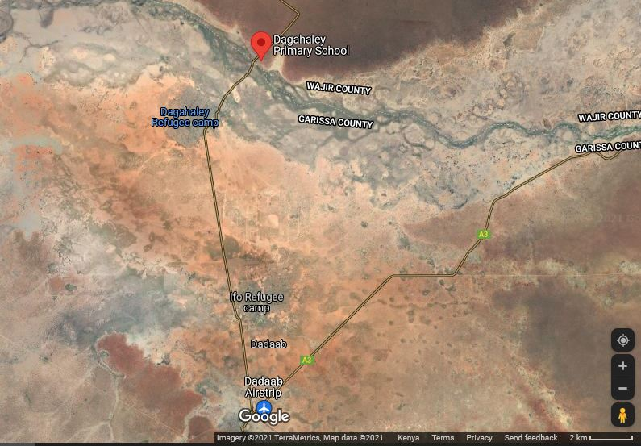
Project Location: Source: Google Earth

Project site setting
The proposed Dagahaley mini grid is located in Wajir County which falls under Lot 3. The site area is neighboured by Dagahaley Primary School.
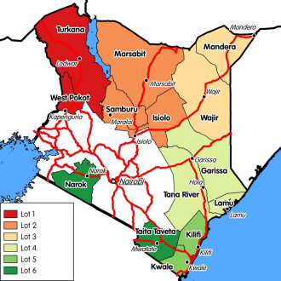
Map showing the KOSAP Counties Lot 1-6

Description of Project Facilities, Components and Activities

Project Components

Architecture and Basic Design Specifications
This hybrid power generation site is projected to generate 236(kWp) and is meant to serve between 900-1000 households (customers). The proposed mini-grid installations will be built to comply the International Electro technical Commission (IEC) standards. It will have an installation of solar panels of with a capacity of 236 (kWp) and battery house with 766 kWh. The solar panels will have a connection to the batteries through underground cables.

This generator will be a capacity of 110 kVA capacity with a fuel tank of 2000ltrs capacity. To optimize this hybrid system the HOMER software will be used. The goal of the hybridization of diesel systems is to reduce fuel consumption by switching off diesel generator set(s) for several hours a day, in order to reach a PV energy, share in the final mix of at least 60% or more. The power will be distributed to the customers by overhead lines. The project site is expected to serve clients within a radius of 1.5km from the site (generation source).

The PV plant and the battery capacity have been sized accordingly to the daily demand and the solar resources. In addition to this Design architecture, the project site shall have a site office that shall also have a Control Room adjacent as well as a guard house. The guard house shall be constructed using concrete and masonry works whereas the control room and office can also be a containerized facility.
The Solar PV hybrid system is based on a centralized photovoltaic plant connected to a 3-phase 415V AC busbar line, where the multi-mode battery inverter and the diesel generator are also connected.
The plant is configured such that a significant portion of daytime loads is fed directly from the solar generator (grid-tie inverter) without intermediate battery storage usage. The solar PV power plant is also equipped with a Diesel Generator, which is normally used as reserve power. The diesel generator switches on automatically whenever the battery state of charge reaches a certain defined DOD (Depth of Discharge). The diesel generator is equipped with automatic startup function controlled by the battery inverter charger. The table 2 below illustrates the preliminary data for the mini-grid in Daghaley.
Figure 2: The preliminary Data for Daghaley Solar Mini-grid
Name | Residential | Nonresidential | Circuit(km) | Peak demand (kw) | Daily demand (KW) | Monthly demand (kWh) | PV(DC-KWp) | Genset fuel Tank |  | Batteries | Generator (kva) | Cost (USD
Daaful | 955 | 8 | 14 | 90 | 789 | 23,668 | 236 | 2000 | 766 |  | 110 | 1,028,124
Key Components of the Project:

Power Generation Sources:
- Low Voltage Power Distribution Network:
A kilometer Low Voltage (LV) power distribution network is established to distribute the generated electricity to the residential and nonresidential consumers. The LV network is designed to efficiently transmit power while minimizing losses, ensuring a stable supply to the customers.
- Monthly Energy Demand: The project is expected to meet a total monthly energy demand of 23,668 kWh.
- Daily Energy Demand: The average daily energy demand is approximately 789 kWh, ensuring a consistent supply for the consumers.
- Peak Demand: The peak demand of the system is 90 kW, which is the maximum power requirement during any given moment.
- PV Capacity: The solar photovoltaic panels have a total capacity of 236 kWp.
- Battery Capacity: The Battery Energy Storage System has a capacity of 766 kWh, providing energy storage and ensuring a continuous power supply.
- Generator Capacity: The diesel generator has a capacity of 110 kVA, serving as a backup power source.
- LV Network Length: The low voltage distribution network spans a length of 14 kilometers, connecting consumers to the power source.
- Estimated Project Cost:
The estimated cost of the Daaful Mini Grid project is approximately USD 1,028,124. It's important to note that this cost may be subject to change as more detailed plans and implementation phases are developed. The investment is expected to provide long-term benefits to the local community, improving their quality of life, economic opportunities, and access to modern amenities.

Nature of the Project
The proposed project will be having two components in one that is a Hybrid Mini-Grids (PV- and Diesel) and construction of Power line reticulation lines. The following sections are explanations for each of the components that will be implemented.

PV Hybrid Mini-Grid Sizing
The power system has been sized based on the energy parameters. These are:
- The proposed Residential & Non-Residential Users available
- The PV Capacity in kilo Watt peak.
- The storage battery Capacity
- The Inverter capacity in (kW)

The system will be modular, so that it can be upgraded easily to meet future demand needs. The proposed power plant will be configured as AC coupled due to the significant portion of daytime loads that can be fed directly from the solar PV generator without intermediate battery storage. This will include:
- PV modules with PV inverters,
- Diesel Genset,
- Deep-cycle lead-acid electrochemical batteries with liquid electrolyte (largely used in off-grid applications thanks to its well proven technology at baseline costs compared with other types of batteries).
The proponent will be required to apply for a NEMA ESIA variation of the license, during the design changes over the project lifespan.

Solar PV modules
The project will use PV Array (DC-kW) 236 polycrystalline silicon module with three strings connected in series. Each string will have five sets of panels connected in series, with output converged at the six-way combiners. The life expectancy of the PV modules is estimated at 25-30 years.

Powerhouse
The Battery, Multi-mode inverter and all monitoring equipment will be installed indoors with adequate air ventilation accordingly to the manufacturer’s recommendations. Thus, a powerhouse or a containerized solution, considering the equipment manufacturer’s recommendations shall be installed. All electrical boards and LV protections will also be installed indoors. The batteries will be installed in the powerhouse in a separate room, specifically for their use and meeting the electrical safety requirements according to its voltage class.

Battery

A 766 kWh Battery Energy Storage System is incorporated to store excess solar energy during the day, ensuring a consistent power supply even during cloudy or nighttime conditions.
The battery considered is lead-acid, deep discharge type with a permissible repeated deep discharge without damage. Automotive or starting type batteries are not acceptable. It shall be of the open “vented” OPzS type with recombination caps and transparent enclosure for easy inspection of electrolyte level.
OPzS stands for:
O = Ortsfest (stationary)
Pz = PanZerplatte (tubular plate)
S = Flüssig (flooded).
Other batteries can be considered:
- OPzV type, “gel” lead-acid batteries are “maintenance less” but the unit weight is higher and the lifetime is sensitive to high temperatures.
- Li-ion batteries, have longer lifetime, are lighter and smaller. But they have a higher investment cost and are not adapted to high air temperature so that an additional active cooling system is needed.
The batteries must be manufactured according DIN 40736-1: “Stationary batteries with tubular positive plates. Capacities, measurements and weights”. The battery array will have 12 batteries.

Battery Rating
The battery nominal voltage does not need to be established at this stage and different technology providers may offer different solutions on this issue. Nevertheless, it must be noted that the voltage class, either ELV or LV, will determine the electrical isolation and accessibility requirements of the battery room. The battery shall have at least the rated capacity of 2.16V at the C10 discharge rate according to DIN 43539-9.

Battery Performance
The battery shall have a self-discharge when new of less than 5% per month (at 25ºC and fully charged) of its rated capacity and shall have a Coulombic efficiency of at least 85% and energy conversion efficiency of at least 85% when new and charged to more than 50% of capacity. The battery cycle life for discharge/charge regular cycles down to 80% DOD shall be more than 1500 cycles (According to IEC 896-1).

Lifetime
The design lifetime of the batteries shall be of at least 8 years without losing more than 10% of the rated C10 capacity. When the batteries get damaged, they will be stored separately at the site and then transported to Nairobi for proper disposal.

Battery Cabling and Protections
The battery connection point shall be as close as possible to the Multi-mode Inverter. Cables used to connect the battery shall have a temperature rating higher than 20°C above ambient temperature. It is recommended that they be flexible (multithreaded) to allow for easy installation and maintenance. Fuses in cables that connect components to the battery shall be rated for D.C. use, be installed separately as close as possible to the battery terminals and rated to interrupt high fault currents from the battery. A neutralization kit will be provided at the site to manage any battery acid spills that may occur.

Multi-mode Inverters

Inverters and Chargers:
PV Inverter: A 197 kW solar PV inverter is used to convert the direct current (DC) electricity generated by the solar panels into alternating current (AC) electricity suitable for consumer use.
Battery Inverter Charger: A 153 kW battery inverter charger is employed to manage the energy flow to and from the battery storage system. It ensures efficient charging and discharging of the battery, maximizing the system's overall performance.
The Inverters shall be designed for continuous, reliable power supply as per specification and shall have internal protection arrangement against any sustained fault in the feeder line and against lightning strikes in the feeder line. The inverters shall be capable of complete automatic operation including wake-up, synchronization & shut down independently & automatically.

Cable Requirements
The cables used in the site shall fulfil these requirements:
- The cables shall be suitable for laying on racks, in ducts, trenches, trestles, conduits and under-ground buried installation with chances of flooding by water.
- All cables of module area if laid on cable trays shall be covered. If cables are to be laid underground, laying shall be as per latest relevant code.
- Cables with Copper conductor on DC side & that with aluminum conductor in AC side to be used as power cables shall have tensile strength as per relevant standards. Conductors shall be stranded.
- Cables with XLPE insulation, PVC sheathed & armored suitable for a continuous conductor temperature of 90⁰C and short circuit conductor temperature of 250⁰C shall be used.
- PVC insulation shall be suitable for continuous conductor temperature of 70⁰C and short circuit conductor temperature of 160⁰C.
- Only terminal cable joints shall be accepted. No cable joints to join two cable ends shall be accepted.
- Cables inside the control room shall be laid in suitable Cable Trays of approved type.
- Cable terminations for LT cables shall be made with suitable cable lugs & sockets etc. crimped properly and passed through brass compression type cable glands at the entry and exit point of the cubicles.
- The panels’ bottoms shall be properly sealed to prevent entry of snakes / lizard etc. inside the panel.
- The terminal end of cables and wires are to be fitted with good quality letter and number ferrules of proper sizes so that the cables can be identified easily.

Diesel Genset

A 110 kVA diesel generator is included to serve as a backup power source for periods of low solar generation or in case of battery depletion. It provides reliability and backup in the event of extended periods of cloudy weather or high demand. The he Diesel Generator Set shall have a capacity as per KPLC requirements/specifications. It should include a highly corrosion resistant enclosure, control panel and monitoring, fuel tank and circuit breaker protections. The Diesel Genset shall be suitable for indoor or outdoor installation and shall perform accordingly with Multi-mode Inverter and the mentioned architecture model. The Diesel Genset shall be working in a fully automatic manner with the above stated components. The diesel gensets will have base mounted fuel tanks that will be factory tested for leaks. There will also be an external reserve fuel tank with a capacity of 2000 litres. The proponent, through the operating entity will have regular inspection by the manufacturer. The noise rating for the generator set will be 75dBA @ 1 meter at 75% load under free field conditions. The generator sets will have a high-quality noise absorbent and fire-retardant grade acoustic insulation material complying to IS 8183.

Substation
The mini-grid site will have a 200 kVA transformer that will allow stepping up of the voltage before it is connected to the distribution line.

Distribution lines
Daghaley site will have a distribution line circuit of 14km in total. Supply of concrete poles for the distribution lines will be based on detailed survey and accessories like phase plates, circuit plates, number plates, danger plates, anti-climbing devices as per KPLC requirements/specifications. Erection of the Poles, fixing of insulator strings, stringing of conductor and earth wires along with all necessary line accessories and earthing will be as per KPLC requirements/specifications

Resource Requirement

Workforce Requirement
The Solar Mini-grid will be installed, operated and maintained by the O&M contractor for the first Seven years and then handed over to KPLC engineers and operators. So, for the seven years KPLC will be monitoring the operations of the contractor.

Water Requirement and Source

Construction Phase
Water will be used during construction phase of installation of the solar panels and systems. Water will be required for workers at project site. However, this quantity of water requirement will vary depending upon the mobilisation of construction workers at site. The water for the construction phase will be supplied by a water tanker from the area water vendors

Operation Phase
The water required during operation phase of the project will be mainly for washing the face of the solar modules, Minimal water will be used for this purpose. Water requirement during operational phase of the project will be met from the water vendors in the area.
Approximately, 10 employees (direct and contractual) will be working during operation phase. For this workforce, approximately 10,000 Litres of water will be required for domestic consumption.

Raw Material Requirement

Construction Phase
The major raw materials required for the construction phase will be solar modules, fencing materials, construction materials like cement, sand and aggregate. The fencing materials and the construction materials will be sourced from the local hardware facilities. Solar Modules for the project along with associated structures will be obtained from China.

Operation Phase
There will not be major requirement of raw materials during operation phase. Only maintenance spares will be required at this phase.

Power Requirement
Power requirement during the construction phase will be met through Diesel Generators sets. The exact number of Diesel Generator sets to be used, as well as the quantity of fuel, will be ascertained once the project is in the implementation stage.

Fire Safety and Security

Construction Phase
Appropriate firefighting system and equipment shall be provided throughout the construction period. The fire extinguishers will be well distributed according to the fire risks and will be available in areas such as the site office, security area, storage yard etc. A comprehensive emergency response plan with all the emergency numbers will be well displayed at the site and on the fence.

Operation Phase
Suitable fire protection and fighting systems that will include portable fire extinguishers, automatic fire detection system and means of fire communication will be made available at the entire PV array area, inverter stations, main control room and switchyard.
The systems and equipment’s will align to the Kenyan Fire Reduction Rules of 2007. The Fire protection and fighting systems will be maintained and serviced after every 6 months.

Pollution Streams during Construction Phase

Solid Waste Generation

Construction Phase
The key solid waste that is expected to be generated during construction phase includes;
- Broken solar panels and PV Modules
- Hazardous waste like waste oil, lubricants, oil contaminated rags
- Domestic soil from the temporary site office.
The hazardous wastes will be stored onsite at separate designated covered area provided with impervious flooring and secondary containment. The storage containers/ bins/ drum will be clearly marked and color coded for their hazards. The waste will then be collected by a NEMA approved waste handler.
Any broken solar panels or PV Modules will be sent back to the vendor as part of buyback arrangement. All the other domestic solid waste will be disposed at the nearest municipality dumpsite.

Operation Phase
During operation phase, waste generated from the project will include domestic waste at site office, scrap materials like scrap tools, damaged PPEs etc.; hazardous waste like waste oil, lubricants, used transformer oil; damaged batteries; electronic waste like damaged PV modules etc.
The hazardous wastes will be stored onsite at separate designated covered area provided with impervious flooring and secondary containment. The storage containers/ bins/ drum will be clearly marked and color coded for their hazards. The waste will then be collected by a NEMA approved waste handler.
Any broken solar panels or PV Modules will be sent back to the vendor as part of buyback arrangement. All the other domestic solid waste will be disposed at the nearest municipality dumpsite.

Air Emissions

Construction Phase
Air quality will be impacted due to onsite construction activities. The likely emissions from construction activities would include the following:
- Dust emissions from the murram roads leading to the site;
- Increased vehicular emissions due to the high traffic of vehicles transporting construction materials, PV Modules and accessories;
- Dust emissions from site clearing, material handling, piling and use of the construction machinery.
- Exhaust emissions from the diesel generator.
The high dust emissions arising from various activities such as piling, transportation of material (loading and unloading), vehicular movement (on unpaved roads) should be minimized through sprinkling of water and maintaining vehicular speed to 10-15 km/hr.
All the vehicles and the Diesel generator should be well maintained and serviced to reduce the rate of exhaust emissions.

Operation Phase
It is expected that the normal operations of the site will produce minimal gaseous emissions from all the operating areas. The minimal gaseous and fugitive dust emissions will be attributed to the in and out movement of the maintenance vehicles. It will be ensured that well maintained vehicles are used for maintenance purposes.

Waste Generation

Construction Phase
The liquid effluents generated during the construction phase will include domestic sewage from temporary site offices, kitchen and washing areas. As part of the site preparation stage, septic tank will be constructed for the camp and site office. Sewage disposal trucks should be used to periodically remove the sludge/sewage from the septic tank.

Operation Phase
The operational phase will have negligible wastewater generation at site office. Septic tank and soak pits will be provided at the site office for disposal of sewage.

Noise Emissions

Construction Phase
Noise emissions will be generated from piling, movement of vehicle and other construction machinery and operation of the Diesel Generator. The main noise receptors will be the neighbouring settlements and the construction workers. Noise from Diesel Generators will be minimised through provision of acoustic enclosures and occasional maintenance of the generator. Every single noise generating activity will be restricted to Day time only.

Operation Phase
Under normal operations, none of the activities of solar power plant will generate noise. The only noise that can be generated at this phase is during the maintenance works and it will be restricted to daytime only.

Analysis of Alternatives and Project Justification
This section analyses the project alternatives in terms of site and technology. Solar projects are non -polluting energy generation projects which are site specific and dependent on the availability of solar irradiance resource. The current site selected is a high solar power potential site with high irradiation and consistent sunny days throughout the year.

CHAPTER THREE: ANALYSIS OF PROJECT ALTERNATIVES

Consideration of Project Alternatives
In this chapter, various alternatives available to the project are discussed. The alternatives are as follows; “no-go/do nothing” alternative, alternative construction materials and technology, the alternative Mini Off-grid site and alternative sources of energy identified during the ESIA process.
The identification and examination of alternatives is fundamental to environmental assessment. It provides decision-makers with information that enables them to properly consider optimal solutions to development proposals. Alternatives illustrate and contrast the environmental implications and consequences of different options available to achieve the same end. In this way, both the KPLC and the authorities who must consider granting the authorization, are put in a position where all involved are able to make informed choices or decisions.
This section analyses the project alternatives in terms of site, technology and waste management options.

Factors considered while selecting the site for the proposed project
Mini Off-grid Sites under KOSAP were selected based on several factors.
- Geophysical Factors-Proximity to Hills-Shade effect, Soil erosion, Drainage of the area, Flooding etc.
- Land identified is free from any dispute on ownership or any other encumbrances
- Proximity to public utilities-Schools, Dispensaries, Places of worship and community settlements
- No squatters, encroachers or other claims to the land
- The Size of the Mini Off-grid to be constructed and the optimal coverage of a Mini Off-grid in terms of the number of people to be reached.
- The Land identified should be on spaces set aside for public use within the community centres.
- The land was identified by the beneficiary communities and confirmed by technical staff to be suitable for the sub-project and free from any environmental or health risks. The impacts on the Community will be marginal and will not result in displacement of households or cause loss of household’s incomes and livelihood.
The site identified was considered against the criteria highlighted above and was found suitable for Mini Off-grid construction.

Power Scenario in Dagahaley
This option involves remaining on the status quo.
The no construct/no project alternative will not achieve the objectives of the project since the listed benefits will not be achieved.
Failure to construct and operate the mini grid will lead to the failure of achieving one of the Kenya’s national long-term development policies that aims to transform Kenya into a newly industrializing, middle-income country, by providing a high quality of life to all its citizens by 2030 in a clean and secure environment. PAPs will be households, public and community institutions, enterprises and community facilities that cannot access electricity through the national grid and whose use of electricity will replace kerosene and other fuels for lighting and other activities like pumping water.

Present Power Supply Position
According to the KIHBS 2005/6, 98.4 per cent of the county households depend on wood fuel (Firewood and Charcoal) for cooking and 31.5 per cent depend on kerosene lantern for lighting. 96.6 per cent of households use traditional stone fire for cooking. This contributes to massive environmental degradation, increased health risks and additional workload for women and girls, and increased emissions of carbon content. Moreover, low enrollment, retention and transition for girls is partly attributed to increased workload related to energy search.
Wajir, Griftu, Abakore, Tarbaj Habaswein and Eldas centers are Wajir County Integrated Development Plan (2018-2022) 30 connected to diesel power plants where over 20,000 households are supplied with power. Bute is connected to the Ethiopian Grid through Moyale. Solar energy accounts for 0.2 per cent (2009 KPHC) of energy source but is also limited to schools and health facilities as it is out of reach for majority of the households.
The county has a huge potential for renewable energy which can tapped through wind and solar energy and hence be channelled to productive sectors within the county as well as export to other counties.

Relocation Option
Relocation option to different sites is an option available before the project implementation. At present the project KPLC does not have alternative sites in the general direction of the proposed sites. This means that the project proponent must look for the alternative lands. Looking for the lands to accommodate the scale and size of the proposed project and completing official transaction may take a long time although there is no guarantee that the land would be available.
This project is to improve electrification and accessibility to an already established market centre. Several alternatives were considered to improve other areas, but this one was selected because it meets the electrification needs of the area
In consideration of the above concerns and assessment of the current proposed sites, relocation of the projects is not a viable option.

Zero or No Project Alternative
The No Project option in respect to the proposed project implies that the status quo is maintained. This option is the most suitable alternative from an extreme environmental perspective as it ensures non-interference with the existing conditions. This option will, however, involve several losses both to DAGAHALEY village and the community. The target Project-Affected Persons (PAPs) will stay without electricity and the government objectives of bring electricity in order to open the area and provide better public services will not be realized. The No Project Option is the least preferred from the socio-economic and partly environmental perspective due to the following factors:
- The socio-economic status of target communities the local economy would remain unchanged.
- Generation of employment opportunities through expansion of business activities that would have been spurred by availability of electric power will not occur
- Opening the area for investors will not occur.
- Health benefits that come with electricity will not be realized
- The targeted consumers will forgo the desired electricity supply in the area
- The country won’t meet its energy requirement
The objectives of the government’s efforts towards achieving Vision 2030 will not be realized.
From the analysis above, it becomes apparent that the no project alternative means no project to the local people and the Government of Kenya, and the benefits outlined above and other indirect benefits that would accrue from construction of the proposed project.
It is thereby concluded that the ‘do-nothing’ option is not a good option economically and should therefore be discouraged and rejected. It is therefore imperative for KPLC to establish a new solar mini Off-grid in the area and supply the community with clean energy.

Alternative Sources of Energy

Thermal Power Generation
Thermal power through installation of Diesel Gen Sets is an option which can be considered to provide power to Dagahaley. This would need more than 250-300litres of Industrial Diesel Oil (IDO) is burnt daily to generate targeted 50kWp of electricity at Dagahaley. Thermal generation can also be fuelled using alternative fuels such as natural gas, bio diesel, industrial kerosene, heavy vehicle fuel, coal and unleaded petrol. Thermal power generation has serious negative environmental impacts including generation hence the need for the KPLC to install the proposed solar power plant.

Hydro Electric Power – HEP
This would mean exploring the possibility of extending the existing national grid to Dagahaley since there are no hydro facilities within the region to facilitate HEP generation. The proposed project is quite far from the national grid hence this is a costly venture and may take time before the residents need power for their livelihood.

Other Sources of Energy:
Wood fuel is the greatest source of Energy contributing to 80% of energy requirements in Africa. Over reliance on wood has led to deforestation, desertification, global warming and climatic change among other socio – economic demerits. The Government of Kenya should investigate the possibility of using nuclear energy to generate electricity. This is a long-term consideration and has several deleterious effects to the environment and human health. Nuclear Waste disposal will also create a huge environmental challenge.
Based on this discussion the proposed solar Mini Off-grid presents the most appropriate option of electrifying/ bringing power to Dagahaley in terms of technology, cost and environmental considerations.

Analysis of Alternative Construction Materials and Technology
The proposed solar Mini Off-grid will be constructed using modern, locally and internationally accepted materials to achieve public health, safety, security and environmental aesthetic requirements. Equipment that guarantees efficient use of locally available materials will be encouraged to ensure reliability in supply with minimum power loss and good design to allow efficient distribution of power in the area.
The support structures in the Solar Mini Off-grid can be wooden or steel. Because of its durability and strength, steel is the best choice, and all support structures will be steel. Perimeter fence can be a reinforced wire mesh fixed to support structures that can be wooden, concrete or steel. Alternatively, a stone perimeter wall can be constructed, and this is the option of choice since it is more durable, offer better protection and requires less maintenance.
The design of the solar mini Off-grid will be easy to install and dismantle with minimum labor requirements and maintenance costs will be minimal. The process material that are input for the proposed project such as generator diesel fuel and oil and water for cooling the generator and for cleaning purposes are critical elements. There is no alternative for generator oil and water for standby generator cooling and for mini Off-grid facilities cleaning water. So, the task was to assess alternative water and Diesel generator oils and fuel sources for the project.

Solid Waste Management Alternatives
A lot of solid wastes will be generated from the proposed project. An integrated solid waste management system is recommendable. First, the KPLC will give priority to reduction at source of the materials. This option will demand a solid waste management awareness program in the management and the staff. Recycling and reuse options of the waste will be the second alternative in priority. This will call for a source separation program to be put in place. The third priority in the hierarchy of options is combustion of the waste that is not recyclable. Finally, the KPLC will need to establish partnership with NEMA approved waste handlers for regular waste removal and disposal in an environmentally friendly manner. In this regard, a NEMA registered solid waste handler would have to be engaged. This is the most practical and feasible option for solid waste management.

Alternative Solar Mini Off-grid Site
The identification of potential Mini Off-grid site for the proposed Dagahaley Solar Mini Off-grid involved site visits to the study area, preliminary site assessments and consultations among the concerned departments of the KPLC, MOE and REREC. Two sites have been proposed by the community.
The site identified is part of a larger piece of land which had been identified by the community for setting up community service projects. Between site A and B, site A was rejected because it would result in physical displacement and site B was found to be suitable for the project.
The appropriateness of potential Mini Off-grid sites identified by the KPLC during the initial site visits was assessed in terms of various suitability criteria and technical restrictions stipulated by KPLC, as outlined below:
- Load growth - the location of Mini Off-grid first and foremost is informed by the existing and load growth of an area. Technical studies show that the area will experience load growth over time and there is need to supply electricity.
- Size – proposed potential sites need to be sufficient for the average size of Solar Mini Off-grid and associated auxiliary facilities. Therefore, the size acquired must meet the required size. The proposed site is 1.62 Hectares
- Topography – consideration is given to the topography of potential sites whereby flat or gently sloping topography is preferred. An ideal gradient for the natural ground is 1:100. A gentle slope facilitates surface drainage and movement of vehicles and people on-site during construction. A steep slope requires costly levelling (cut and fill) for the construction of the solar Mini Off-grid. In addition, a steep slope inhibits movement, makes vehicle access problematic and increases the potential for environmental impacts during construction as well as operation e.g., steeper slopes have higher surface water flow rates and therefore higher erosive potential. The proposed site is flat and cost-effective during construction.
- Hydrology – consideration is given to the proximity of potential sites to adjacent water courses and wetlands where there may be potential impacts in terms of erosion and siltation of water courses, as well as implications associated with storm-water control at the Solar Mini Off-grid site. The site is not close to water resources or wetland and so no impact to water sources through siltation. Further, construction of drainage is not complicated.
- Geology and soils – consideration is given to the soil type present within the potential site whereby stable soil and founding conditions are preferable. Less stable soils, i.e., shallow, dispersive soils and soils with poor drainage present an erosion hazard if not managed correctly, and require the instalment of additional, costly foundation infrastructure. The soils at the site are well drained.
- Flora and fauna – potential sites need to be assessed in terms of their ecological value at both a macro and micro scale i.e., within the site and the environment surrounding the site. Both a faunal and floral investigation may be required, with particular emphasis on ensuring the protection of endemic and red data species and their habitat, should they be present. An identified site that has a high ecological value may be excluded from the list of potential sites. The site is not of a high ecological value.
- Visibility – highly visible sites i.e., on a ridge / elevated terrain are considered less favourable in that they have a high visual impact on the surrounding landscape. Sites that are hidden or out of site e.g., behind a hill, may be considered more suitable; the site is on flat part near chief’s office and may not create sharp visual impact because it is not on an elevated point.
- Access – it is preferable that potential sites are near existing public roads to avoid the need for construction of new access roads of considerable length. Access is also important particularly as it relates to the transportation of the solar panels, batteries and generator to the site, which are heavy weights and requires the use of a low-bend vehicle. As such, long access routes with sharp bends are to be avoided and the site should not be in an area that has excessively steep inclines or declines that could hinder access, particularly during periods of heavy rainfall; the site is well accessible as it along the road.
- Distance to site – it is important that the site be located strategically within the receiving area’s electrical load Centre; this is true of the proposed site. The site is approximately 544metres from the DAGAHALEY shopping Centre and school.
- Adjacent land use – adjacent land use has implications for access and required clearances for the power lines extending from the solar plant site, i.e., it is important that the land surrounding the Mini Off-grid is relatively clear of obstructions which might otherwise inhibit / obstruct the path of the power lines out of the Mini Off-grid. Current and future development planning of adjacent land use should therefore also be considered. The site and the developments around do not pose a hindrance for incoming and outgoing feeders.
- Public acceptability – public acceptance criteria relate to such issues as the possible adverse impact on public health, quality of life, and local land and property values. During the public consultations there was overwhelming support for the project with mitigation measures being put in place for the negative impacts.
Based on the above-mentioned suitability criteria and technical requirements, the proponent decides to put up the Solar Mini Off-grid within Dagahaley. Relocation option to a different site is an option available to the proponent. The project proponent can look for alternative land to accommodate the scale and size of the project. However, this will be a costly venture, may take a long time although there is no guarantee that the land would be available in the targeted area. It is recommendable that the proponent be allowed to install the project in the proposed site.

BASELINE SETTINGS - ENVIRONMENT, ECOLOGY AND SOCIAL

Area of Influence
The Area of Influence (AoI) of the project comprises of the project site and the surrounding area, where the influence of the project activities is anticipated.
The project activities and facilities operated and managed by the Ministry of Energy, Kenya Power and Lighting Company (KPLC), Rural Electrification Authority and Renewable Energy Corporation (REREC) and project components such as solar modules, control room and transmission line to power grid sub-stations; and any other selected CSR project, such as the construction water abstraction and distribution points.
- Impacts from unplanned but predictable developments caused by the project that shall occur later or at a related location such as increase in traffic on the approach road;
- Impacts on biodiversity or on ecosystem services upon which affected communities’ livelihood are dependent;
- Associated facilities e.g. approach road construction and widening of existing road; Further to this, the AoI with respect to the environmental and social resources was considered based on the following reach of impacts:
Air Quality
- Impact on ambient air quality from vehicle exhaust;
- Impact of air pollutants emission from construction activities and
- Dustfall- typically up to 200 m from construction activities
Noise
- Noise impact area (defined as the area over which an increase in environmental noise levels due to the project can be detected) - typically 500 m from operations and 200 m from the access road
Water
- Surface water body- typically 500 m upstream and downstream of water intake point and downstream of discharge point
- Other surface water bodies within 1 km of the project footprint
- Groundwater in 1-2 km radius of project footprint
Flora and Fauna
- The direct footprint of the project comprising the project site
- The areas immediately adjacent to the project footprint within which a zone of ecological disturbance is created through increased dust, human presence and project related activities (e.g., trampling, water intake/outfall, transportation). This kind of disturbance has been estimated to occur within the project footprint and surrounding areas of about 500 m to 1 km from the activity areas. Based on the above the AoI for environmental studies was limited to 5 km from the project site.

Socio-economic/Social
The AoI for social receptors was fixed to include 2 km radial zone which has been developed based on the reconnaissance site visits and stakeholder consultations with the local community. The AoI for development of the social baseline is Dagahaley village which according to the administrative structure falls within Dagahaley Location. The socio-economic information presented in this report has drawn from primary socio-economic survey and the Population and housing census 2019, Kenya Bureau of Statistics (KBS).

Project Footprint Area
The project site will be implemented in Wajir South Sub County, Wajir County.
Wajir County is within semi-arid area falling in the ecological zone V-VI. Zone V receives rainfall between 300-600mm annually, has low trees, grass and shrubs. On the other hand zone VI receives an annual rainfall of 200-400mm. Overall; the county receives an average of 240 mm of rainfall per year which is erratic and short making it unfavourable for vegetation growth and rain fed agriculture. There are two rainy seasons’ i.e. short and long rains. The short rains are expected between October to December and the long rains from March to May each year. Crop activity is carried out in the Lorain swamp and along the drainage lines in Bute. The main crops grown in the area are sorghum, maize, beans and watermelons.
The side is generally in open area with minimal fauna and flora and the land is communally owned within Dagahaley area.

Study Area
The project site is located at Dagahaley village, Banane Ward, Dagahaley Location, Wajir South Sub County in Wajir County.
Locations of ecological and social surveys were also selected based on receptor locations; in addition, special emphasis is given to areas within 500m radius of the project site, transmission towers and access roads.

Environment Baseline

Land Use
The land-use and land-cover of the study area (5kms) has been interpreted from visual interpretation, survey maps of the area, and subsequently by ground checking during field surveys. The land use within 5 km radius of project site represents low trees, grass and shrubs. The area is majorly semi-arid with a sparse population within the area.
An A-RAP applies where affected persons are not physically displaced, and less than 10% of their productive assets are lost, or fewer than 200 people are displaced. In the case of KOSAP sub-projects, there is no physical displacement of affected persons, and the foreseen impacts on livelihoods such as grazing occasioned by mini-grid construction, wayleaves acquisition, and implementation of community projects are considered minor. A-RAPs will be implemented for sub-project sites on registered and unregistered community land/group ranches.

Topography
The topography of the project site is a featureless plain and lies between 150 metres and 460 metres above sea level and along latitude 1°45'N and longitude 40°4'E. The plain rises gently from the south and east towards the north rising to 200 metres at Buna and 460 metres at Bute and Gurar at the foothills of Ethiopian highlands.

Hydrogeology and Drainage
Geologically, major parts of the Wajir South Sub County are generally covered with young sedimentary rocks with loamy soils in the north bordering the Ethiopian highlands. The county has considerable deposits of Limestone and sand which are used in the local building industry.
The sources of water in the project area are 4 existing boreholes and a number of public and private pans.

Ecology
The project area is located in Dagahaley village, Banane Ward, Dagahaley Location, Wajir South Sub County in Wajir County.
The county receives an average of 240 mm of rainfall per year which is erratic and short making it unfavourable for vegetation growth and rain fed agriculture. There are two rainy seasons’ i.e. short and long rains. The short rains are expected between October to December and the long rains from March to May each year. Crop activity is carried out in the Lorain swamp and along the drainage lines in Bute.
The main crops grown in the area are maize, watermelons, sim sim and daokra.

Ambient Air Quality
The proposed project area falls within Dagahaley village which can be described as generally rural with interfaces of natural vegetation and cultivated lands. Most of the areas are covered in low trees, grass and shrubs and there are no major industrial developments. The air quality at the proposed project sites is therefore considered to be generally good.

Ambient Noise Quality
In general, the project area is in a rural area and main source of noise is from motorists and from machines such as the generators used to supply power.

Soil Type
The soils Wajir County are predominantly sandy soil with patches of depressed land of loam soil.

The soils within the project site are sandy, loams and heavy sandy. This type of soil easily gets eroded particularly due to flood and sometimes heavy wind, Natural pasture are annual species that are easily eroded by the strong winds and wild fire hence limited in the peak of the dry spells, only few individual with small water pans maintain and preserve their pasture in their compounds.

Socio-economic Environment

Demographic Profile
Dagahaley village has a population of approximately 7908 people with estimate number of households as 1500 households.. The gender ration is currently estimated to be about 46% male and 54% female.
The village is dominated by larger MZ Clan Sub Clan Ogaden ethnic group which make 100% of the general population and is primarily of Islam religion.
Below is a summary of demographic profile of Dagahaley;

Demographic profile of Dagahaley
Attribute | Magnitude/Number
Approx. population | 7908
Households | 1500
Gender. | Male – 46%  Female – 54%
Indigenous | Indigenous- 100%  Settlers – 0%
Vulnerable classes | PLWDs
Dominant ethnic group | Ogaden
Primary religion | Islam
Other groups | Degodia, Murulleh
Employment (formal/Informal) | Formal – <1%  Informal – 3%
The village has approximately 27 vulnerable households that mainly compose of PLWDs. The average growth rate of the population is on the upward trajectory with generally high birth rates within the last 2 years.

Occupation and Livelihood Profile
The community main source of income is sale of live animals and livestock products. Livestock rearing is major livelihood while crops like maize, tomatoes, sorghum, and onions mainly for household consumption while the rest are sold near the Dagahaley Refegees’ Camp and Dagahaley . Major species of livestock are Goats, Sheep, Cattle, Camels and Donkeys.
Other activities practiced in the village include; small scale trades e.g. shop-keeping, vending of clothes and vegetable as well as transport services.
The main formal jobs at the area are teaching and other civil servants which accounts to less than 1% of the population while approximately 5% of the population is involved in informal employment.

Land Use
There are two types of land in Wajir County; Private and Communal land. Private land is mainly found is town and used for residential, business and crop/fodder production.
The land type within the project area is communal. The main activities undertaken on available land area are grazing and crop farming.
The project site is within a land which is communally owned, there are no environmentally sensitive areas to be affected.

Infrastructure

Education | Dagahaley has one primary (Dagahaley Primary School) and one secondary (Sheik Omar) school. The primary school is mainly understaffed with a total of 7 teachers and has a low enrollment rate.  The average walking distance of student to school is 1.5km, the farthest student lives 2km from the school. There is no Feeding programme available in the school
Health | Dagahaley has one Dispensary namely Daaful Health Centre which operates between 8am and 1230pm and serves approximately 30 people within a 50km radius. Its offers general health care services like maternal care, out-patient services, immunization services and family planning free of charge. The facility is generally understaffed as it only has 1 nurse and 1 community volunteer although the infrastructure is at moderate condition. The main challenge in health care in the village is vaccination stigma
Water | Dagahaley village’s main sources of water are 4 boreholes and a number of public and private water pans.
Roads | The roads within the area is poor and are mainly earth or gravel roads These roads become impassable during heavy rains due to the water surface run off. The roads are also encroached by trees and overgrown bushes that grow along the roadsides.
Mobile Network | Safaricom mobile network is available in the village.
Electricity | The area currently has no connection to the national grid. There are few generators and solar panels used by individuals to access electricity.
Mosques | The community is predominantly of Islam religion. There are currently 4 Mosques serving the local community.

APPLICABLE LEGAL AND REGULATORY FRAMEWORK

Introduction

This Chapter outlines the existing national and international environmental and social legislation, policies and institutions applicable to energy generation that guide the development of the Project.
As Kenya is a signatory to various international conventions and laws, national projects need to be aligned with their requirements; relevant international conventions and laws are therefore presented in this chapter.
Finally, a summary of the World Bank (WB) Environmental and Social operational policies relevant to this Project are presented.

The Kenyan Constitution
Section 42 of the Constitution states that every person has the right to a clean and healthy environment, which includes the right a) to have the environment protected for the benefit of present and future generations through legislative and other measures, particularly those contemplated in Article 69, and b) to have obligations relating to the environment fulfilled under Article 70.
Chapter five of the new constitution covers "Land and Environment" and includes the aforementioned articles 69 and 70. This Chapter seeks to eliminate processes and activities likely to endanger the environment. Article 69 states that the State shall a) ensure sustainable exploitation, utilization, management and conservation of the environmental and natural resources, and ensure the equitable sharing of the accruing benefits; b) work to achieve and maintain a tree cover of at least ten per cent of the land area of Kenya; c) protect and enhance intellectual property in, and indigenous knowledge of, biodiversity and the genetic resources of the communities; d) encourage public participation in the management, protection and conservation of the environment; e) protect genetic resources and biological diversity; f) establish systems of environmental impact assessment, environmental audit and monitoring of the environment; g) eliminate processes and activities that are likely to endanger the environment; and h) utilize the environment and natural resources for the benefit of the people of Kenya.
By commissioning this ESIA Study, the project proponent is complying with the constitutional requirements. During the project life cycle (construction; operation and decommissioning phases); the proponent will be required to put in place mitigation measures against adverse project effects.

Kenya Policy Provisions

Kenya Energy Policy, 2014
The Energy Policy sets out the national policies and strategies for the energy sector that align to the Constitution of Kenya and Kenya’s Vision 2030 (section 3.6.5).
The Energy Policy envisages promoting an energy mix that includes solar energy at both the household/institutional levels as well as large-scale solar energy generation. The Government of Kenya has initiated and has been promoting programmes for the provision of electricity to institutions far from the grid through solar PV systems. The Government has also embarked on a programme to provide solar/diesel and solar/wind hybrid generation capacity to off-grid stations.
The Policy strategizes the need to:
- promote the widespread use of solar energy while enforcing existing regulations and standards;
- provide incentives to promote the local production and use of efficient solar systems;
- provide a framework for connecting electricity generated from solar energy to the national and isolated grids, through direct sale or net metering;
- promote the use of hybrid power generation systems involving solar and other energy sources; and
- facilitate the generation of electricity from solar energy by, among other things, funding, provision of land, fast-tracking issuance of permits and licenses, as well as acquisition of data and information so as to realize at least 100 MW from solar by 2017, 200 MW by 2022 and 500 MW by 2030.
The Kenya Electricity Supply Industry (ESI) is one of the sub-sectors in the energy sector which the Ministry of Energy and Petroleum oversees on behalf of the Government of Kenya (GoK). Under the Energy Act of 2006, the Ministry is responsible for formulation and articulation of policies to provide an enabling environment for operators and other stakeholders in the energy sector. Relevant stakeholders in the ESI are briefly described below.

Stakeholders | Role
Kenya Power Company | Responsible for distribution and retail supply of electrical energy to end users. Kenya Power purchases power in bulk from the Kenya Electricity Generating Company Limited (KenGen) and the Independent Power Producers (IPPs) through bilateral contracts or Power Purchase Agreements (PPAs) approved by the Energy Regulatory Commission (ERC) () .
Ministry of Energy and Petroleum | Aims to facilitate provision of clean, sustainable, affordable, reliable, and secure energy services for national development while protecting the environment.
The Rural Electrification and Renewable Energy Corporation (REREC): | Is established under Section 43 of the Energy Act, 2019 as a corporate body. The Corporation is the successor to the Rural Electrification Authority established under section 66 of the Energy Act No. 12 of 2006 (now repealed) and subject to this Act, all rights, duties, obligations, assets and liabilities of the Rural Electrification Authority existing at the commencement of this Act is to be automatically and fully transferred to the Corporation and any reference to the Rural Electrification Authority in any contract or document shall, for all purposes, be deemed to be a reference to the Corporation.
The Geothermal Development Company (GDC): | Is a 100% state-owned company, formed by the Government of Kenya as a Special Purpose Vehicle to fast track the development of geothermal resources in the country. The creation of GDC was based on the government’s policy on energy - Sessional paper No. 4 of 2004, and the energy Act No. 12 of 2006.
The Kenya Electricity Transmission Company (KETRACO): | Was incorporated on 2nd December 2008 and registered under the Companies Act, Cap 486 pursuant to Sessional paper No. 4 of 2004 on Energy. KETRACO’s mandate is to design, construct, operate and maintain new high voltage electricity transmission infrastructure that will form the backbone of the National Transmission Grid, in line with Kenya Vision 2030.
Energy and Petroleum Tribunal (EPT): | The tribunal is established under section 25 of The Energy Act, 2019. The tribunal is established for the purpose of hearing and determining disputes and appeals in accordance with The Energy Act, 2019 or any other written law. In relation to the proposed Project, any disputes or appeals if they arise will need to be addressed by the EPT.

Policy paper on Environment and Development (Sessional Paper No. 6 of 1999)
The overall goal of this Sessional Paper is to ensure that environmental concerns are integrated into the national planning and management processes and provide guidelines for environmentally sustainable development. The objectives of the Paper are to conserve and manage the natural resources of Kenya including air, land, flora, and fauna and promote environmental conservation with regard to soil fertility and conservation, biodiversity, to foster afforestation activities, and to protect water catchment areas. More importantly, the Policy emphasizes the enhancement of public awareness and appreciation of the essential linkages between development and environment, involving NGOs, private sector, and local communities in the management of natural resources and their living environment and ensures that an environmental impact assessment report is undertaken for all public and private projects and programmes.
The proposed solar plant facility must ensure that it promotes this integrated approach to environmental management and development, without compromising the livelihoods of the local community.

National Policy on Water Resources Management and Development, 1999
While the National Policy on Water Resources Management and Development enhances a systematic development of water facilities in all sectors for promotion of the country’s socio-economic progress, it also recognizes the by-products of this process as wastewater. The Policy therefore calls for development of appropriate sanitation systems to protect people’s health and water resources from institutional pollution. This implies that industrial and business development activities should be accompanied by corresponding waste management systems to handle the wastewater and other waste emanating therefrom.
The Policy will be applicable to the Project during its construction and operational phases. During construction, water will be required for concrete works and during the operational period water supply may be necessary for cleaning the PV modules. Appropriate water treatment and waste handling must be incorporated into the Project design to be in alignment with this policy.

Sessional Paper No. 10 of 2014 on the National Environmental Policy, 2014
The overall goal of this Session Paper is to ensure better quality of life for present and future generations through sustainable management and use of the environment and natural resources. This Session Paper calls for the use of environmentally sound technologies based on the best available techniques and policies as a way of minimizing negative impacts to the environment.
Section 5.6 of this Session Paper focusses on infrastructure development and environment and makes explicit policy statements to ensure sustainable management and use of the environment and natural resources during the construction and operation of infrastructure developments. These policy statements require the commitment of the government to:
- Ensure Strategic Environmental Assessment (SEA), Environmental Impact Assessment, Social Impact Assessment and Public participation in the planning and approval of infrastructural projects.
- Develop and implement environmentally friendly national infrastructural development strategy and action plan.
- Ensure that periodic Environmental Audits are carried out for all infrastructural projects
In line with the above policy statements, this ESIA has been conducted for the proposed solar project (including the associated infrastructure) to ensure that environmental and social issues are appropriately addressed.
Once approved by NEMA, the Project Proponent will also need to conduct periodic Environmental Audits to ensure continuous conformity with the overall goal of this Session Paper. In addition, this ESIA has considered analysis of alternatives including alternatives to technology to ensure that the best available and appropriate technology is used.
- Corporation.

National Legal Framework Review
The applicable legal framework is illustrated in the table below.

Legal framework National
No | Legislation/  Guidelines | Description of the Legislation/Guideline | Relevance of the legislation/regulations in terms of license, permits, and other requirements
 | NATIONAL POLICY FRAMEWORK
 | Vision 2030 | Kenya Vision 2030 is the current national blueprint for development from its inception in 2008 until the milestone year of 2030. This plan is the national long-term development policy that aims to transform Kenya into a newly industrialised, middle-income country by 2030. The Vision is comprised of three key pillars (economic, social, and political), two of which are projected to be positively affected by project implementation | - Under Vision 2030, Energy is identified as one of the key sectors that form the foundation for socio-political and economic growth. Promoting equal opportunities across the entire Kenyan territory and enhancing access to competitively priced, reliable, quality, safe and sustainable energy is essential to the achievement of this vision.
 | The Poverty Reduction Strategy Paper (PRSP) of 2001 | The PRSP has the twin objectives of poverty reduction and enhancing economic growth. The paper articulates Kenya ‘s commitment and approach to fighting poverty; with the basic rationale that the war against poverty cannot be won without the participation of the poor themselves. | - The proposed project aims at provision and access of renewable electricity geared towards improved economic performance and thus will contribute to poverty alleviation in the project area.
 | National Environmental Action Plan (NEAP) of 1994 | The NEAP for Kenya was prepared in mid 1990s. It was a deliberate policy whose main effort is to integrate environmental considerations into the country ‘s economic and social development. The integration process was to be achieved through multi-sectoral approach to develop a comprehensive framework to ensure that environmental management and the conservation of natural resources forms an integral part of societal decision-making. | - The NEMA does not approve a development project unless the impacts of the proposed project are evaluated and mitigation measures proposed for incorporation in the project‘s development plan, which is in line with the requirements of the NEAP.  - The project will be reviewed by NEMA for approval before implementation.
 | Environmental and Development Policy (Session Paper No.6 1999) | As a follow-up to the foregoing, the goal of this policy is to harmonize environmental and developmental goals so as to ensure sustainability. The paper provides comprehensive guidelines and strategies for government action regarding environment and development.  The Government will:  1. Ensure Strategic Environment Assessment (SEA), Environmental Impact Assessment, Social Impact Assessment and Public participation in the planning and approval of infrastructural projects.  2. Develop and implement environmentally-friendly national infrastructural development strategy and action plan.  3. Ensure that periodic Environmental Audits are carried out for all infrastructural projects | The proponent:  - Is undertaking an Environmental Impact Assessment, Social Impact Assessment and Public participation as part of the planning and approval of infrastructural projects.  - Will ensure that periodic Environmental Audits are carried out for the project
 | The National Energy and Petroleum Policy 2015 | The overall objective of the energy and petroleum policy is to ensure affordable, competitive, sustainable and reliable supply of energy to meet national and county development needs at least cost, while protecting and conserving the environment. This policy stipulates the transformation of the Rural Electrification Authority (REA) to Rural Electrification and Renewable Energy Corporation (REREC) to be the lead agency for development of renewable energy resources. | The policy is relevant to the project in the sense that the project will provide sustainable and reliable energy supply and measures will be put in place to protect and conserve the environment during its development. REREC will be in charge of the development of the mini grid and maintenance.
 | The Gender and Development Policy (Sessional paper no.2 2019) | The overall goal of this policy is to achieve gender equality by creating a just society where women, men, boys and girls have equal access to opportunities in the political, economic, cultural and social spheres of life.  The anticipated outcome of this policy as enshrined in the Constitution that aligns to the project include:  a) Equality and economic empowerment will be of both genders,  b) Women and men will have equality of opportunity to participate in decision making and to contribute to the political, social, economic and cultural development agenda;  c) Sexual and Gender based Violence will abate and men, women, boys and girls will live with dignity | - In the absence of appropriate measures, the project can exacerbate gender inequalities and sexual and gender based violence. In adherence to this policy, measures will be put in place to :  - ensure gender inclusivity in decision making, employment opportunity and access to the energy generated from the Mini-Grid  - mitigate social risks including sexual and gender based violence, and any form of discriminations
 | The HIV/ AIDS Policy 2009 | In summary, the policy aims at:  i. Establishing and promoting programmes to ensure non-discrimination and non- stigmatization of the infected;  ii. Contributing to national efforts to minimize the spread and mitigate against the impact of HIV and AIDS;  iii. Ensuring adequate allocation of resources to HIV and AIDS interventions; | - The proposed project is to be implemented in the rural setting at Dagahaley area. The area is not economically empowered hence few HIV/AIDS prevention resources are available. This policy shall provide a framework to both the project proponent and contractor to address issues related to HIV/AIDS during the entire project phase.
National Laws
 | The Constitution of Kenya, 2010 | The Constitution of Kenya promulgated in 2010 is the supreme law of the republic and binds all persons and all State organs at all levels of government. The Constitution provides the broad framework regulating all existence and development aspects of interest to the people of Kenya, and along which all national and sectoral legislative documents are drawn. | The proposed project complies with the Constitution by proposing a structure in its ESIA on how to deal with Social, Health, safety and environmental issues for sustainable development.
 | ENVIRONMENTAL MANAGEMENT AND COORDINATION ACT, 1999 (AND THE AMENDMENTS OF 2015) | The EMCA is a framework environmental law in Kenya. This Act (assented to on January 14, 2000) provides a structured approach to environmental management in Kenya. With the EMCA coming into effect, the environmental provisions within the sectoral laws were not superseded; instead, the environmental provisions within those laws were reinforced to better manage Kenya’s ailing environment. | The proposed project will be undertaken in accordance with relevant sections of the EMCA, specifically Clauses 58 – 63. These sections of the Act are operationalised by subsidiary legislation promulgated under the Act and specifically Legal Notice (L.N.) 101: Environment (Impact Assessment and Audit) Regulations, 2003.
 | L.N. 101: EIA/EA REGULATIONS, 2003 AND 2016 AMENDMENTS | These regulations provide the framework for undertaking EIAs and EAs in Kenya by NEMA licensed Lead Experts and Firms of Experts. An EIA or EA Study in Kenya is to be undertaken by a firm duly licensed by the National Environmental Management Authority (NEMA). The EIA/EA Regulations also provide information to project proponents on the requirements of either an EIA or EA as required by the EMCA. | - The proposed project is subject to relevant provisions of these regulations and subsequently, the ESIA has been undertaken in accordance with the requirements.
 | L.N. 120: WATER QUALITY REGULATIONS, 2006 | These regulations provides for the sustainable management of water used for various purposes in Kenya. For effluent discharges into the environment and aquatic environment, a Proponent needs to apply directly to the NEMA. For discharges into public sewers, a Proponent needs to apply for the license to the relevant county. The regulation contains discharge limits for various environmental parameters into public sewers and the environment. | - These regulations will apply to the proposed project during the construction and operational phases. The contractor will be required to properly manage the effluent from construction activities in accordance with the above regulations prior to discharge into the environment.
 | L.N. 121: WASTE MANAGEMENT REGULATIONS, 2006 | These regulations are comprehensive and cover the management of various kinds of waste in Kenya. Generally, it is a requirement under the regulations that a waste generator segregates waste (hazardous and non-hazardous) by type and then disposes tthem in an environmentally acceptable manner. Under the regulation, it is a requirement that waste is transported using a vehicle that has an approved “Waste Transportation License” issued by NEMA. Wastes generated in Kenya must be disposed of in a licensed disposal facility. Such a facility will require annual environmental audits to be undertaken by NEMA registered Lead Experts.  The regulation requires that prior to generating any hazardous waste, a proponent shall undertake an EIA Study and seek approval from the NEMA. Labelling of hazardous wastes is mandatory under the regulation and the specific labelling requirements are provided in Rule 18. The treatment options for hazardous waste disposal provided in Rule 19 include incineration or any other option approved by the NEMA. | - During the construction and operation phases, the proposed project will generate various streams of wastes. For the most part, it is expected that the wastes will be non-hazardous in nature and can be disposed of in accordance with these regulations.
 | L.N. 61: NOISE AND EXCESSIVE VIBRATION CONTROL REGULATIONS, 2009 | The general prohibition of these regulations states that no person shall make or cause to be made any loud, unreasonable, unnecessary, or unusual noise which annoys, disturbs, injures, or endangers the comfort, repose, health, or safety of others and the environment.  The regulations further provide factors that will be considered in determining whether or not noise and vibration is loud, unreasonable, unnecessary, or unusual. | - Rules 13 and 14 of the regulations define the permissible noise levels for construction sites. These noise limits will be applicable to the proposed project.
 | LICENSES AND PERMITS REQUIRED UNDER THE EMCA | The subsidiary legislations under the EMCA are partially monitored through the use of permits and licenses. Subsequently all licenses and permits required during the construction phase shall be the responsibility of the individual contractors and their agents. During the operational phase, all permits and licenses required to operate the project will be the responsibility of the proponent. | The subsidiary legislations under the EMCA requires some or all the following types of permits to be available for inspection during the construction and operational phases of the project:  - Effluent Discharge License under Legal Notice 120: The Environment Management and Coordination (Water Quality) Regulations 2006;  - Waste Transport License under Legal Notice 121: The Environment Management and Coordination (Waste Management) Regulations 2006 for disposal of all types of wastes; and  - Noise Permit under Legal Notice 61: The Environment Management and Coordination (Noise and Excessive Vibration Control) Regulations, 2009.
 | OCCUPATIONAL HEALTH AND SAFETY ACT, 2007 | The Occupational Safety and Health Act (OSHA) was enacted to provide for the health, safety and welfare of persons employed in workplaces and for matters incidental thereto and connected therewith.  Part II of the Act provides the General Duties to which the occupier must comply with respect to health and safety in the workplace. Such duties include undertaking safety and health (S&H) risk assessments, S&H audits, notification of accidents, injuries and dangerous occurrences. A number of sections under this part shall be applicable to the proposed project.  Part IV deals with the enforcement provisions that Directorate of Occupational Safety and Health Services (DOSHS) has under the Act. It discusses the instances when Improvement and Prohibition Notices can be issued as well as the powers of Occupational S&H officers. This part of the Act will be mandatory for the occupier to comply with for the proposed project.  Part V of the Act requires all workplaces to be registered with the DOSHS. This part will be applicable for the proposed project as the Occupier will have to apply for registration of their project with the DOSHS on completion of the construction phase and before the operational phase of the project.  Part VI of the Act lists the requirements for occupational health provisions which include cleanliness, ventilation, overcrowding, etc. This section of the Act will apply to the Occupier during the operational phase of the project.  Part VIII of the Act contains provisions for general safety of a workplace, especially fire safety. This part of the Act will apply to the proposed project during the design, construction, and operational phases.  Part X of the Act deals with the General Welfare conditions that must be present during the construction and operational phase of the project. Such conditions include first aid facilities, supply of drinking water, accommodation for clothing, ergonomics, etc. This part of the Act will apply to the proposed project during the construction and operational phases.  Part XI of the Act contains Special Provisions on the management of health, safety, and welfare. These include work permit systems, PPE requirements and medical surveillance. Some sections of this part of the Act will be applicable to the proposed project during the construction and operational phase.  Part XIII of the Act stipulates various fines and penalties associated with non-compliance with the Act. It includes those fines and penalties that are not included in other sections of the Act and will be important for the Occupier to read and understand the penalties for non-compliance with S&H provisions.  Part XIV of the Act is the last section of the Act and contains miscellaneous provisions which are not covered elsewhere in the Act. Some sections under this part of the Act will apply to the proposed project and it is in the interest of the occupier to read, understand, and ensure compliance. | The proposed project will be undertaken in compliance with the OSHA-2007 during the construction, design, and operational phases.  During the construction phase, the contractors will be required to fully comply with the requirements of Legal Notice 40 titled: Building Operations and Works of Engineering Construction Rules, 1984 (BOWEC). Each contractor will develop and implement a formal construction health and safety plan for the entire construction phase duration in alignment with the OSHA and international health and safety best practices.
 | L.N. 31: The Safety and Health Committee Rules, 2004 | These rules came into effect on April 28, 2004, and require that an Occupier formalise a S&H Committee if there is a minimum of 20 persons employed in the workplace. The size of the S&H Committee will depend on the number of workers employed at the place of work.  For the Proponent and Contractor, the OSHA and the S&H Committee Rules 2004 are important as they require compliance with the following measures:  - Posting of an Abstract of the Factories and Other Places of Work Act in key sections of each area of the factory or other workplace;  - Provision of first aid boxes in accordance with Legal Notice No. 160 of 1977;  - Ensuring that there are an appropriate number of certified first aiders trained by an approved institution and that the certification of these first aiders is current;  - Provision of a General Register for recording, amongst other things, all incidents, accidents, and occupational injuries;  - Appointment of a S&H Committee made up of an equal number of members from management and workers based on the total number of employees in the workplace;  - Training of the S&H Committee in accordance with these rules; and  - Appointment of a S&H management representative for the Proponent. | The contractor will be required to constitute Health and Safety Committee to oversee safety and health at the construction site. The number of the committee members will be dictated by the number of staff hired by the contractor. The S&H Committee must meet at least quarterly, take minutes, circulate key action items on bulletin boards, and may be required to send a copy of the minutes to the DOSHS provincial office.  Appropriate recordkeeping including maintenance of all current certificates related to inspection of critical equipment such as cranes, air compressors, lifts, pulleys, etc. Such inspections need to be undertaken by an approved person registered by the Director of the DOSHS.
 | L.N. 24: Medical Examination Rules, 2005 | These rules provide for Occupiers to mandatorily undertake pre-employment, periodic, and termination medical evaluations of workers whose occupations are stipulated in the Eighth Schedule to the OSHA and the First Schedule to this Rules. Workers that fall under the above two schedules are required to undergo medical evaluations by a registered medical health practitioner duly registered by the DOSHS. | Some construction activities such as metal cutting and grinding, repair or maintenance of construction equipment could expose the construction workers during construction phase and operations and maintenance workers during operation phase to physical and chemical hazards The contractor should that the workers exposed to such hazards undergo requisite medical examinations as required by these rules
 | L.N. 25: Noise Prevention and Control Rules, 2005 | The rules set the permissible level for occupational noise in any workplace (which includes construction sites) as follows:  • 90 dB(A) over an 8-hour time weighted average (TWA) period over 24-hours; and  • 140 dB(A) peak sound level at any given time.  Additionally, the rules set permissible limits for community noise levels emanating from a workplace as follows:  • 50 dB(A) during the day; and  • 45 dB(A) at night.  The Proponent is to ensure that  - any equipment brought to the site for use shall be designed or have built-in noise reduction devices that do not exceed 90 dB(A).  - those employees that may be exposed to continuous noise levels of 85 dB(A) are medically examined as indicated in Regulation 16. If found unfit, the occupational hearing loss to the worker will be compensated as an occupational disease. | It is expected that during the construction phase of the project, there may be plant equipment that exceeds the threshold levels of noise stipulated under the Rules. It will therefore be incumbent on the contractor and his or her sub-contractors to ensure that their equipment is serviced properly and/or use equipment that complies with the threshold noise values given above. Alternatively, each contractor will be required to develop and implement a written hearing conservation programme during the construction phase.
 | L.N. 59: Fire Risk Reduction Rules, 2007 | A number of sections of the rules apply to the proposed project as enumerated below.  • Regulation 5 requires Proponents to ensure that fire resistant materials are used for construction of new buildings. A number of minimum specifications of materials are provided in this rule.  • Regulation 6 requires that all flammable materials be stored in appropriately designed receptacles. Some of the flammable materials anticipated at the project site including; fossil fuel using running construction equipment and vehicles (during construction phase ) and stand by generator (operation phase)  • Regulation 7 requires that all flammable storage tanks or flammable liquid containers be labelled with the words “Highly Flammable” in English or Swahili. It is therefore practical for the Proponent to use a system similar to the Hazardous Material Identification System of labelling their product containers. The regulation requires a Proponent to consult the product’s MSDS for appropriate labelling requirements.  • Regulation 8(3) requires a Proponent to have a Spill Prevention, Control, and Countermeasures (SPCC) plan. This may be important if there will be chemicals stored in the refuelling area at the construction site.  • Regulation 16 requires Proponents to ensure that electrical equipment is installed in accordance with the respective hazardous area classification system. It is also a requirement that all electrical equipment is inspected every six months by a competent person and the Proponent is required to keep records of such inspections.  • Regulation 22 provides a description of the functions of a fire-fighting team.  • Regulation 23 requires Proponents to mandatorily undertake fire drills at least once a year.  • Regulation 33 requires Proponents to have adequate fire water storage capacity. As a minimum this regulation requires Proponents to have at least 10 cubic meters of dedicated fire water storage capacity.  • Regulation 34 requires Proponents to develop and implement a comprehensive written Fire Safety Policy. This policy should contain a Fire Safety Policy Statement signed by the CEO, a Fire Safety Policy Manual and a brief summary of the Fire Safety Policy of the company.  • Regulation 35 requires a Proponent to notify the nearest Occupational S&H area office of a fire incident within 24 hours of its occurrence and a written report sent to the Director of DOSHS within 7 days. | The proponent is expected to comply with the requirements of L.N. 59: Fire Risk Reduction Rules, 2007 by  - Carrying out, and record, a fire risk assessment identifying any possible dangers and risks.  - Reducing, or where possible remove, the risk of fire and take precautions to deal with the remaining risks.  - Putting in place protection measures if there are flammable or explosive materials used or stored on the premises.  - Developing an emergency plan should a fire occur which includes evacuation procedures etc
 | THE ENERGY ACT, 2019 | The Energy Act deals with all matters relating to all forms of energy including the generation, transmission, distribution, supply, and use of electrical energy, as well as the legal basis for establishing the systems associated with these purposes. The Energy Act also established Energy and Petroleum Regulatory Authority (EPRA) in place of the Energy Regulatory Commission (ERC), whose mandate is to regulate all functions and players in the energy sector. One of the duties of the EPRA is to ensure compliance with environmental, health, and safety standards in the energy sector, as empowered by Section 99 of the Energy Act, 2019. In this respect, the following environmental issues will be considered before approval is granted:  - The need to protect and manage the environment and conserve natural resources; and  - The ability to operate in a manner designated to protect the health and safety of the project employees, the locals, and other potentially affected communities.  An ESIA approved by NEMA must support licensing and authorisation to generate and transmit electrical power.  - Part VI Section 121 (1a) stipulates that the EPRA shall, before issuing a license, take into account the impact of the undertaking on the social, cultural or recreational life of the community.  - Part VI Section 121(1b) stipulates that the EPRA shall, before issuing a license, take into account the need to protect the environment and to conserve natural resources in accordance with the Environmental Management and Coordination Act.  - Part VI Section 136 (1a) stipulates that it shall be the duty of a transmission licensee to operate, maintain (including repair and replace if necessary) and protect its transmission grid to ensure the adequate, economic, reliable and safe transmission of electricity; and | The proponent is in line with the Energy act regulations in the following ways;  - The proponent has identified an available site  - alignment of the Mini-Grid Project to County development plans;  - the Mini-Grid proponent has the technical and financial capability to conduct the project  - The proponent has conducted the necessary engagement with the community.
 | THE ENERGY (SOLAR PHOTOVOLTAIC SYSTEMS) REGULATIONS, 2012 | These regulations shall apply to a solar PV system manufacturer, importer, vendor, technician, contractor, system owner, a solar PV system installation and consumer devices.  The Regulations prohibits any person from designing or installing any solar PV system unless he/she is licensed by EPRA. | The Regulations regulates the design and installation of PV systems. The Proponent will ensure that persons engaged in the designing and installation of the Mini-Grid are licensed by EPRA
 | THE PUBLIC HEALTH ACT (CAP. 242) | The Act prohibits the project proponents from engaging in activities that cause environmental nuisance or those that cause danger, discomfort or annoyance to inhabitants or is hazardous to human and environmental health and safety. | The proponent will be in line with the regulations of this act and will ensure suppression of infectious diseases and maintain proper sanitation during all the phases of the project.
 | COMMUNITY LAND ACT, 2016 | This Act is critical for the proposed project is within community land. Section 6(1) of the Act provides that ‘county governments shall hold in trust all unregistered community land on behalf of the communities for which it is held’. Furthermore, Section 6(2) maintains that ‘the respective county government shall hold in trust for a community any monies payable as compensation for compulsory acquisition of any unregistered community land’. Therefore, the proposed road project can access land or water resources in community land that may be unregistered and pay compensation to the County Government which the law authorizes to hold such monies in trust for the communities.  Section 30(1) states that ‘Every member of the community has a right to equal benefit from community land’. Section 26(1) provides that ‘a community may set aside part of the registered community land for public purposes’ and Sub-section (2) holds that ‘where land is set aside for public purposes under Sub-section (1), the (Land) Commission shall gazette such parcel of land as public land’. This provisions offer a window for the proposed project to acquire land for project works legally for communities as necessary and to convert the same into public land. This is useful for the project as once done powerful groups will not have opportunity to exclude them on account of their socio - economic statuses. In any event, Section 35 holds that, ‘subject to any other law, natural resources found in community land shall be used and managed-  (a) Sustainably and productively;  (b) For the benefit of the whole community including future generations;  (c) With transparency and accountability; and  (d) On the basis of equitable sharing of accruing benefits’.  The concept of community land has been defined broadly enough to include VMGs. Women, children, old people and future generations have been thought of as PAPs and thus their rights secured in this Act | The proposed project site falls on community land and the land belongs to the Ogaden community pastoralist in Dagahaley. The community has since offered to the land in kind for project use. The establishment of the mini grid will convert communal land to generation and distribution of electric energy for long term. Further, based on community need assessment the proponent will undertake in kind development project to support the community water needs.  The proponent should adhere to the provision of this legislation
 | HIV AIDS PREVENTION AND CONTROL (CAP 246A) | This Act is to promote public awareness about the causes, modes of transmission, consequences, means of prevention and control of HIV and AIDS. It also seeks to positively address and seek to address conditions that aggravate the spread of HIV infection. | Like other projects, the proposed project is expected to attract new people to the project area seeking employment. This can lead to increased transmission of HIV/AIDS and other sexually transmitted diseases (STDs) as they engage in sexual relationships amongst themselves and/or local community members. In line with the requirements of this Act, the Contractors will create awareness and sensitize the workers and other persons on the risks of infections to foster prevention and control.
 | THE PHYSICAL AND LAND USE PLANNING ACT, 2019 | This Act of Parliament makes provision for the planning, use, regulation and development of land and for connected purposes.  The objects of this Act related to the project include;  (a) the principles, procedures and standards for the preparation and implementation of physical and land use development plans at the national, county, urban, rural and cities level;  (b) the procedures and standards for development control and the regulation of physical planning and land use; (d) a framework for the co-ordination of physical and land use planning by county governments;  (c) a framework for equitable and sustainable use, planning and management of land; | The proposed site is not in contravention of any Zoning regulations. The project site is within unregistered community land; necessary county approvals will be sought by the proponent e.g. Project design approval and change of use. The approvals shall be issued by the Physical planner in the department of Lands, Housing and Urban Development – Wajir County.

World Bank OP applicability
The table below shows the applicability of World Bank Operational OPs to the proposed project in Dagahaley site;

S.No. | Description of World Bank OPs | Applicability to Project
 | OP 4.01 (Environmental and Social Impact Assessment) | OP 4.01 has been triggered. The main potential environmental impacts anticipated are civil works that would be limited to construction of the site in the remote Dagahaley area and the construction of distribution lines to connect the area residents.
 | OP 4.10 (Indigenous People) | OP 4.10 will be triggered due to the known presence of indigenous peoples (IPs)/vulnerable and marginalized groups (VMGs) at the project area (Somali Community). Dagahaley area is overwhelmingly IP/VMG area and is inhabited mainly by the Ogaden clan nomadic pastoralist community of Somali tribe. The Ogaden are the predominant inhabitant of Dagahaley.
 | OP 4.12 (Land Acquisition and Involuntary Settlement) | The Dagahaley site does not envisage major physical or economic displacement of people. Dagahaley community have given land for project development, hence the OP 4.12 is not triggered
 | Natural Habitats OP/BP 4.04 | OP 4.04 has is not triggered

Licenses and Permits Required
The subsidiary legislation under the EMCA is partially monitored through the use of permits and licenses. Subsequently all licenses and permits required during the construction phase shall be the responsibility of the individual contractors and their agents. During the operational phase, all permits and licenses required to operate the project will be the responsibility of the proponent.
Before the contractor mobilizes to the site, there are certain permits that he will need to put in place. Some permits may be obtained during construction since they will be determined as need arises. Table overleaf below lists the environment-related permits required for this project.

Project Permit and License Requirements
No. | Relevant activity | Statute | Permit and License Requirement | Competent Authority | Responsible Agency for Obtaining Clearance | Date of Acquisition | Duration
Pre-Construction Stage
1 | Construction and operation of the solar mini grid | Environmental Management and Coordination Act (EMCA) Cap 387, Rev 2018 | Need to submit ESIA report to obtain EIA license | NEMA | Proponent | Upon approval of ESIA report | Max 90 Days from date of submission of ESIA Report
2 | Construction activities | Occupational Safety and Health Act (OSHA), 2007 | Need to apply registration of premises | DOSHS | Contractor | Before commencement of construction | 1 – 4 weeks
3 | Setting up of construction camp sites | Environmental Management and Coordination Act (EMCA) Cap 387, Rev 2018 | Need to submit Project report for the Camp Sites to obtain EIA License | NEMA | Contractor | Before commencement of construction | 1– 1.5 months
4 | Storage, transport and disposal of ordinary domestic and office waste | Environmental Management and Coordination Act (EMCA) Cap 387, Rev 2018 | Need to obtain waste license through submission of Waste Management Plan | NEMA | Contractor | Before commencement of construction | 1 – 1.5 months
5 | Storage, transport and disposal of hazardous waste | Environmental Management and Coordination Act (EMCA) Cap 387, Rev 2018 | Need to obtain hazardous waste license through submission of Waste Management Plan | NEMA | Contractor | Before commencement of construction | 1 – 1.5 months
Construction stage
1 | Food handling in the campsite | Public Health Act | Obtain Food Handler Certificate | County Government | Contractor | Before handling of food in the campsite | 6 months
2 | Workplace registration | Occupational Safety and Health Act, 2007 | Apply for Registration of a Workplace | DOSHS | Contractor | Before utilizing the campsite | Annual

STAKEHOLDER ENGAGEMENT
This section profiles the key stakeholders for the Dagahaley solar project and assesses their potential concerns and levels of influence. The process of stakeholder engagement involved;
- stakeholder identification and analysis
- planning how the engagement with stakeholders will take place;
- disclosure of information;
- consultation with stakeholders
- addressing and responding to grievances; and
- reporting to stakeholders

Stakeholder Consultation and Disclosure Requirement for the Project
The World Bank Environmental Social Safeguards 10 emphasises on engagement in meaningful consultations with all stakeholders with timely, relevant, understandable, and accessible information, and consult with them in a culturally appropriate manner, which is free of manipulation, interference, coercion, discrimination, and intimidation.
A documented record of stakeholder engagement, including a description of the stakeholders consulted, a summary of the feedback received, and a brief explanation of how the feedback was taken into account is in place.

Stakeholder Characterisation and Identification
A stakeholder is “a person, group, or organization that has a direct or indirect stake in a project/organization because it can affect or be affected by the Project/organization's actions, objectives, and policies” Stakeholders thus vary in terms of degree of interest, influence and control they have over the project.
Stakeholders are classified in the following two categories;
- Primary Stakeholders- Stakeholders who have a direct impact on or are directly impacted by the project.
- Secondary Stakeholders- Stakeholders who have an indirect impact or are indirectly impacted by the project.
In line with the nature of the project and its setting in Dagahaley, the stakeholders have been identified and listed in the table given below;
Identified Stakeholders
Stakeholder Groups | Primary Stakeholders | Secondary Stakeholders
Community | Local Labourers  Land sellers | VMG’s  Pastrolists  Local Community
Institutions | Faith Based Organisations  Education institutions  Community Based organisations
Government Bodies | NEMA  County Government  District and local administration

The Consultative Public Participation (CPP) and Community Engagement for Dagahaley (Daaful) Solar Mini Grid

A Consultative Public Participation (CPPs) session is conducted to provide project information and facts to the local community and other stakeholder especially local government administrator thus giving them a platform to enable them express their appreciation, concerns and fears as well as contribute ideas and opinions towards the project sustainability.

A detailed CPP and community engagement for Dagahaley (Daaful) Solar Mini Grid was held at Dagahaley village on 26th October 2021 chaired by the Chief of the area.

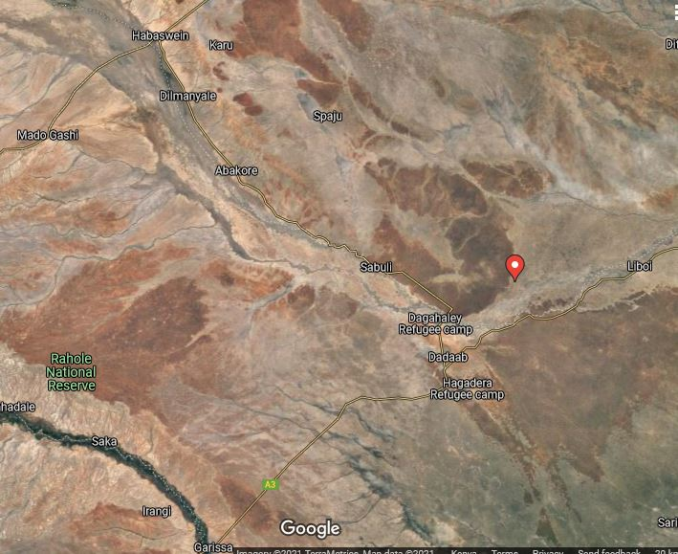
Project Location: Source google Maps

During the consultative forum, there were remarks from various key personnel including the following;

Area Chief’s Remarks
The Area Chief, Mr Osman Mohamed welcomed the KOSAP team and the members of the Dagahaley community to the Baraza. He invited Sheik Gabow to open the Baraza with a word of prayer. He then welcomed the Ms Lydiah Komen from Norken to introduce the team from Norken and Kosap after which Mr. Hassan Adan elaborated on the reason from the visit from the Kosap team.

Consultant’s Remarks
Ms Lydia Komen then enlightened the members that the aim of the meeting was to conduct a public participation exercise in order to collect the opinions from the community regarding the proposed solar project and produce an ESIA before the project implementation. She clarified the importance of ESIA and told the community that it was important to include the opinion of the community. She went ahead and introduced the project and its plan.
The consultant with assistance from the area chief then guided Focused Group Discussions and requested the participants to give information for documentation.

Focused Group Discussions

The in-depth interviews were used as a tool for stakeholder identification and mobilization as well as collection of baseline data to enable identification of the likely project impacts. In addition it provided an opportunity to the participants to raise their fears and concerns as well as make recommendation as pertains to the project.

During the discussions, information was gathered different roles, livelihood, health issues, challenges, perception of quality of life, education options for children, health care and project perception.

The consultative meeting had a wide representation as follows:

Category | Male | Female | Total
Youth | 10 | 0 | 10
Adult | 10 | 10 | 20
TOTAL | 10 | 10 | 30

The target groups of the FGD were Males, Females, Youth, Health and Education sectors, Traders as well as the Grievance Redress Committee.

Female Stakeholders’ Consultation and Participation
The females participants were 10 and between the ages of 25-60. The female participants indicated that they were aware of 20 females who were heads of their households since their husbands had died. The following were the response from the female participants during the FDG.
The project perception
- The women indicated that they had prior knowledge of the project. They indicated that the project if constructed, will greatly benefit the community by providing access lighting to lighting and will also improve security in the village.
Role of women
- The role of women in the community involves taking care of livestock, doing business and building the houses.
- They women feel that women should be given more opportunities than men
- They indicated that they had more control over land and household equipment compared to men
- Women feel safe in the community and there is no crime or conflict experienced
- The main challenges encountered by women are lack of employment opportunities and lack of medicine.
- Women receive information about local issues and development or news through radios, telephones and from the local chief.
- Women feel that roles are changing since they are now take care of livestock and do business.
- The women indicated that they are involved in the decision making at both household level and community level.
- Their top 3 priorities include access to water, construction of more classes at schools and provision of more teachers

Development
- The NGOs currently working with the community are WARDA, WASDA and World Bank.

Economy /income generation
- Women earn majority of their income through conducting business.
- In some households, there are some women who contribute more than men
- Women feel that the need to be involved in more business in order to have greater economic opportunities.
- The women indicated that they had saving accounts, own personal accounts and also use MPESA mobile banking services.
Land use
- The main land-based activity carried out by women in Dagahaley is agriculture where they mainly grow crops such as watermelon, beans and maize; 20% of these crops are consumed in the household while 80% are sold to earn income.
- The main livestock kept for both subsistence and income generation include goats, cattle, camels and sheep.
- Community members are nomadic- moving with livestock and move as far Djibula in search of water and pasture
- The women indicated that they collect natural resources like firewood and fruits for both domestic use and commercial purposes
- The women are involved in business of agricultural crop produce and selling of labour.
- The women indicated that there was no conflict or any form of GBV experienced in the community so far and there are no centers that support GBV victims.
- They however said that to eliminate GBV, discrimination against women should be avoided.
Education, literacy, and training
- The women indicated that they have access to quality education provided by Dagahaley Primary and Sheik Omar Secondary Schools
- The women in the village are able to read and write.
Health care
- The women access health care from the health center in the village although their medical needs are not adequately met
- The top 3 health problems facing women include general infections, ulcers and Typhoid
- There are at times some Environmental issues that affect quality of health within the community
- The women indicated that there is no access to family planning in the village
- VMGs like the elderly and PLWDs access medical care by being taken to the medical centers
- Women prefer seeking conventional medical care at the hospital over traditional methods.
Access to Water
- Women access water from the community borehole whose quality of water is reported as good although the water levels within the borehole reduce during droughts
Sanitation and hygiene
- The main type of toilets in the village ventilated pit latrines
Hygiene and waste management
- Women do not access sanitary facilities and or products e.g. sanitary towels
- Household waste is usually dumped near the roads while others burn or dump near their homesteads.
Access to Power
- Sources of energy in the village
- For lighting use of solar from the center
- For warming they use firewood
- Cooking -firewood
- Charging mobile-solar
- Cooling – NIL
- The main challenge regarding access to power is absence of sun where solar charging is affected.

Transport and communication
- The main form of transport are Taxis, matatus and motorcycles
- Telecommunication services are available in the village
Cultural heritage
- the area has no historical sites although religious centers exist

Male Stakeholders’ Consultation and Participation
The male participants were 10 elderly men. The following were the response from the male participants during the FDG.
The project perception
- The men had prior knowledge about the project and fully understood its purpose.
- They said that they strongly believe that the project will greatly benefit the community through empowering the local businesses but said that negative impacts like fire outbreak could also arise due to the project implementation.
- They said that they expected qualified technicians/experts to be involved in installation in order to minimize the negative impacts.
Role of Men
- The main roles of men in Dagahaley community are livestock keeping/farming, resolving of conflicts and shop keeping.
- The men believe they have better opportunities than women and have more control over land and water resources
- Men generally feel safe in the community although small conflicts arise from time to time e.g. conflicts over land; these conflicts are however solved amicably.
- The main challenges facing men in the community are use of Miraa (Khat) and illiteracy.
- Information about local issues and development or news are received through radios and mobile phones.
- The men have cultural groups such as Disow and Saar
- Their top three community development priorities building of more classrooms at the schools and provision of a backup engine for the community borehole to help pump water.
Economy /income generation
- The main source of income for men in Dagahaley include livestock keeping, shop keeping, farming and transportation (Donkey carts)
- Men contribute more that women and believe that availability of more water will increase farming activities thereby bringing greater economic opportunities in the village.
- The man access banking services from equity Bank and through mobile banking.
Land use
- The land based activity carried out by men are crop farming and livestock keeping
- Agriculture is also carried and crops planted include watermelon, simsim, Lady’s finger and sorghum which are all consumed within the household
- Animals kept include cattle, camels, sheep, goats and donkey both for subsistence and for income generation
- Community members are nomadic- moving with livestock in search of water and pasture especially during the dry seasons.
- Men sell and buy agricultural produces from Dagahaley Refugee’s Camp.
Education, literacy, and training
- According to the men, access to quality education is good since the village has both primary and secondary schools within
- There is no adult education for men but the boys attend school
- The main factor affecting boys from accessing further education is poverty.
- The boys can read and write although the older men cannot
Health care
- Access to medical care is through Dagahaley Health Center which according to the men is fairly adequate although more serious cases are taken to Garissa and Wajir towns.
- The top 3 dominant health issues among men include appendicitis, TB and gonorrhea.
- The men said that is someone is sick at home, they take them to the health center, then pray for them.
Access to Water
- The community source of water is the community borehole which is about 500m from the center of the village.
- The men indicated that women and children are mainly responsible for water collection for the households.
- The borehole was installed in 2006 through the Kenya Ministry of Water.
Sanitation and hygiene
- The main type of toilets in the village are pit latrines
- Men indicated that open defecation is practiced as an alternative where there was no access to latrines
Hygiene and waste management
- Handwashing and general cleaning is done by use of jericans
Access to Power
- Sources of energy for Dagahaley village
- For lighting use of solar and torches
- For warming they use firewood
- Cooking -firewood
- Charging mobile-solar
- Cooling – NIL
- The men said that the main challenges regarding access to power was the lack of access at all and further said that they would appreciate the project implementation so as to access electricity.
Transport and communication
- The main forms of transport in the area are bodaboda, taxis, tuktuk, buses, motorcycles and donkey carts.
- The village is served by an earth road that is impassable during dry and wet seasons
- The area is severed with Safaricom service provider as the dominant means of communication
- The Safaricom mobile services available but only for voice communication; there are no internet services available.
Religious heritage
- There are no historical/sacred sites within the area
- The main festivals undertaken by men include Eids and weddings.

Youth Stakeholders’ Consultation and Participation
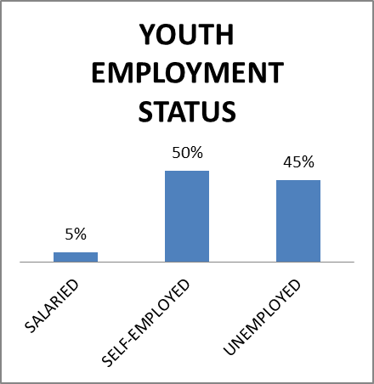
The youth fully participated in the FDG and were partially motivated. The following were the response from the youth participants during the FDG.
The project perception
- The youth had prior knowledge of the project through the area chief
- They indicated that they understood the project and were of the view that the project will help boosts their business, create self-employment, improve security in the area and contribute to infrastructure development.
Role of Youth
- The youth play a role in the decision making within the community and feel that their voice is being heard since even the area chief is youth.
Institutions/community Development /Youth Programmes
- There is a youth group called Dagahaley Youth Group whose main functions are to create public awareness on public health and hygiene, promote sports as well as promote washing programmes.
- The key development priorities among the youth in Dagahaley are job creation and knowledge and skills development.
Economy/Income Generation /Employment
- About 50% of the youth participants indicated that they are self-employed while about 5% have full-time salary jobs
- The youth are mainly in driving, kiosks operation and tailoring businesses.
- The main skills that the youth have include business skills, teaching skills and football skills.

Education, literacy, and training
- Approximately 75% of the youth participants during the FDG have completed secondary education while a further 35% have completed Vocational/College level education.
- The main skills that enable the youth to work mainly include mechanical and electrical skills, driving skills, carpentry skills as well as football skills.
Recreation
- During their spare time, the youth play football, attend Mosques and are involved in teaching.

Education Stakeholders’ Consultation and Participation
The Education Stakeholder who participated in the FDG was Mr. Mohamed Isaack, a teacher for Dagahaley Primary School which is a government sponsored institution. He indicated that he has worked at the school for 2 months. The following are his responses during the FDG.
The project perception
- The participant that indicated that he had heard about the project in September this year
- He indicated that the project will have positive impacts such as provision of electricity. He further said that the community and the education sector will benefit through powering of electronic devices such as laptops, the children will be able to attend evening classes due to availability of light and that the security lights shall improve the general security situation in the area.

Infrastructure/Resources at Dagahaley Primary School
- The participant said that Dagahaley Primary School currently has 7 teachers; 3 are employed by the TSC while 4 some through Board of Management.
- The teacher indicated the challenges at the school included low student enrollment, inadequate classrooms and staff quarters, understaffing and insufficient water.
- He indicated that government; through Constituency Development Fund sometimes assist in development projects in the school especially in classroom construction.
- The average walking distance of student to school is 1.5km, the farthest student lives 2km from the school.
- There is no Feeding programme available in the school
- The teacher said he can participate in the project through community sensitization
The School Curriculum
- The teacher pointed out that the main constraint to access of education was distance to school and lack of water in the school.
- He further stated that the main challenge to access to education was domestic chores and negative perception.
- The performance of boys in the school is generally better than that of girls
- There is a 100% transition from the primary school to secondary schools
The School Attendance
- The attendance rate of both boys and girls at 90%while the completion rate is 80% for both male and female.

Health Stakeholders’ Consultation and Participation
The Health Stakeholder during the FDG was Mr Abdi Fatah of Daaful Dispensary. The facility is under Ministry of Health. The following are his responses during the FDG.
The project perception
- The participant said had no prior knowledge of the project
- He said the project will create positive impacts like provision of electricity and water pumping.
- He said he can participate in the project through sensitization.
- The hospital was going to benefit from the project through availability of power.
Facility Profile
- The Daaful dispensary operates between 8am and 1230pm and serves about 30 patients per day within a 50km radius.
- It offers general health care services like maternal care, out-patient services, immunization services and family planning
- The health care services available are accessible for free
Infrastructure/Resources
- The facility is generally understaffed as it only has 1 nurse and 1 community volunteer.
- The facility infrastructure is at moderate condition.
- The main challenge in health care in the village is vaccination stigma
Prevalence Rates/Health Issues
- The main health issues pre-dominant among the children are diarrhoea, URTI and UTI
- The main health issues pre-dominant among the women are UTI, URTI and malnutrition.
- The main health issues pre-dominant among the men are UTI and URTI.
- The main health issue pre-dominant among the VMGs is malnutrition.
- Prevalence of malnutrition in the village is generally low; food security is a problem I the village.
- There are no known cases of STIs including HIV/AIDS or domestic sexual violence among the community.
- The life expectancy for both men and women is 60-80yrs; most common reasons for death are natural causes.
- Maternal and infant mortality rate is generally low.
- There are few cases of intimate GBV; dust also affects the quality of the environment.
- The most vulnerable groups within the community are mental health victims, PLWDs, the children and the elderly.

Traders/Livelihood/Market Association’s Consultation and Participation
The traders participated fully in the FDG had the following response;
The project perception
- The participant had prior knowledge of the project through the area chief.
- They were of the view that the project would have positive impacts to the community businesses through boosting of the business, enabling 24/7 operation of the kiosks as well as improving security in the village.
- He also pointed out that there are likely negative impacts from the project e.g. accidents from electric shocks
- He however said that the negative impacts can be mitigated through vigilance, installation using quality cables and preparedness.
Trading in Dagahaley
- Dagahaley does not have a traders association
- The main trading activities in the village include selling of food stuff, bookstore and milk which is done within a 80km radius of the village
- Main route of is Dagahaley-Dadaab-Sabuli
- The businesses operate from 7am to 11pm and are powered by solar and lighting from daylight.
- The county Government charge traders up to Kshs.2000 for permit to operate their businesses.
- Most traders are self-employed and make good income although they mainly experience challenges such as lack of electricity.
- The top need that would improve the trader’s business is installation of a reliable source of energy.

Grievance Redress Committee’s Consultation and Participation
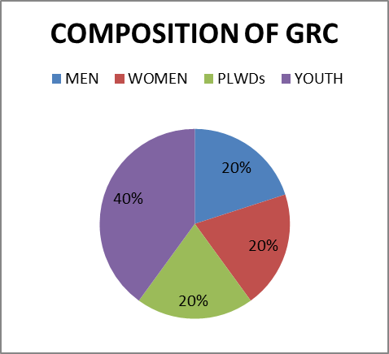
The Dagahaley Grievance Redress Committee Members who participated in the FDG composed of 2 men and 3 women. The following are their responses during the FDG.
Details of the GRC
- The participants said that the Dagahaley GDC was constituted early this year through community consensus.
- The committee consists of 1 female, 1 male, I Disabled male and 2 youth member.
- The structure of the committee composes of a Chairman and the other 3 members.
- The main role of the committee to the project is to solve disputes that may arise during the construction and operation of the project.

Positive Comments about the Project from the Participants
Some of the positive impacts that were identified by the participants include the following;
- The project will provide access to electric power.
- Children will be able to study at night through provision of lighting to individual homes.
- The project will enhance and boost business e.g. Kinyozis, salons and small shops which will operate fridges to cool drinks; the access to power will lead to indirect employment.
- The project will create employment opportunities especially for casual labourers during construction phase.

The identified negative impacts of the project
Some of the positive impacts that were identified by the participants include the following;
- Noise pollution from the generators
- Air pollution from fumes produced by the generators
- Dust from the construction site of the solar project;
- Destruction of vegetative cover
- Solid Waste generation from construction site
- Electric shocks from exposed cables/wires

Socio-economic impacts of the project

- Culture shock; there was a concern over the possibility of disputes arising between the local community with visitors of different cultures in the construction sites
- Inappropriate sexual advances may arise during the construction stage

Other concerns
- Mr Hassan Abdi sought to know the capacity of the project
- Some of the members asked when the project will commence
- The youth sought to know how the project will create jobs for them

Consultant’s Response
The consultant while addressing the community’s issues raised, gave the following response on Mitigation measures for the negative impacts
- Noise from the generators will be minimized through installation of silencer or through use of less noisy generators
- The generators will be properly and frequently serviced to limit noise
- There will be proper solid waste management during the construction phase
- Water bowsers will be used to minimize dust from construction site
- Water bowsers will be used to eliminate dust during construction phase
- Replanting of trees in areas where vegetation was removed
- Any misunderstanding arising from the project implementation will be handled by the Grievance Redress Committee (GRC)

She also highlighted that the community will benefit from Corporate Social Responsibility as a result from the project implementation and that the community may choose from these areas;
- Water sector
- Education sector
- Health Sector
She also further clarified that the project will cover 13.8km Radius and that this was enough to provide access to all the residents and businesses.

Consent
The Community members present agreed unanimously accepted the Project Proposal and further agreed that the positive impacts outweigh any likely negative impacts and expected that the project will be speedily implemented.

Public participation “Baraza” Session
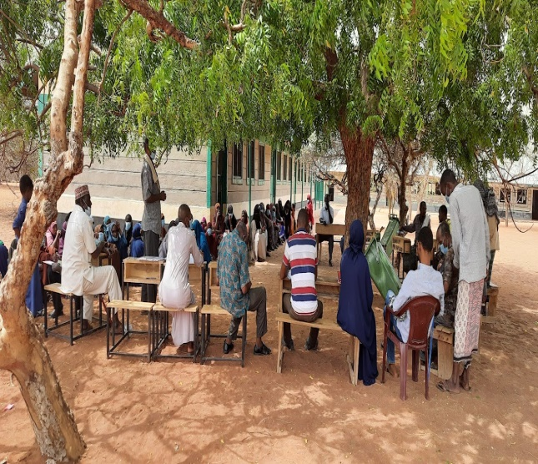 | 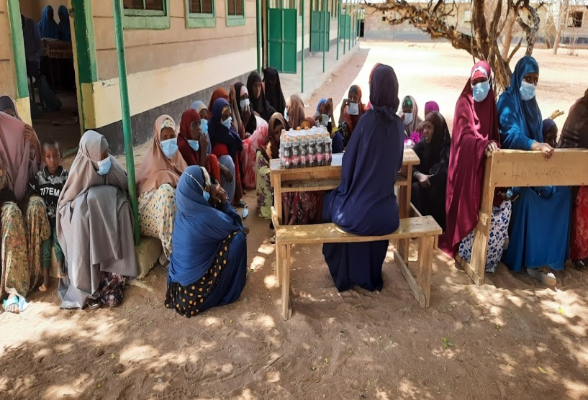
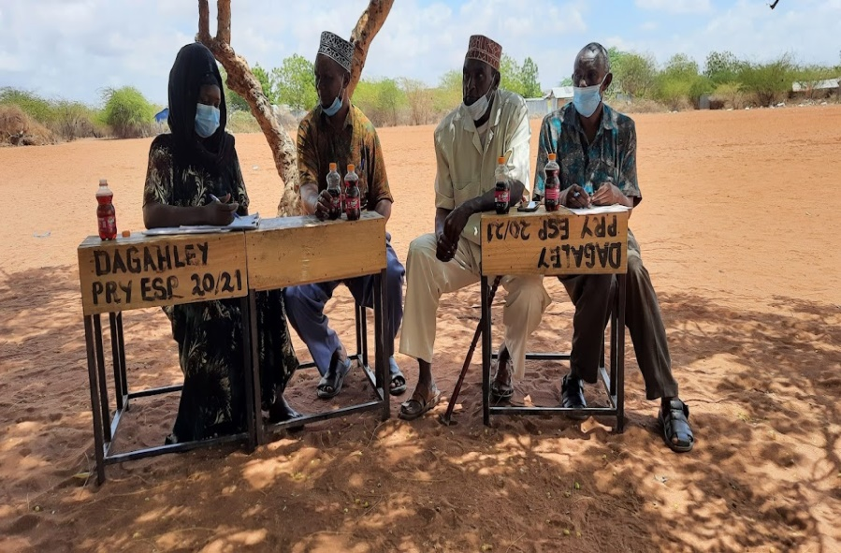 | 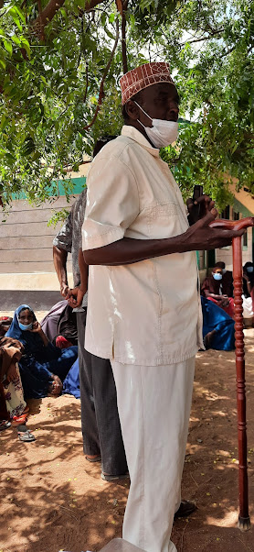

IDENTIFICATION AND ASSESSMENT OF POTENTIAL IMPACTS AND PROPOSED MITIGATION MEASURES

Introduction

This section provides an assessment of potential environmental and social impacts from the proposed Projects as well as the proposed mitigation measures to avoid, reduce, remediate or compensate for potential negative impacts and to enhance positive impacts. A description of the assessment methodology used to assess the significance of potential impacts, taking into account impact magnitude and sensitivity of receptors and resources affected, is provided below. To facilitate the reading of the ESIA, the same heading structure in terms of environmental indicators, receptors or resources affected by the project activities were considered as the ones used in the baseline and listed in section 4. All the mitigation measures identified in this chapter have been collated into the Environmental and Social Management Plan (‘ESMP’) matrix. This is including Occupational Health and Safety

Impact Assessment Methodology
An impact is essentially any change to a resource or receptor brought about by the presence of the Project component or by the execution of a Project related activity. In general, the assessment of impacts will proceed through an iterative process considering four key elements:
- Prediction of potential impacts and their magnitude (i.e., the consequences of the development on the natural and social environment);
- Evaluation of the importance (or significance) of potential impacts taking the sensitivity of the environmental resources or human receptors into account;
- Development of mitigation measures to avoid, reduce or manage the potential impacts or enhancement measures to increase positive impacts; and
- Assessment of residual significant impacts after the application of mitigation and enhancement measures.
Where significant residual impacts remain, further options for mitigation may be considered and impacts re-assessed until they are as low as reasonably practicable for the Project and would be deemed to be within acceptable levels.

Defining Impact
Impacts will be defined in a number of ways, including:
- Nature of impact: positive or negative;
- Type of impact: direct, indirect, or cumulative;
- Duration of impact: temporary, short-term, national, international
- Scale of impact: onsite, local, regional, national, international.

Assessment of Significance
Criteria for assessing the significance of impacts will stem from the following key elements:
- Status of compliance with relevant Kenyan legislation, policies and plans and any relevant Kenyan or industry policies, standards or guidelines, as well as international best practice standards and guidelines;
- The magnitude (including nature, scale and duration) of the change to the natural or socioeconomic environment (e.g. an increase in coastal erosion, or an increase in employment opportunities), expressed, wherever practicable, in quantitative terms. The magnitude of all impacts is viewed from the perspective of those affected by considering the likely perceived importance as understood through stakeholder engagement;
- The nature and sensitivity of the impact receptor (physical, biological, or human). Where the receptor is physical, the assessment considers the quality, sensitivity to change and importance of the receptor. For a human receptor, the sensitivity of the household, community or wider societal group is considered along with their ability to adapt to and manage the effects of the impact; and
- The likelihood (probability) that the identified impact will occur. This is estimated based upon experience or evidence that such an outcome has previously occurred.
It is generally accepted that significance is a function of the magnitude of the impact and the likelihood of the impact occurring.
For this assessment, significance has been defined based on five levels described in table below;
Categories of Significance
category | significance
Positive impacts | Positive impacts provide resources or receptors, most often people, with positive benefits. It is noted that concepts of equity need to be considered in assessing the overall positive nature of some impacts such as economic benefits, or opportunities for employment
Negligible impacts (or Insignificant impacts) | Negligible impacts (or Insignificant impacts) are where a resource or receptor (including people) will not be affected in any way by a particular activity or the predicted effect is deemed to be ‘negligible’ or ‘imperceptible’ or is indistinguishable from natural background variations.
Minor | An impact of minor significance (‘Minor impact’) is one where an effect will be experienced, but the impact magnitude is sufficiently small (with or without mitigation) and well within accepted standards, and/or the receptor is of low sensitivity/value.
Moderate | An impact of moderate significance (‘Moderate impact’) is one within accepted limits and standards. Moderate impacts may cover a broad range, from a threshold below which the impact is minor, up to a level that might be just short of breaching a legal limit. Clearly to design an activity so that its effects only just avoid breaking a law and/or cause a major impact is not best practice. The emphasis for moderate impacts is therefore on demonstrating that the impact has been reduced to a level that is ALARP (as-low-as-reasonably-possible). This does not necessarily mean that ‘Moderate’ impacts have to be reduced to ‘Minor’ impacts, but that moderate impacts are being managed effectively and efficiently.
Major | An impact of major significance (‘Major impact’) is one where an accepted limit or standard may be exceeded, or large magnitude impacts occur to highly valued/sensitive resource/receptors. An aim of EIA is to get to a position where the Project does not have any major residual impacts, certainly not ones that would endure into the long-term or extend over a large area. However, for some aspects there may be major residual impacts after all practicable mitigation options have been exhausted (i.e. ALARP has been applied). It is then the function of regulators and stakeholders to weigh such negative factors against the positive ones in coming to a decision on the Project.

For environmental impacts the significance criteria used in this ESIA is shown in the table below;

Overall Significance Criteria for Environmental Impacts
 |  | Sensitivity/vulnerability/importance of resource/receptor
 |  | Low | Medium | High
Magnitude of impact | Negligible | Negligible | Negligible | Negligible
 | Small | Negligible | Minor | Moderate
 | Medium | Minor | Moderate | Major
 | Large | Moderate | Major | Major

For the social impact assessment, the perceptions of stakeholders, expressed as opinions around certain issues, can be as important as actual impacts. Consequently, the concept of perception is explicitly brought into the evaluation of significance after an impact is evaluated. When an impact is of significant stakeholder concern, this may be causing to raise the significance rating. This prompts the formulation of more rigorous and appropriate mitigation measures which focus on the source of the impact and also address stakeholder perceptions. The risk of not addressing stakeholder perceptions is that reputational damage could arise, resulting in the loss of a ‘social licence to operate.

Magnitude of Impact
The impact assessment describes what will happen by predicting the magnitude of impacts and quantifying these to the extent practical. The term ‘magnitude’ covers all the dimensions of the predicted impact to the natural and social environment including:
- the nature of the change (what resource or receptor is affected and how);
- the spatial extent of the area impacted, or proportion of the population or community affected;
- its temporal extent (i.e., duration, frequency, reversibility); and
- where relevant (accidental or unplanned events), the probability of the impact occurring.
For social impacts, the magnitude considers the perspective of those affected by taking into account the likely perceived importance of the impact, the ability of people to manage and adapt to change and the extent to which a human receptor gains or loses access to, or control over, socio-economic resources resulting in a positive or negative effect on their well-being (a concept combining an individual's health, prosperity, their quality of life, and their satisfaction).

The table below (under Likelihood) provides an account of the key features (definitions) of each of the impact significance classifications (from Not Significant to High); specifically linking them to the need for mitigation measures.

Sensitivity of Resources and Receptors
Sensitivities are defined as aspects of the natural or social environment which support and sustain people and nature. Once affected, their disruption could lead to a disturbance of the stability or the integrity of that environment. For ecological impacts, sensitivity can be assigned as low, medium or high based on the conservation importance of habitats and species. For habitats, these are based on naturalness, extent, rarity, fragility, diversity and importance as a community resource.

For socio-economic impacts, the degree of sensitivity of a receptor is defined as ‘a stakeholder’s (or groups of stakeholders’) resilience or capacity to cope with sudden changes or economic shocks. The sensitivity of a resource is based on its quality and value/importance, for example, by its local, regional, national or international designation, its importance to the local or wider community, or its economic value.

Likelihood
Terms used to define likelihood of occurrence of an impact are explained in the table below;

Explanation of Terms Used for Likelihood of Occurrence
An impact with a
High probability | Refers to a very likely impact | Refers to very frequent impacts
Medium probability | Refers to a likely impact | Refers to occasional impacts
Low probability | Refers to rare impacts | Refers to rare impacts
 | As far as one-time events (e.g. air emissions) or slowly developing effects are concerned (e.g. impacts on local life style) | As far as possibly recurring impacts are concerned, such as accident or unplanned events (e.g. traffic accident, fire)

Definition of mitigation measures
Mitigation measures are developed to avoid, reduce, remedy or compensate for significant potential negative impacts, and to create or enhance potential positive impacts, such as environmental and social benefits. In this context, the term “mitigation measures” includes operational controls as well as management actions. These measures are often established through industry standards and may include:
- Changes to the design of the project during the design process (e.g., changing the development approach);
- Engineering controls and other physical measures applied (e.g., waste water treatment facilities);
- Operational plans and procedures (e.g., waste management plans); and
- The provision of like-for-like replacement, restoration or compensation.
For potential impacts that are assessed to be of major significance, a change in design is sometimes required to avoid or reduce the significance. For potential impacts assessed to be of moderate significance, specific mitigation measures such as engineering controls are often sufficient to reduce these impacts to ALARP (‘as-low-as-reasonably-practicable’) levels. This approach takes into account the technical and financial feasibility of mitigation measures. Potential impacts assessed to be of minor significance are usually sufficiently managed through good industry practice, operational plans and procedures.

In developing mitigation measures, the first focus is on measures that will prevent or minimise potential impacts through the design and management of the Project rather than on reinstatement and compensation measures.

Assessing residual impacts
Impact prediction takes into account any mitigation, control and operational management measures that are part of the project design and project plan. A residual impact is the impact that is predicted to remain once mitigation measures have been designed into the intended activity. Social, economic and biophysical impacts are inherently and inextricably interconnected. Change in any of these domains will lead to changes in the other domains.

Positive environmental and social impacts of the project

Vision 2030
During operation phase, the most significant positive impact of the project will be the realization of its objective by injecting additional electric energy into the national grid. This will enhance the country’s energy supply and security through a relatively more environmentally friendly energy generation process and thereby enable the energy sector make strides towards the policy directions envisaged in the Vision 2030.

Income generation
During construction, the project shall create skilled and unskilled employment opportunities to the local population.

Ready market for supply of goods and services
The project shall depend on suppliers for goods and services during the construction phase through sale of local construction materials and food by women.

Improvement of local economy
There will be increased trade activities and potential diffusion and transfer of communication and knowledge from specialist construction staff to the local participants thereby improving the local economy and skills.

Creation of job opportunities
The operation phase is anticipated to create direct and indirect opportunities in the plant management and maintenance.

Access to renewable energy source
The injecting additional electric energy into the national grid shall help meet the increasing energy demand and reduce work downtime caused by power outage by offering alternative more environmentally friendly energy source.

Reduction of carbon footprint
There will be a reduction of overall emissions of greenhouse gases (GHGs) as a result of cost effective, pollution free and renewable mode of solar power.

The enhancement measures for the positive impacts of the project that should be carried out are as follows;
- Engage a competent and certified technician to set up the solar power system
- Adhere to the design specifications and source solar panels from credible suppliers/manufacturers,
- Ensure routine maintenance of the solar panels installed,
- Provide security to reduce on vandalism.

Negative environmental and social impacts

Non-adherence to the design specifications
Failure to follow the approved designs is likely to lead to procurement of sub-standard solar system equipment.

Site clearance
Clearing of site and levelling (where applicable) could lead to loss of vegetation and soil erosion.

Dust and particulate matter emissions
The potential sources of air pollution include dust and gaseous emissions (construction vehicles/ burning of waste on site). This is a short-term negative impact and will last within the actual excavation period.

Localised Noise Emissions
Activities during construction such as excavation and installation of PV panels, use of equipment and vehicles and noise from workers on site are likely to cause noise pollution. The noise and vibration produced during construction may have some temporary negative impacts to the immediate residents.

Solid Waste generation
The construction and operation phases will generate solid waste which may include waste streams associated with packaging of the solar equipment, metal scraps, timber, water bottles, food wrappings, faulty solar equipment, electrical and electronic cables.

Soil and water contamination
Sources of hazardous wastes such as broken panels, used oil and fuel and paint from construction vehicles may cause soil contamination as a result of leachate of these hazardous wastes into the oil.

Occupational health and safety
During construction, workers and immediate local population will be exposed to a number of health, safety and welfare concerns including;
- OHS hazard, accidents and injuries; risk of falling from heights, use of faulty equipment
- Risks relating to electricity; risks of electrocution caused by incompetent technician/faulty equipment.
- Risk of damage to electrical equipment
- Slips and fall due to working at height

Energy Consumption
During operation phase, occupants shall require energy to function therefore putting more pressure on energy demand through lighting, cooking and powering of household and business appliances such as TVs, fridges etc.

Risks from Operation and Maintenance of solar system
During the Operation and Maintenance of solar system, the following risks are likely to be caused;
- Possible risks of vandalism of the solar equipment ,
- Potential fire hazard due to failure of electrical installation,
- Accidents and exposure to heat, noise and light, chemicals during maintenance

Risks during Decommissioning Phase
The following risks are likely to occur during decommissioning of the Solar System;
- Air quality deterioration,
- Generation of hazardous waste,
- Soil contamination from indiscriminate dumping of waste

Impact on community health and public safety
The receptors for impacts on community health and safety include project site workers, settlements in the close proximity of the project which will be exposed to health impacts from the project activities. The construction phase activities such as installation of solar panels, construction of transmission lines and substations and movement of material and personnel may result in impacts on the health and safety of the community.
Construction activities will involve the use of heavy machinery and live transmission power lines. Furthermore, the movement of material and personnel via the access roads may result in damage to human life or livestock due to accidents. The major community health and safety risks include structural failure of project infrastructure, life and fire safety, public accessibility and management of emergency situations. As per WB ESS guidelines, the occupational and community health and safety hazards during the construction, operation, and decommissioning of solar power projects are generally similar to those of largest infrastructure projects.

Risk of contraction of Covid-19
Spread of Covid-19 may occur at the site may occur if appropriate mitigation measures are not conducted for prevention.

Social pressure on local community such as spread of HIV/AIDs and other STIs
These may occur at the site may occur if appropriate mitigation measures are not conducted for prevention.

Reduction of Land-Holding Income
Loss of land used by the communities for livestock grazing and farming as a result of the project implementation may trigger land disputes. New settlements may arise due to migration of people to the centres near the mini-grid disrupting the existing community settlement patterns.

Labour Influx
The nature of the project will require technical skills that may not be all available in the project areas. This will require movement of construction workers into the project community. With an increase in population of the project area, the social set up may be affected resulting to different negative social impacts such as competition for resources, illicit behaviour and crime (including prostitution, theft and substance abuse).

Child Labour
Implementation of the project could lead to increased opportunities for the host communities to sell goods and services to the incoming workers. This can lead to child labour to produce and deliver these goods and services, which in turn can lead to increased cases of school truancy and dropout.

Gender Based Violence & Sexual Exploitation
In the processes of interacting with the community members some workers may be involved in gender-based violence. SEA may also occur where the workers may use their influence in terms of money to lure young girls and exploit them sexually.

Gender Disparities
There is potential risk of lack of intentional actions by the mini-grids contractor(s) and implementing agencies to exclude some members of the community from the project activities and benefits by virtue of their gender. This potentially leads to the exclusion of women from the benefits and opportunities derived from the proposed mini-grid facilities.

Exclusion of community members especially VMGs
There is potential risk of lack of intentional actions by the mini-grids contractor(s) and implementing agencies for the inclusion of VMGs in the project activities and benefits. This potentially leads to the exclusion of VMGS from the benefits and opportunities derived from the proposed mini-grid facilities.

Interference with physical cultural resource
Cultural and paleontological artifacts and cultural landscapes may be disturbed by the construction of the mini grid facilities. These could include community burial sites, sacred shrines. It is expected that a number of workers will be on-site during project construction of the project including skilled, semi-skilled, and unskilled personnel. During the consultation and field survey, no cultural artefact was established at the proposed project site.

Mitigation Measures for Negative Environmental Impacts

Non-adherence to the design specifications
Measures that will be taken to minimize risks due to poor designs will include:
- Adhere to the design specifications during procurement process
- Ensure procurement of solar equipment from credible manufacturers, avoid purchase of second hand refurbished or obsolete devices with short shelf life
- Solar equipment purchased should have products warranty period
- Faulty equipment should be returned to supplier in line with the warranty period
- Identify buy back options with the different suppliers/manufacturers.

Site clearance
Measures that will be taken to minimize risks associated with site clearance will include:
- Careful selection of the site to limit disruption of existing vegetation and limit removal of vegetation to project site only.
- Soil erosion control measures such as compacting loose soil on excavated areas and planting vegetation cover.

Dust and particulate matter emissions
Measures that will be taken to minimize risks the emissions will include:
- Wetting of active construction sites to lay off dust levels
- Provide dust screen nets around the site
- Restore vegetation through grassing on areas prone to soil erosion.

Localized Noise Emissions
Measures that will be taken to noise pollution will include:
- Limit construction activities during day time 0800hrs -1700hrs,
- Optimize on the construction schedule,
- The contractor should use equipment (i.e. hand drilling machine) that is/are in good working condition and are periodically serviced,
- Ensure no running of vehicle engines when not in use

Solid Waste generation
The following measures will be taken to minimize risks associated with solid waste generation:
- Construction workers should be sensitize on appropriate waste handling and disposal of all construction related waste in designated areas
- Provide appropriate waste receptacles on site
- Restrict open burning of solid waste generated at sites
- Engage licensed waste contractor to dispose solid waste in approved dumping sites
- Sell recyclable materials (scrap metal waste) to local recyclers
- Ensure the faulty solar panels are properly packed and sent to manufacturer/supplier
- Use solar panels that have longer life span
- Optimize on the buyback option from the manufacturers/suppliers
- Contract a NEMA licensed e-waste contractor to manage the e-waste generated from the faulty devices
- Comply with the provisions of EMCA (Waste Management Regulations, 2006) and NEMA e-waste guidelines 2010, on collection, sorting, recycling of e-waste and require them to follow good international industry practice for the waste being handled

Soil and water contamination
The following measures will be taken to mitigate against soil and water contamination:
- Hazardous material (oil, grease,) shall be stored in appropriate areas, concretized platforms, record kept and ensure no contamination to soil & water,
- Ensure maintenance of all equipment and machinery used on site, if there is a risk of hazardous materials spillage during such maintenance, dripping pans shall be provided ( where applicable),
- All the broken solar panels should be collected in closed containers and sent back to manufacturers.

Occupational health and safety
The following measures will be taken to occupational hazards:
- Use of competent and certified technician with valid work permits. All the electrical works should be carried out by trained professional,
- Ensure the work site is secured and limit entry of unauthorised personnel to active construction site,
- Ensure use of well services and maintained equipment,
- Provision of adequate and appropriate PPE for workers such as face shields, helmets, gloves, safety shoes and safety googles,
- Train workers on health and safety, safe handling of materials, safety in welding and fabrication, some advisory on working at heights, basic information on installation of solar panels, first aid measures,
- Accident reporting and monitoring record should be maintained on sites,
- Provide sanitation facilities for workers on site,
- Provision of accessible and regularly maintained fire-fighting equipment, fully equipped first aid kit,
- Plan the work in such a way that work at height can be avoided. If work at height cannot be avoided, ensure that a system is in place to prevent or arrest falls such as use of safety harnesses/scaffolding and other relevant PPE.

Energy Consumption
The following measures will be taken to minimize pressure on energy demand:
- Sensitize the users to use energy efficiently such as through installation of energy efficient bulbs
- Switch off electrical equipment, appliances and lights when not in use
- Monitor energy use during operation of the project and set target for efficient energy use

Risks from Operation and Maintenance of solar system
The following measures will be taken to minimize risks associated with Operation and Maintenance of solar system:
- Ensure the operation and maintenance is carried out by a certified personnel
- Minimize the health and safety impacts to the extent possible
- Regular training of workers on health and safety and in fire control and encourage regular fire drills,
- Provide PPE to the workers involved in operation and maintenance,
- Provide serviceable and regularly maintained fire extinguishers,
- Contract a NEMA licensed e-waste waste contractor to manage the e-waste generated from the faulty devices or sell to authorised waste recyclers
- Ensure there is adequate security at the project site area
- Record and report any accidents/ incidents on site

Risks during Decommissioning Phase
The following measures will be taken to minimize risks associated with Decommissioning Phase:
- Prepare an inventory of all the items to be decommissioned,
- Optimise on buy back from manufacturers/suppliers to the extent possible,
- Engage NEMA approved recyclers for purchase of the equipment,
- Avoid to the extent possible of commingling hazardous and non-hazardous waste generated during decommissioning phase

Impact on community health and public safety
The following mitigation measures will be executed to minimize the impact;
- Implementation of an Environmental, Health and Safety (EHS) plan being that of contractual agreement by the contractor in order to outline procedures for avoiding health and safety incidents and for emergency medical treatment.
- Provision of suitable Personal Protective Equipment (PPE) to workers in accordance with the EHS plan

Risk of contraction of Covid-19
The following mitigation measures will be executed to minimize the impact;
- Provision of face masks, hand sanitizers, soap and temperature monitors
- Adhere to the Public health act; 242 legal notice 54 of April 2020, on COVID 19 regulations thorough provision of social distancing and wearing PPEs, regular temperature checks and hand washing with soap

Social pressure on local community such as spread of HIV/AIDs and other STIs
The following mitigation measures will be executed to minimize the impact;
- Enlighten personnel about STDs (HIV/AIDS) and use of condoms.
- Partner with NGOs in campaign to stop the spread of HIV/AIDS.
- Conducting of HIV/AIDS awareness, sensitization and prevention program for the project with the entire community coverage

Reduction of Land-Holding Income
The following mitigation measures will be executed to minimize the impact;
- The Project Proponent’s adequately compensate the community in Kind for the land that will be acquired for the project. Adequate compensation will include Community development projects e.g. water sources.
- Provide training, skills development, work experience, and employment opportunities, with first preference being extended to project-affected persons.
- Consult local and higher-level government officers in Wajir County during the compensation period.
- Providing skills-based training interventions, especially for self-employment to the young and unemployed in the families who will be selling land to project. This will enhance their employability and create potential for income generation through self-employment;
- Providing preference to members of the families who will be selling land to the project for livelihood opportunities in Construction phase;
- Procuring resources from the local sources so as to induce more employment in the supply chain

Labour Influx
The following mitigation measures will be executed to minimize labour influx;
- In contract documents for the Contractor, MOE/KPLC should make explicit reference to the need to abide by Kenyan law, international best practice and the ratified ILO conventions and MOE’s policies in relation to health and safety, labour and welfare standards.
- In selection of a Contractor, MOE/KPLC should refer to past performance in similar assignments as an indicator of future performance with respect to worker management, worker rights, health and safety as outlined in Kenyan law and international standards.
- Regular checks by MOE/KPLC should be undertaken to ensure the relevant labour laws and occupational health and safety plans are adhered to at all times.
- All project workers should, as part of their induction, receive training on health and safety.
- The contractor should put in place mechanism to ensure no employee or job applicant is not discriminated against on the basis of his or her gender, marital status, nationality, ethnicity, age, religion or sexual orientation.
- All workers will have contracts which clearly state the terms and conditions of their employment and their legal rights. Contracts will be verbally explained to all workers where this is necessary to ensure that workers understand the provisions. Contracts must be in place prior to workers reporting to duty for the first time. The contract document will be enhanced by the Code of Conduct that will be provided by the Proponent.
- The Contractor will put in place a worker grievance redress mechanism accessible to all workers, whether permanent or casual, directly or indirectly employed. The Proponent worker grievance mechanism shall be open to the Contractor workforce in the event that their grievance is not adequately resolved by their direct employer. The Proponent will then have the authority to act to resolve this grievance.
- All project workers should have access to training on communicable diseases and STDs and community interactions in general. This training will be developed in collaboration with local health institutions.
- Carry out surveillance to ensure that no children are employed in the project, and to the extent possible by third parties related to the project and primary suppliers where such risk may exist

Child Labour
The following mitigation measures will be executed to minimize child labour;
- The Contractor to develop a code of conduct to ensure children are protected from any negative impact from the construction works.
- The Contractor to strictly hire people who are above 18yrs and ensure they produce their Identity Cards.
- The Contractor to ensure every worker under their jurisdiction signs a document committing themselves to the protection of the area children.

Gender Based Violence & Sexual Exploitation
The following mitigation measures will be executed to minimize the impact;
- Capacity building and awareness of the community on GBV and SEA
- Emphasize prevention and minimal harm to women and girls. Adopt risk-based approaches that aim to identify key risks of SEA and undertake measures to prevent or minimize harm.
- Build on existing local knowledge. Engage the community partners, local leaders, civil society organizations, gender and child advocates and mechanisms for support though out the project cycle.
- Effective and on-going community engagement and consultation, particularly with women and girls.
- Review of specific project components that are known to heighten GBV and SEA risk at the community level, e.g. Compensation schemes; employment schemes for women; delivery of water supplies; etc.
- Specific plan for mitigating these known risks, e.g. Sensitization around gender-equitable approaches to compensation and employment; water services; etc.
- Ensure adequate referral mechanisms are in place if a case of GBV and SEA at the community level is reported related to project implementation.

Gender Disparities
The following mitigation measures will be executed to minimize the impact;
- Ensure gender equity and social inclusion during the construction phase of the project
- Mobilize groups and train on gender involvement

Exclusion of community members especially VMGs
Prioritization of local communities in matters of employment particularly VMGs and training (skilled) for sustainable work force in the project area e.g. operations and maintenance.

Interference with physical cultural resource
Continuous inspection of archeological activities in the area.

ENVIRONMENTAL AND SOCIAL MANAGEMENT AND MONITORING PLAN Introduction
Environmental and Social Management and Monitoring Plan (ESMMP) for development projects provides a logical framework within which identified negative environmental and socio–economic impacts can be mitigated and monitored. The ESMMP has been developed to be used as tool to manage the environmental and social impacts that the activities of the proposed project will cause. The contractor before construction will refer to this ESMMP and develop specific implementation plans. In addition, the ESMMP assigns responsibilities of actions to various actors and provides a timeframe within which mitigation measures and monitoring can be done.
The key objectives of the ESMMP are:
- To monitor the implementation of mitigation measures against potential adverse impacts of construction and operation phases of the project to ensure that they conform and comply with relevant environmental and social policies, guidelines and legislation
- To assess for emerging non-anticipated adverse environmental and social impacts and implement relevant mitigation measures to maintain them within acceptable levels
- To maintain best practice in environmental, social health and safety during project construction and operation
The ESMMP outlined below addresses the identified potential negative impacts and mitigation measures of the proposed Mini Off-grid during pre-construction, construction, operational and decommissioning phases, based on the chapter of Environmental Impacts and Mitigation Measures of the potential negative impacts.

Monitoring
Monitoring denotes a systematic process of collecting, analysing and using information to track the progress of implementation of the ESMMP including coming up with measures to address any emerging issues. Monitoring of the ESMMP will involve recording information to track performance and recommendations to keep implementation of ESMMP on track. Reporting is a key component of the monitoring exercise.
The proposed ESMMP will be subjected to monitoring. Monitoring will have two elements: routine monitoring against standards or performance criteria; and periodic review or evaluation. Monitoring will often focus on the effectiveness and impact of the ESMMP.
During construction phase, the Implementing agency (KPLC) shall monitor the contractor’s activities in order to verify that the management measures/procedures/specifications are implemented as contained in the ESMMP. Compliance will mean that the contractor is fulfilling their contractual obligation.
During operation phase, KPLC will monitor facility’s operations to ensure compliance with management measures in the ESMMP and operation procedures. As part of this monitoring, the KPLC will undertake or statutory initial environmental audit as required by the ESIA/EA Regulations, 2003 and subsequent annual environmental audits.

Plan Monitoring
All the management plans make provision for monitoring and evaluation. Special attention should be given to the monitoring arrangements relating to biophysical impacts, occupational health and safety, social risks, facility operational and emergency response.
During the construction phase of the project, the contractor’s Environmental Health and Safety Officer (EHSO) shall report on the implementation of the ESMMP i.e., all environmental, safety and health impacts as well as accidents and incidents to the implementing agency. The social specialist of the contractor will report on implementation of the social measures as spelt out in the ESMMP.
The reported impacts and incidents will be captured on a database to ascertain trends and track progress in the implementation of preventive and corrective actions, and benchmarking against other, similar operations.
During operation, the implementing agency – KPLC will monitor the health and safety of personnel and contractors, in compliance with legislative requirements. Emergency incidents should be reported to the relevant authorities. The reported impacts and incidents will be captured on a database to identify weakness in the emergency response plan and track progress in the implementation of preventative and corrective and benchmarking against other similar operations.
The Environmental and Social Management and Monitoring Plan (ESMMP) will provide the basis for monitoring of potential Environmental, social and health Impacts associated with the project. The ESMMP provides effective observation and documentation of monitorable parameters that will help in analysing the effectiveness of the proposed mitigation measures with the advantages of improving operational efficiency, promoting competitive advantage, improving risk management, reducing liabilities and improving business performance.

Environmental and Social Monitoring by Contractors
KPLC will require that contractors monitor, keep records and report on the following environmental, health and social issues of the proposed project.
- Safety: hours worked, recordable incidents and corresponding root cause analysis (lost time incidents, medical treatment cases), first aid cases, high potential near misses, and remedial and preventive activities required (for example, revised job safety analysis, new or different equipment, skills training, and so forth).
- Environmental incidents and near misses: environmental incidents and high potential near misses and how they have been addressed, what is outstanding, and lessons learned.
- Major works: those undertaken and completed, progress against project schedule, and key work fronts (work areas).
- E&S requirements: noncompliance incidents with permits and national law (legal noncompliance), project commitments, or other E&S requirements.
- E&S inspections and audits: to include date, inspector or auditor name, and records reviewed, major findings, and actions recommended and implemented.
- Workers: number of workers, indication of origin (expatriate, local, nonlocal nationals), gender, age and skill level (unskilled, skilled, supervisory, professional, management).
- Training on E&S issues: including dates, number of trainees, and topics.
- Footprint management: details of any work outside boundaries or major off-site impacts caused by ongoing construction—to include date, location, impacts, and actions taken.
- External stakeholder engagement: highlights, including number of formal and informal meetings, and information disclosure and dissemination—to include a breakdown of women and men consulted and themes coming from various stakeholder groups, including vulnerable groups (e.g., disabled, elderly, children, etc.).
- Details of any security risks: details of risks the contractor may be exposed to while performing its work—the threats may come from third parties external to the project.
- Worker grievances: details including occurrence date, grievance, and date submitted; actions taken and dates; resolution (if any) and date; and follow-up yet to be taken grievances listed should include those received since the preceding report and those that were unresolved at the time of that report.
- External stakeholder e.g., community grievances: grievance and date submitted, action(s) taken and date(s), resolution (if any) and date, and follow-up yet to be taken grievances listed should include those received since the preceding report and those that were unresolved at the time of that report. Grievance data should be age and gender disaggregated.
- Major changes to contractor’s environmental and social practices.
- Deficiency and performance management: actions taken in response to previous notices of deficiency or observations regarding E&S performance and/or plans for actions to be taken—these should continue to be reported until KPLC determines the issue is resolved satisfactorily.

Sub-project Background Information:
The table below shows background information of the proposed project at DAGAHALEY

Table 8.1: Background information of the proposed project at Dagahaley.
- Name of the Sub-project | Kenya Off-Grid Solar Access Project (KOSAP) For Underserved Counties, Dagahaley, Wajir South
- Name of County, Sub- County and Village | County: Wajir | Sub-county: Eldas | Village: Dagahaley
Description of sub-project
- Specific project activities | - Construction and installation of off grid solar power at Dagahaley
- Specify the expected sub-project benefits and opportunities to all community members, including men, women, youth, vulnerable individuals, and households, PWDs etc. | - Improved access to power  - Creation of employment both skilled and unskilled
- Briefly highlight any sensitive environmental and social aspects (wetlands, natural forest, schools, and settlements, dumping sites, physical cultural resources (graveyards and shrines etc) within the project site. | The project site does not have any sensitive environmental and social aspects
Sub-project compliance Requirements
- Include all permits and approvals that apply to the sub-projects, as guided in the section below on documentation to be annexed to this ESMMP. | - The CPR shall be submitted to WAJIR NEMA CDE for issuance of EIA authorization letter for the implementation of the proposed sub-project.  - Approval of architectural designs.
Documentation to be annexed to this ESMMP (please check the relevant boxes and attach required documentation)
Signed public consultation minutes.  Signed list of stakeholders consulted. | Sub-project design specifications.  Environment and Social screening form.  Other (Please specify) N/A....A-RAP

Environmental and Social Management and Monitoring Plan (ESMMP)

Potential Impacts | Recommended Mitigation Measures | Project phase | Responsibility | Monitoring Indicator | Frequency | Estimated Cost (Ksh)
Local employment | -Prioritize hire of locals for all unskilled labour.  -Implement a local recruitment plan that is fair and transparent (including recruitment processes that ensure inclusivity of both men and women, vulnerable individuals, minority clans, ethnic groups and VMGs.  -Adhere to labour laws, and labour management practices (timely renumeration, equitable compensation for both genders for equal work etc.)  -Create awareness to workers and the community on worker and project grievance redress mechanisms. | Construction  Operations  Decommissioning | Contractor  Proponent | -Fair and transparent local recruitment plan in place.  -Recruitment processes (job adverts, interviews, selection etc.).  -Number of locals employed based on gender, vulnerability, ethnic group, clan etc.  -Type of employment (skilled, semi-skilled and unskilled).  -Grievances raised, those aggrieved, status of resolution. | Quarterly | Contractor’s cost
Local Sourcing | -Source materials from local businesses/communities, and where necessary give opportunities to businesses owned or operated by vulnerable individuals. | Construction  Decommissioning |  | -Number and types of businesses sourced from, businesses owned and operated by vulnerable individuals, types and quantities of materials etc. | Quarterly | No additional cost
Land acquisition and compensation for land and assets on land | In line with the RPF provisions;  -Prepare and implement an Abbreviated Resettlement Action Plan (A-RAP) to guide land acquisition for the mini-grid, and wayleaves for power distribution. Further, the proponent will fast-track A-RAP preparation to ensure that land acquisition and contractor mobilization to the site is undertaken after the A-RAP is finalized, cleared, and disclosed.  -The contractor will implement and adhere to agreements for temporal use of land and restoration of land after use.  -Compensate affected communities in-kind (priority project) for the loss of land.  -The construction activities will be restricted to within the allocated land and the immediate surroundings only.  -After construction work, any land taken for a temporary basis for storage of material will be restored to their original form.  -Consultations with the community on the low voltage lines.  -The design of the distribution line will utilize the existing road reserves. However, any damage to structures, crops, trees, community facilities and other assets will be compensated in line with the RPF provisions. | Pre- Construction | Contractor- (contractors’ facilities, workers camps)  Proponent- (project land for generation assets) | -Land Acquisition and consultation report (consultation (minutes and lists of participants).  -Type and amount of compensation paid to affected persons.  - Priority community project implemented and handed over to affected communities.  -Signed agreements with communities on the use and restoration of their land. | Quarterly | Value of compensation in kind project will be equivalent to the value of land acquired as per NLC
Labor Influx and related impacts (SEA/SH, HIV/AIDs and other STIs) | -Tap into the local workforce to the extent possible to reduce labor influx.  -Recruit local workforce to the extent possible especially for unskilled and semi-skilled jobs.  -Consult with and involve local community in project planning and other phases of the project.  -Raise awareness among local community and workers on the need to have a good /cordial working relation  -Sensitize workers regarding engagement with local community.  -Make provision to provide resources needed by the workers if the need for such resources may result to competition e.g., water.  -Establish and operationalize an effective Grievance Redress Mechanism accessible to community members.  -The contractor and the project/community grievance redress committee to work closely address complains raised on time.  -Include gender considerations in employment opportunities.  -Provide appropriate compensation for work done.  -Respect for community values/culture.  -Prompt payment of workers as per the contractual agreements/terms. | Construction  Decommissioning | Proponent, Contractor | -Records of employees/updated employee register.  -Number of local community employees and external employees/ updated employee register. | Quarterly | 50,000.00
Child labour | -Employ workers who are 18 years and above, and with a valid national ID at the time of hire.  -Implement and monitor the employment register regularly. Compliance with the national labor laws and labour management practices.  -Put visible signage on site “No Jobs for children”  -Do not allow children at the project site. | Construction  Decomissioning | Contractor, Proponent | -Updated employment register indicating locals employed, their ages, national identification numbers etc.  -Grievances raised, aggrieved persons and status on resolution etc. | Quarterly | 20,000.00
GBV- SEA and SH | -Prepare an SEA/SH Prevention and Response Action Plan, to manage the SEA/SH risks.  -The Action Plan to be proportionate to potential SEA/SH risks, and to include measures such as awareness creation for communities and workers; identification of referral services for survivors and a GRM that ensures confidential reporting of GBV cases.  -Implement a code of conduct signed by all those with physical presence on site. | Construction  Operations  Decommissioning | Contractor  Proponent | -Minutes of awareness creation sessions for the community and workers on GBV-SEA/SH.  -Code of conduct signed by all those with physical presence on site.  -GRM that ensures confidentiality of GBV cases in place.  Documented referral services for survivors.  -Grievances raised, aggrieved persons and status on resolution etc | Quarterly | 50,000.00
Forced Labor | -Adhere to the Employment Act which outlaws any form of forced labor.  -Report any form of forced labor at the site.  -Ensure that all workers have a national ID card or documentation to show they are adults (above 18 years). | Construction  Decommissioning | Contractor  Proponent | -Number of reported cases of forced labor. | Quarterly | 20,000.00
Risks related to Inadequate stakeholder engagement | -Prepare a stakeholder engagement/consultation plan (SEP) that is proportionate to the subproject and the identified stakeholders.  -Timely and prior disclosure of project all project information, including project instruments, the full rights and entitlements of project affected persons, sub-project positive and negative impacts and opportunities, proposed subproject budget.  -In line with the SEP, undertake adequate consultations prior to construction and throughout the project cycle with all segments of the community and other relevant stakeholders.  -Prepare and implement a grievance redress mechanism to deal with grievances.  -The grievance redress committee to include representatives from the community.  -Sensitize stakeholders on SEP and GRM. | Construction  Operations  Decommissioning | Contractor | -Availability of and implementation of the Stakeholder Engagement Plan.  -# of stakeholder consultations held  -Record of stakeholder consultations held (minutes of meetings and list of participants).  -Information disclosed, to whom it was disclosed  (men women, PWD, youth, vulnerable individuals and households etc., methods and languages used in the disclosure (culturally appropriate and accessible), grievances raised and status on resolution etc.  -Concerns raised andactons raised. | Quarterly | 30,000.00
Exclusion of VMGs and vulnerable individuals and households | In line with the provisions of the ESMF, VMGF and Social Assessment ensure the following.  - Early identification and inclusion of VMGs and disadvantaged groups.  - Meaningful consultation to effectively participate in the project.  - Timely and prior disclosure of relevant project information to VMGs and disadvantaged groups.  - Adequate and ongoing consultations with VMGs and disadvantaged groups in line with the SEP.  - All concerns or grievances raised are fully resolved in a timely manner.  - Access to culturally appropriate project benefits and opportunities. | Pre-construction  Construction  Operations  Decommissioning | Contractor  Proponent | Minutes of consultative meetings with all community segments including VMGs and vulnerable individuals and households, grievances raised and status on resolution etc. | Quarterly | No additional cost
Inaccessibility of project benefits to VMGs and other vulnerable individuals due to affordability challenges | -Consult VMGs and Vulnerable individuals and households on charges for sub project services, and put in place specific interventions to ensure the vulnerable equally access project benefits. | Operations | Proponent | -Interventions to enable those vulnerable access project benefits.  -Number of complaints raised by VMGs/vulnerable individuals regarding access to project services.  -GRM that is culturally appropriate and accessible.  Grievances raised and status on resolution etc | Quarterly | No additional cost
Inadequate grievances management | -Constitute a Local Grievances Committee is in consultation with all community segments, and incorporates the existing local dispute resolution mechanism.  -Implement a workers grievances mechanism.  -Awareness on the culturally appropriate and accessible GRM to all community segments  including VMGs, vulnerable individuals and households and CSOs  -All reported grievances are logged, dated, processed, resolved and closed out in a timely manner.  -Proportionate representation of VMGs and vulnerable individuals in the local grievances committee.  -GRM provides for confidential reporting of particularly sensitive social aspects such as GBV, as well as anonymity. | Construction  Operations  Decommissioning | Contractor  Proponent | -Local Grievances Committee in place, composition of committee, awareness of community and workers on project and worker GRMs, updated GRM logs, types of grievances  -Availability of grievance redress process  -Number of grievances reported  -Number of grievances resolved in a timely manner  -Number of grievances escalated to national courts and the World Bank Grievances Redress Service and Inspection Panel. | Quarterly | No additional cost
Environmental Impacts
Vegetation clearance | - Clear only the necessary areas  - Ensure proper demarcation and delineation of the project area to be affected by construction works.  - Specify locations for vehicles and equipment, and areas of the site which should be kept free of traffic, equipment, and storage.  - Designate access routes and parking areas  - Re-vegetation including planting of trees around the plant/facility | Construction | Contractor | -Number of trees cleared  -Planted trees | Once off | 50,000.00
Soil erosion | - Avoid groundbreaking during the seasons of high rainfall to avoid erosion.  - Monitoring of areas of exposed soil during rainy seasons to ensure that any incidents of erosion are quickly controlled.  - Construction related impacts like erosion and cut slope destabilizing should be addressed through landscaping and grassing, carting away and proper disposal of construction materials  - Use silt traps where necessary  - Cover soil stock piles  - Landscaping with grass on areas without electrical installation (lower areas)  - Monitoring of areas of exposed soil during rainy seasons to ensure that any incidents of erosion are quickly controlled. | Construction | Contractor | Assess size of rills or Gulleys forming from accelerated run off from compacted areas | Quarterly | Part of contractor’s fee
Contamination of soil from fossil fuels | - Ensure waste water generated is discharged or drained into approved drainage facilities  - Construction vehicles must be maintained in good state and proper servicing to ensure no oils are likely to leak  - Care must be exercised not to spill any fossil fuels  - Any contaminated soil shall be scooped and disposed-off appropriately.  - No servicing vehicles on site | Construction | Contractor | Records of any leakages from construction equipment/ vehicles. | Quarterly | 50,000.00
Dust emissions | - The construction area should be fenced off to reduce dust to the public  - Suppress dust during dry periods by use of water sprays;  - Stockpiles of excavated soil should be enclosed/covered/watered during dry or windy conditions to reduce dust emissions.  - Burning of woody debris & construction waste to be prohibited  - Use of personnel protective equipment (PPE) -masks should be provided to all personnel in areas prone to dust emissions  - Restrict speed on loose surface roads during dry or dusty conditions  - Keep stockpiles and exposed soils compacted and re-vegetate as soon as possible.  - Construction trucks moving materials to site, delivering sand and cement to the site should be covered to prevent material dust emissions into the surrounding areas  - Plant short trees to break speed of wind | Construction | Contractor | -Visual Observation of dust  -Provision of PPEs especially masks | Daily | 100,000.00
Vehicle exhaust and emissions from Generator | - Drivers of construction vehicles must be sensitized so that they do not leave vehicles idling so that exhaust emissions are lowered.  - Maintain all machinery and equipment in good working order to ensure minimum emissions of carbon monoxide, NO_{X}, SO_{X} and suspended particulate matter  - Maintain equipment in good running condition – no vehicles to be used that generate excessive black smoke  - Use of diesel which is Sulphur- free to run the power producing generators to be encouraged  - The stack chimney of the generators will be increased from its normal height of 3 meters to 6 meters | Construction | Contractor | -Engine maintenance records  - inspection of stacks | Quarterly | 100,000.00
Solid waste generation | - Ensure spoil from excavations is arranged according to the various soil layers. This soil can then be returned during landscaping and then rehabilitation, in the correct order which they were removed that is top soil last;  - Segregate waste  - Provide litter collection facilities such as bins  - Contractor to put in place and comply with a site waste management plan  - The contractor should comply with the requirement of OSHA ACT 2007 and Building rules on storage of construction materials  - Use of durable, long-lasting materials that will not need to be replaced as often, thereby reducing the amount of waste generated over time  - Recovery of materials remains and return to stores  - Re-use of materials where possible  - Proper budgeting to avoid waste generation  - Proper disposal of waste in line with solid waste regulation  - Construction wastes to be managed in accordance with construction standards in Kenya | Construction | Contractor | Presence of well-maintained receptacles and centralized collection points | Quarterly | 100,000.00
Impacts on Water Resources and Water Quality | - Clear the necessary areas only.  - Appropriate remedial measures shall be implemented by the contractor in the event of erosion.  - Infrastructure shall be designed to ensure that contaminated run-off does not reach water source i.e., earth dam.  - Contractor to develop an oil-spill containment plan as part of the emergency response plan. In the event of an oil spill the procedures contained in the emergency response plan of the contractor will come into effect.  - No vehicle maintenance and service shall be done at project site  - Ensure that potential sources of petro-chemical pollution are handled in such a way to reduce chances of spills and leaks. | Construction | Contractor | -Oil spill containment plan.  -Provision of fuel/oil drip and spill trays | Quarterly | 150,000
Noise & vibration | - Construction activities to avoid any unchanneled flow of water at the site  - Storage areas that contain hazardous substances should be bunded with an approved impermeable liner and provision for a pit to be made in case of oil spill.  - The excavation and use of rubbish pits during construction should be strictly prohibited.  - A waste disposal area should be designated within the active construction area and this should be equipped with suitable containers i.e., skips or bins of sufficient capacity and designed to contain and prevent refuse from being blown by wind,  - Areas contaminated by spilled concrete and/or fuels and oils leaking from vehicles and machinery should be cleaned immediately | Construction | Contractor | Noise levels-Records of noise measurements done by contractor within the project area and at distances of 30m from the Solar mini-grid | Quarterly | 150,000.00
Impacts from Hazardous materials - | - Maintenance of construction vehicles will not be done on site  - All hazardous products and waste should be labeled and handled properly to avoid contact with the ground  - Dispose hazardous waste through a NEMA approved waste handler | Construction | Contractor | Presence of well-maintained receptacles and centralized collection points | Quarterly | 100,000.00
Accidental Oil Spills or Leaks | - In the event of accidental leaks, contaminated top soil should be scooped and disposed of appropriately.  - Refueling and maintenance of vehicles will not take place at the construction site.  - Create awareness for the employees on site on procedures of dealing with spills and leaks  - Vehicles and equipment must be serviced regularly and kept in good state to avoid leaks.  - In case of spillage the contractor should isolate the source of oil spill and contain the spillage using sandbags, sawdust, absorbent materials and/or other materials approved by materials.  - All chemicals should be stored within the bunded areas and clearly labeled detailing the nature and quantity of chemicals within individual containers. | Construction | Contractor | Records of all accidental spills and number of liters | Quarterly | 150,000.00
Fire Hazards | - Create awareness to the construction workers on potential fire hazards  - Provision of firefighting equipment on site during construction.  - No smoking shall be done on construction site  - ‘No smoking’ signs shall be posted at the construction site  - A fire risk assessment and evacuation plan should be prepared and must be posted in various points of the construction site including procedures to take when a fire is reported.  - Designate an assembly point | Construction | Contractor | -Records of any Fire incidences  -Fire equipment and evacuation plan | Quarterly | 100,000.00
Impacts of construction material sourcing (e.g., quarrying) | - Source all building materials such as stone, sand, ballast and hard core from NEMA approved sites.  - Ensure accurate budgeting and estimation of actual construction materials to avoid wastage.  - Reuse of construction materials where possible. | Construction | Contractor | Sources of raw materials (from local community) | Quarterly | Part of contractor’s cost
Increased water demand | - Prudent use of available water  - Consultations with the project local committee on use of water in the community to avoid conflicts with the community  - Source and utilize a sustainable and reliable water supply for both construction and operation phase. | Construction | Contractor | Water usage records | Quarterly | Part of contractor’s cost
Energy Consumption | - Ensure responsible electricity use at the construction site through sensitization of staff to conserve electricity by switching off electrical equipment or appliances when they are not being used.  - Proper planning of transportation of materials will ensure that fossil fuels (diesel, petrol) are not consumed in excessive amounts.  - Complementary to these measures, they monitor energy use during construction and set targets for reduction of energy use. | Construction | Contractor | Energy consumption records | Quarterly | No additional cost
Occupational Health and safety Impacts | - Use skilled personnel for activities which demand skills/technical tasks  - Awareness creation/Tool box talks on safety to workers while at construction site  - Workers coming to the site should be knowledgeable on safety precautions to take  - Appropriate PPE (helmet, safety harness, boots, masks, climbing irons)  - Proper general house keeping  - Close supervision of workers  - Risk assessment by contractor of the construction activities and implement mitigation measures appropriately  - Adherence to occupational Safety and Health Act 2007  - Availability of equipped first aid box on site  - Provide safe drinking water for workers  - Engagement of trained first aider on site  - Ensure the WIBA cover is taken for the staff  - Establish safety committees | Construction | Contractor | Records of any near misses, incident, and accidents.  Records of corrective actions implemented if there was an accident. | Quarterly | 1,000,000.00
Community safety –access | - Proper barricading  - Hazard communication.  - Controlled access to the site by designated personnel  - Maintain records of any person who comes to site | Construction | Contractor | Presence of a controlled access and records of every person accessing the site | Daily | 20,000.00
Public Health Impacts | - Sensitize workers and the community on prevention and mitigation of HIV/AIDS and other sexually transmitted diseases, through staff training, awareness campaigns and community Barazas.  - Awareness creation and consultations with local communities prior and during construction on the dangers of these diseases  - Informing workers on local cultural values and health matters.  - Provision of condoms to workers  - Allowing migrant workers time to be with their families  - The contractor is impressed upon not to set a construction camp on site.  - The contractor will provide public education/information about HIV/AIDS transmission and prevention measures.  - Ensure equal treatment of workers  - Provide all appropriate COVID-19 preventive measures including campaign to maintain individual measures at the workplace. | Construction | Contractor | Number of awareness creation sessions conducted.  -Availability of and distribution of condoms | Quarterly | 20,000.00
Sanitary waste | - Construct/ install pit latrines for both genders clearly labelled | Construction | Contractor | Presence of separate and clean washrooms for both the gents and ladies | Quarterly | 300,000.00
Solid Waste Generation | - Provide waste handling facilities such as labeled waste bins  - Emphasis on prudent waste generation and give priority to reduction at source  - Solid waste management awareness to operators  - Operator to contract a NEMA licensed waste handler to collect and dispose solid waste | Operation | Contractor | Presence of well-maintained receptacles and centralized collection points | Quarterly | 50,000.00
Liquid Waste/Oils Generation | - Proper storage of the oil is required to ensure no leakages  - Frequent inspection and maintenance of the generator to minimize leakages.  - No vehicles should be serviced or maintained at the Mini-grid area.  - The waste oil or used oil must be disposed-off appropriately.  - Proper training for the handling and use of fuels for the operators of the Mini-grid.  - In the event of accidental leaks, contaminated top soil should be scooped and disposed of appropriately. | Operation | Contractor | -Engine maintenance records  -Oil spill containment plan | Quarterly | 200,000.00
Increased oil Consumption | - Efficient energy consumption  - Install an energy-efficient lighting system | Operation | Contractor | Energy consumption records | Quarterly | No additional cost
Increased storm water flow | - Construct the drainage system in a way to follow natural drain of the water  - Concrete only the required area and leave the rest of the land with vegetation like grass  - Construct rain water harvesting system on the control buildings/office and harness into storage tanks for use | Operation | Contractor | Provision of a drainage system and a rain water harvesting system | Quarterly inspections | 200,000.00
Fire Outbreaks | - The power plant must contain firefighting equipment (Portable fire extinguishers) of recommended standards and in key strategic points  - Detection/alarm systems that can detect fire should be and installed  - A fire evacuation plan should be prepared and posted at strategic points and should include procedures to take when a fire is reported.  - Workers especially operators of the plant must be trained on fire management  - ‘No smoking’ signs shall be posted within the Mini-grid area  - A fire Assembly point should be identified and marked | Operation | Contractor | -Provision of serviced fire equipment, evacuation plan and safety signages  -Records of fire safety training | Quarterly | 50,000.00
Visual Impacts | - Fence round the solar Mini-grid to keep off/screen the solar panels. | Operation | Contractor | Presence of a perimeter fence | Quarterly inspections | No additional cost
Water demand | - Ensure prudent use of water.  - Install water-conserving automatic taps.  - Any water leaks through damaged pipes and faulty taps should be fixed promptly. | Operation | Contractor | Water usage records | Quarterly | 20,000.00
Sanitary waste | - Provide sanitary waste facilities for both genders clearly marked  - Disposal of waste through septic tanks | Operation | Contractor | Presence of separate and clean washrooms for both the gents and ladies | Quarterly | No additional cost
Flooding | - Ensure drainage channels are free of any obstruction at all times i.e., not blocked  - Construct more channels and or expand existing ones  - Raise foundations of the solar panels and ensure a proper and from concrete base  - Create flooding diversions and or spill ways to divert water from getting into the solar power facility | Operation | Contractor | -Provision of drainage system  -Raised foundations for the structures | Quarterly | 100,000.00
Occupation health and Safety | - Ensure only qualified staff are employed to work in the facility  - All workers operating the Mini-grid must be equipped with appropriate and adequate person protective equipment (PPE) such as; safety footwear, helmet among others.  - Operators must be skilled on firefighting management  - Annual environmental audits should be done  - WIBA cover for staff is mandatory | Operation | Contractor | -Provision of PPEs and WIBA cover  -Environmental audit reports | Quarterly | 100,000.00
Hazardous waste-damaged panels | - Segregation from other waste streams  - Proper disposal through a NEMA approved/licensed handler | Operation | Contractor | Presence of well-maintained receptacles and centralized collection | Quarterly | 200,000.00
Noise and Vibration | - Generator room should be sound proof to ensure no noise of a nuisance level will be produced.  - Monitor noise levels | Operation | Contractor | Noise levels-Records of noise measurements done by contractor within the project area and at distances of 30m from the Solar mini-grid | Quarterly | Part of contractor’s cost
Shocks and electrocutions | - Inspect the wiring of the houses before connecting power  - Safety awareness campaigns to the community before connection of power on safety precautions such as:  - Require community to engage a certified technician to do wiring in the premises  - Use of quality materials while wiring  - Refraining from individual illegal extensions of power lines to other houses  - Observing safety measures while using electricity such as not touching sockets and switches with wet hands or wiping with wet cloths  - Keeping off all electricity infrastructure e.g., not tying livestock on electric poles, no cutting earth wires that run along some electric poles, not interfering with sockets or switches  - Reporting any electric wire/conductors if found fallen on the ground  - Report any incident regarding electricity at the local office –staff in charge of operating the Mini-grid | Operation | Contractor, Consumer | -Records of awareness sessions conducted  -Incidences report | Quarterly | No additional cost
Community Safety- Access to site by general public | - Fencing off the facility to keep of community members, children and livestock from entering into the facility  - Controlled access to the site only with prior approval  - Maintain records of any person who comes to site | Operation | Contractor | Presence of a controlled access and records of every person accessing the site | Daily | Part of contractor’s cost
Risks related to poor or inadequate stakeholder engagement (Conflict) | - Employ from the community to the extent possible  - Engage the community members and other stakeholders in a timely manner  - Work closely with the GRM committee members in solving the conflicts  - Solve all conflicts/grievances at the earliest time possible  - Ensure all grievances are logged and closed  - Monitoring the pattern of grievances to come up will long term measures | Operation | Contractor, Proponent | Grievance records | Quarterly | 20,000.00
Gender Based Violence –SEA and SH | To manage GBV risks, the contractor will prepare a SEA/SH Prevention and Response Action Plan that will include a GRM that ensures confidentiality. The plan will include the necessary measures for prevention and response and must ensure survivor-based approach | Operation | Contractor | -SEA/SH Prevention and Response Action Plan  -Grievance records | Quarterly | 20,000.00
Public Health Impacts –HIV/AIDs | - Sensitize workers and the community on prevention and mitigation of HIV/AIDS and other sexually transmitted diseases, through staff awareness and awareness campaigns for the community  - Provision of condoms to workers  - Allowing migrant workers time to be with their families | Operation | Contractor | Number of awareness creation sessions conducted.  -Availability of and distribution of condoms |  | 20,000.00
Public health Impacts -Covid 19 disease | - Social distance must be observed  - Provision of hand wash facilities before access  - Temperature check and monitoring of the temperature of workers and any other person coming to site  - Enforce wearing of masks  - Make provision for testing and treating especially of workers  - Provision of contact numbers for the nearest health facility for testing and treatment  - Adhering to any other measures from the ministry of health which may be issued from time to time | Operation | Contractor | Availability of hand washing facilities  Utilization of hand washing facilities  Number of Covid-19 cases reported | Quarterly | 30,000.00
Dust Emission | - Trees can be planted around the plant/facility provided they do not cast shadows to the solar panels to act as wind breakers and hence decrease dust pollution  - Ensure planting of grass around and within the facility compound | Operation | Contractor | Visual inspection | Quarterly | 50,000.00
Vehicle Exhaust Emissions | - Drivers of the vehicles must be sensitized so that they do not leave vehicles idling so that exhaust emissions are lowered.  - Company vehicles should be well maintained | Operation | Contractor | Engine maintenance records | Quarterly | No additional cost
Noise and Vibration | - Install portable barriers to shield compressors and other small stationary equipment where necessary.  - Use quiet equipment (i.e., equipment designed with noise control elements).  - Co-ordinate with relevant agencies in case the noise produced will require a license.  - Limit pickup trucks and other small equipment to a minimum idling time and observe a common-sense approach to vehicle use and encourage workers to shut off vehicle engines whenever possible.  - Demolish mainly during the day when most of the neighbors are out working. | Decommissioning | Contractor | Noise levels-Records of noise measurements done by contractor within the project area and at distances of 30m from the Solar mini-grid | Once off | 20,000.00
Solid Waste Generation | - Demolition contractor to adhere to the various manufacturer’s guidelines and requirements regarding demolition and disposal  - Segregation of waste in order to separate hazardous waste from nonhazardous waste and other streams of waste  - Provision of facilities for proper handling and storage of demolition materials to reduce the amount of waste caused by damage or exposure to the elements  - Adequate collection and storage of waste on site  - Safe transportation to the disposal sites / designated area  - Hazardous waste must be disposed by NEMA approved waste handler | Decommissioning | Contractor | Presence of well-maintained receptacles and centralized collection points | Daily | 700,000.00
Dust Emissions | - Cover all trucks hauling soil, sand and other loose materials or require all trucks to maintain at least two feet of freeboard | Decommissioning | Contractor | Visual inspection | Daily | 20,000.00
Public Health- HIV/AIDS | The project will sensitize workers and the surrounding communities on prevention and mitigation of HIV/AIDS and other sexually transmitted diseases, through staff training and awareness campaigns/ to the community. | Decommissioning | Contractor | Records of awareness creation sessions conducted.  -Availability of and distribution of condoms | Once off | 20,000.00
 | Total |  |  |  |  | 4,380,000.00

Approach to Environmental Impact Management
The proposed ESMMP will be the responsibility of the proponent/KPLC, and the contractor as outlined. This section presents the range of approaches that will be used to manage potential impacts of the proposed project.

Management Plan during Construction Phase
The contractor will prepare targeted management plans to deal with specific environmental and social aspects guided by the ESMMP and any other emerging issues on the ground. The contractor shall prepare these plans and have them approved by both the proponent and the Bank before they mobilize to the site:
- Construction management plan
- Rehabilitation and site closure plan
- Local recruitment plan
- Workplace health and safety plan
- Community safety plan
- Emergency management and response plan
- SEA/SH Prevention and Response plan
- Stakeholder Engagement management plan
- Grievance Redress mechanism
- Labor influx management plan
- Sexual Exploitation and abuse and sexual harassment prevention and response action plan

- Construction Management Plan
The construction management plan for the proposed project shall include the following:
- Management of Fuels and other Hazardous Materials
- The Contractor shall comply with all applicable laws, regulations, permit and approval conditions and requirements relevant to the storage, use, and proper disposal of hazardous materials.
- Management of the Construction Site
- The contractor shall prevent littering and the random discard of any solid waste on or around the construction site
- The contractor shall manage other solid and liquid waste
- Fire Prevention and Management
- The Contractor shall take all necessary precautions to prevent fires caused either deliberately or accidentally during construction process.
- The Contractor shall prepare a fire prevention and fire emergency plan as a part of the plans to be submitted to KPLC.
- Management of Air Quality
- The Contractor shall institute appropriate measures to minimize or avoid air quality impacts. This can be achieved through formulation of air quality management plan.
- Neighbouring Landowner and Occupier Relations
- The Contractor shall always respect the property and rights of neighbouring landowners and occupiers and shall treat all persons with deliberate courtesy.
- The contractor shall respect any special agreements between the KPLC and the neighbours e.g., the wayleaves agreements signed between Kenya power and landowners will need to be respected by the contractors.
- Complaints Register
The contractor shall establish and maintain a register for periodic review by the KPLC that logs all the complaints raised by the neighbours or the general public about construction activities. The register shall be regularly updated, and records maintained including the name of the complainant, his/her domicile and contact details, the nature of the complaint and any action taken to rectify the problem.
- Construction Control
The construction control for the proposed project shall cover the following:
- Control of Access
The contractor shall ensure that the construction site is accessed by authorized persons only and up-to-date records kept
- Control of material supply and burrow areas
- The contractor shall, as far as possible, source all material needed to construct the proposed project from the licensed quarries
- In instances where materials are to be obtained from a new burrow area; the contractor shall comply with relevant legislations.
- The contractor shall prepare a method statement including plans, detailing the expected quantity of excavation, temporary and permanent drainage control, the final contouring of the burrow pit and the proposed method of rehabilitation.
- Rehabilitation and Site Closure Plan
- After completion of construction activities, the contractor shall clear the site of construction materials and dispose wastes in appropriate disposal sites.
- The contractor shall remove all temporary works on the construction site and grow grass on areas that are not covered by the installations to control erosion
- Local Recruitment Plan
The contractor will prepare a local recruitment plan to guide on recruitment of locals. The plan shall pay attention or adhere to Employment Act.
In designing the local recruitment plan contractor shall:
- Comply with the provisions of Employment Act, 2007
- Wherever possible, give priority to qualified local people when hiring employees.
The mitigation measure is:
- Prepare a local recruitment strategy that is fair and transparent to ensure all community segments - men, women, vulnerable individuals, minority clans, and VMGs who meet OP 4.10 criteria) - can access subproject benefits during construction and that prioritizes hire of locals for skilled, semi-skilled and unskilled labour.
- Workplace Health and Safety Plan
The workplace health and safety plan to be implemented by the contractor and KPLC shall include the following key measures:
- The contractor shall comply with all relevant legislative requirements governing worker health and safety at the workplace (e.g., OSHA 2007 and its subsidiary legislations).
- The contractor shall prepare and implement measures to minimize diseases likely to be contracted by the construction workers as a result of the proposed project such as HIV &AIDs and other communicable diseases
- The contractor shall have obligations of managing the safety of its employees by.
    - Provision of appropriate PPEs to employee
    - Training employees on competence
    - Employing competence and qualified staff
    - Provision of First Aid Kits onsite
    - Should have a trained first aider
    - Document and create awareness on safe work procedures and work instruction
- The contractor will manage accidents by having an emergence response plan which will include contacts for emergency service providers e.g., ambulances, fire brigade and nearest hospitals
- Health and safety performance will be continuously monitored, and procedures reviewed with the aim of eliminating risk as far as reasonably practicable.
- Community Health and Safety Plan
The community health and safety plan to be implemented by the contractor shall include:
- Adherence to OSHA 2007 Act and its subsidiary legislations to ensure that health and safety of immediate neighbours and the public is not threatened.
- The contractor to ensure that construction work is undertaken in manner not likely pose risks to community health and safety.
- The contractor shall undertake an independent risk assessment prior to construction. The findings of this assessment will inform the development of a community safety plan and create awareness to the community on the same
- Emergency Preparedness Plan
The Contractor shall develop an emergency plan that will enable rapid and effective response to all types of environmental emergencies in accordance with recognized national and international standards.
The emergency plan shall include establishment of a network of communication between the Contractor and emergency services including police, ambulance services, and fire brigades among others.
- SEA/SH Prevention and Response Action Plan
The contractor will prepare a SEA/SH Prevention and Response Action Plan that will include a GRM that ensures confidentiality. The plan should have an Accountability and Response Framework. The plan will include the necessary measures for prevention and response of GBV impacts.
The mitigation measures shall include:
- Ensure that local employment opportunities are equitably accessible to all segments of the community,
- Ensure equal pay for equal work
- Prepare and implement GBV (SEA/SH management) plan that includes sensitisation of community members and subproject workers on the potential of the subproject giving rise to, exacerbating and/or mitigating SEA and SH, and the appropriate mitigation measures
- Map all GBV service providers and document referral services for survivors and sensitize community members and subproject workers on the referral pathways.
- Prepare and implementing a functional and accessible contractor GBV GRM for use by workers and community members (as appropriate).
- The GBV GRM should allow for anonymous incident reporting and should be GBV survivor-centric
- Sensitize community members and workers on contractor GRMs
- Prepare and sensitise Code of Conduct (CoC) for SEA and SH, and their responsibilities for the same, to demystify the stigma associated with SEA and SH
- Stakeholder Engagement Management Plan
A Stakeholder Engagement Plan is a formal approach to communicate with project stakeholders to achieve their support for the project. The plan prepared shall specifies the frequency and type of communications, media, contact persons, and locations of communication events. The SEP is a useful tool for managing communications between the contractor and other stakeholder. The plan should meet the following objective of a SEP.
- To help improve project design and implementation
- To inform third parties about changes that affect them
- To take their views into account in the implementation of projects
- To identify adverse impacts and mechanisms to enhance project benefits
- To identify risks from and to a project
- To increase project ownership and sustainability
- To comply with Bank policies that require consultations
The plan shall put this measure in to consideration:
- In consultation with the identified stakeholders, prepare a stakeholder engagement plan (SEP) that is based on their locations (maps) and their information needs at the various subproject phases
- Grievance Redress Mechanism
- Overview
One of the key roles of the Grievance Redress Committees, will be to address disputes led by the administrative chiefs. All PAPs will be informed how to register grievances or complaints, including specific concerns about land and environment. The PAPs will be informed about the dispute resolution process, specifically about how the disputes will be resolved in an impartial and timely manner.
The Land Acquisition Tribunal has the jurisdiction to hear and determine appeals from the decision of the NLC on the process of compulsory land acquisition of land. However, if a party is dissatisfied by the decision of the tribunal, they may appeal to the Environment and Land Court. The court will deal with land related disputes. However, the Land Act 2012 and Environment and Land Court Act 2011 advocates for Alternative Dispute Resolution (ADR) methods in tackling land related disputes. ADR approaches will be given preference and based on customary rules, arbitration, or third-party mediation. ADR will be promoted or defended as a resolution to disputes related to land. The affected persons and other stakeholders also have a right to access the World Bank Redress Service (GRS) and the World Bank Inspection Panel at no cost.
- Grievance Redress Principles
The principles of grievance mechanism management that need to be observed include.
- All complaints and grievances are resolved as quickly as possible.
- That the resolution of complaints and grievances should be at the lowest possible level for resolution.
- All complaints that can be resolved, should be resolved immediately on the site. The focus of the GRM is to resolve issues in a customarily appropriate fashion at community level and record details of the complaint, the complainant and the resolution.

- Grievance Redress Committee Capacity Building
A grievance redress mechanism and a committee were established in a culturally appropriate manner in consultation with the community during the consultations for ESIA and will be utilized post ESIA. The GRM committee will have the following roles: log the grievances, maintain records of the GRC meetings and grievances, resolve the grievances to the extent possible.
- Grievance Procedures
a) Registration - Community members can inform the contractor about concerns directly and if necessary, through third parties. Once a complaint has been received, it will be recorded in a complaints log or data system. The log will be kept in hardcopy or electronic form. All reported grievances will be categorized, assigned priority, and routed as appropriate.
Grievance Log: The grievance logbook will ensure that each complaint has an individual reference number and is appropriately tracked, and recorded actions are completed. The information to be recorded will include:
- Name, age, gender of complainant.
- Date the complaint was reported.
- Date the grievance logged.
- Action taken.
- Date information on proposed corrective action sent to complainant (if appropriate).
- The date the complaint was closed; and
- Date response was sent to complainant.
b) Sorting and Processing - This step determines whether a complaint is eligible for the grievance mechanism and its seriousness and complexity. The complaint will be screened however this will not involve judging the substantive merit of the complaint.
The following guide will be used to determine whether a complaint is eligible or not:
Eligible complaints may include those where:
- The complaint pertains to the mini Off-grid project.
- The issues raised in the complaint fall within the scope of issues the grievance mechanism is authorized to address.
Ineligible complaints may include those where:
- The complaint is clearly not mini Off-grid project -related.
- The nature of the issue is outside the mandate of the grievance mechanism.
- The complainant has no standing to file.
- Other project or organizational procedures are more appropriate to address the issue.
- Closing Out and Escalation: Project-related grievances will be addressed and closed out as appropriate. The GRM will provide a channel for escalation e.g., through legal redress.
The proponent KPLC will monitor the activities of the stakeholder engagement and grievance management activities.
The three tiers if the GRM are as described below:
- National Grievances Redress Committee (NGRC)
NGRC has been established at the National level to ensure participatory and transparent implementation of the project. The NGRC will help the project carry out its mandate efficiently- particularly ensuring effective and amicable settling of disputes among the communities/PAP’s.
Members to NGRC include representation from the following agencies and entities
- Representative from the Ministry, chair of the Committee
- Representative from NLC to handle matters that involve land take
- Representative of the Implementing Agencies (IA)-KP and REREC
- Representative from the Ministry’s Legal office to guide on Alternative Dispute Resolution methods
- Representative from the County Grievance Redress Committee-depending on the matter at hand; Land or Environment
- Representative from Gender and Social Development Office who will be responsible for ensuring gender issues are well addressed.
- Representative from NEMA to handle environmental issues
- County Surveyor/Physical planner from the county Lands office
- Project Affected Person’s-to represent the matter before the committee

Functions of the National Grievances Redress Committee
- Ensuring effective flow of information between PAPs, the implementing agency and the County Grievance Redress committee on matters brought before the committee
- Co-ordinate County Grievance Redress Committees (CGRC)
- Co-ordinate activities between the various organizations involved; facilitate grievance and conflict resolution at the highest level
- Resolving disputes that may arise within the project. If it is unable to resolve any such problems, the PAP’s can seek legal redress.

- County Grievance Redress Committees (CGRC)
CGRC has been established at the county level to ensure participatory and transparent implementation of the project. The CGRC will help the project carry out its mandate efficiently- particularly ensuring effective communication with the communities.
Members to CGRC will include representation from the following agencies and entities
- Representative of NLC, to grant legitimacy to the acquisition process and ensure that legal procedures as outlined in Land Act 2012
- Representative of the implementing agency
- Representative of NEMA to handle environmental issues
- The County Administration representative, which will provide the much-needed community mobilization, and support to the sub-project.
- County Land Survey Officer will survey all affected land and produce maps.
- The County Gender and Social Development Officer who will be responsible for ensuring gender programs are adhered to.
- The County Lands Registrar will verify all affected land and validate the same.
- Two PAP representatives from Location Grievance Resettlement Committee – act as voice for the PAPs
- NGOs and CBOs locally active in relevant fields
The CGRC will have the following specific responsibilities:
- Ensuring effective flow of information between PAPs and the implementing agency
- Coordinate Locational Grievance Redress Committees (LGRC)
- Coordinate activities between the various organizations involved; facilitate grievance and conflict resolution; and provide support and assistance to vulnerable groups.
- Conducting extensive public awareness and consultations with the affected people so that they can air their concerns, interests, and grievances.
- Resolving disputes that may arise within the project. If it is unable to resolve any such problems, channel it to the National Grievance Redress committee before utilizing the appropriate formal grievance procedures.

- Locational Grievance Redress Committee (LGRC)
Since counties are large, further decentralized Grievance Redress Committee will be formed at the location of the sub-project. Subsequently, Locational Grievance Redress Committees (LGRC’s), based at each location of a sub-projects, will be established. The LGRC’s will be constituted by implementing agencies and representatives of CGRCs through consultation with the PAPs and will act as the voice of the PAPs.
The LGRCs will work under guidance and coordination of CGRC and the implementing agencies. Their membership will comprise of the following:
- The locational Chief, who is the Government administrative representative at the locational unit and who deals with community disputes will represent the Government in LGRC
- Assistant Chiefs, who supports the locational Chief and Government in managing local community disputes in village units will form membership of the team.
- Female PAP, elected by women PAPs, will represent women and children related issues regarding the project
- Youth representative, elected by youths, will represent youth related concerns in the LGRCs
- Male representatives elected by the members of the PAPs
- Vulnerable persons representative will deal and represent vulnerable persons issues in the LGRCs.
- CBO representatives
Membership of LGRCs will be elected by each category of PAPs except the locational Chief and assistant chiefs who will be automatic members of the team by virtue of their positions. Each of LGRCs will elect their own chairperson and a secretary among themselves.
The roles of LRCCs will include among others the following:
- Conducting extensive public awareness and consultations with the affected people.
- Help ensure that local concerns raised by PAPs as regards to the project are promptly addressed by relevant authorities.
- Resolve manageable disputes that may arise relating to the project. If it is unable to resolve/help refer such grievances to the CGRCs instituted.
- Ensure that the concerns of vulnerable persons such as the disabled, widowed women, orphaned children affected by the sub project are addressed.
- Assist the community in recording grievances, including helping those who cannot write or read.
- Help the vulnerable groups access project benefits
- Ensure that all the PAPs in their locality are informed about the project

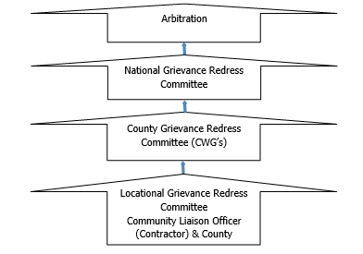

Figure 8.1: KOSAP Grievance Redress Mechanism
It should be noted that if complainants are not satisfied with the grievance process, even after arbitration they have the right to present their complaint through the court system.
It is expected that most disputes will be resolved at the lowest level-Locational Grievance Redress Committee and since most disputes arise during the Construction and operation period the contractor’s Environmental and Social Safeguard team specifically the Community Liaison Officer will work closely with the community to be able to resolve disputes.
Responsibilities of the Community Liaison Officer include:
- Monitor day to day Implementation of the Project
- Address grievances as they arise on the project
- A member of the Locational and County Grievances Redress Management Committee to respond on issues that may have been brought to the attention of the committee before escalating to the National Grievance Redress Committee
      - Escalate grievances internally to get a lasting solution

- Existence of a Local Grievance Redress Mechanism in Dagahaley
The name of GRC is Dagahaley Grievance Redress Committee. The committee was constituted in April 2021 through consultation with the community. The committee has 7 members: 3 men and 4 women.
Contractor will prepare an effective Grievance Redress Mechanisms (GRM) to address and respond to grievances from both the community, the workers and any other stakeholder.
A Grievance Redress Mechanism (GRM) provides access to remedy and identifies procedures to effectively address grievances arising from project implementation. GRM provides an avenue where people can formally lodge their complaints and grievances and have them properly considered and addressed.
The mitigation measures shall include:
- Prepare a project level timebound GRM in consultation with relevant stakeholders
- Ensure the project GRM incorporates existing local dispute resolution mechanisms at the lowest tier and allows access to administrative and judicial processes as well as to other redress mechanisms such as meditation/arbitration and the World Banks grievance redress service (GRS) and the Inspection Panel
- Have a subproject level GRM Focal Point to be responsible for receiving, logging/registering, submitting to the responsible tier for resolution and responding to and updating complainants on resolution status
- Sensitize all stakeholder categories on the GRM and encourage them to make use of it
- Ensure the GRM is functional, culturally appropriate, and accessible to all stakeholders without any cost to them and without fear of retribution or reprisal
- Ensure adequate and proportionate representation of VMGs and vulnerable individuals in the local grievances handling committee.
- Prepare a timebound Contractor’s GRM and sensitize community members and project workers its processes
- Ensure all reported grievances are logged, dated, processed, resolved and closed out in a timely manner, or escalated to other levels.
- Ensure the GRM provides for confidential reporting of particularly sensitive social aspects such as GBV, as well as anonymity for those who wish to report anonymously.

- World Bank Grievances Redress Mechanism
The World Bank has established 2 grievance redress mechanisms that provide avenues for individuals and communities to submit complaints directly if there is belief that they have been, or are likely to be, adversely affected by a World Bank-funded project. In this project PAPs and other stakeholders have the right to know and access at no cost these GRMs as described below.
- World Bank Grievances Redress Service
The Grievance Redress Service (GRS) is an avenue for individuals and communities to submit complaints directly to the World Bank if they believe that a World Bank-supported project has or is likely to have adverse effects on them, their community, or their environment. The GRS enhances the World Bank’s responsiveness and accountability to project-affected communities by ensuring that grievances are promptly reviewed and addressed. Complaints must be in writing and addressed to the GRS and sent through the following methods namely:
Those aggrieved or their representatives can report their complaints through the following mediums; (i) Online by accessing the online form; (ii) Sending an Email to grievance@worldbank.org; or (iii) Submitting a letter to the World Bank Headquarters in Washington D.C., United States or World Bank Kenya County Office.
- World Bank Inspection Panel
The Inspection Panel is an independent complaints mechanism for people and communities who believe that they have been, or are likely to be, adversely affected by a World Bank-funded project. The Panel is an impartial fact-finding body, independent from the World Bank management and staff, reporting directly to the Board. The Inspection Panel process aims to promote accountability at the World Bank, give affected people a greater voice in activities supported by the World Bank that affect their rights and interests, and foster redress when warranted. In September 2020, the Board updated the resolution that created the Panel and added to the Panel functions. At the same time, the Board approved a resolution establishing the World Bank Accountability Mechanism (AM). The new AM began operations in early 2021 and houses the Panel to carry out compliance reviews and a new Dispute Resolution Service (DRS), which will give complainants another way to have their concerns addressed. Contacts for registration of complaints to the IP are (i) Tel: +1 202 458 5200: and (ii) Email: ipanel@worldbank.org.
- Government Management of Land Acquisition Disputes
The Environment and Land Court, established under the Environment and Land Court Act 2011, is a superior court (with offices across the country) that hears and determines disputes relating to land and the environment. Likewise, the Land Acquisition Tribunal established under the Land Act 2012; (PART VIIIA 133A) has jurisdiction to hear and determine appeals from the decision of the NLC on the process of compulsory acquisition of land. Therefore, in the first instance, such appeals are referred to the Tribunal. However, a party dissatisfied with the decision of the Tribunal may appeal to the Environment and Land Court on a question of law only. The regulations to set the Land Acquisition Tribunal established under the Land Value (Amendment) Act of 2019 are underway. Besides, the Judicial Service Commission will chair the Land Acquisition Tribunal once operational.
- Labor Influx Management Plan
The purpose of this plan is to provide a clear set of actions and responsibilities for the control of impacts linked to in-migration within the Project’s area of influence. This plan will be regularly reviewed and updated to reflect revised Project design, socio-economic changes and learning experienced during its implementation.
The objectives of this plan are as follows:
- Monitor the scale of project induced in-migration into the project area and specific in-migration ‘hotspots.
- Support local government and communities to manage both internal and external immigration into the project area; and
- Mitigate and manage any negative impacts and enhance and promote any positive impact related to labor influx.
The plan shall consider these measures:
- Prepare and Implement a Labour Management Plan (LMP) with policies and measures for ensuring that:
- Subproject managers and workers are sensitised on:
  - County/National Labour laws
  - County/National Child Labour laws
  - National/International Forced Labour laws
- Enforce:
  - The Code of conduct
  - County/National Labour laws
  - County/National Child Labour laws
  - National/International Forced Labour laws

Rehabilitation and Decommissioning Management Plan
The rehabilitation and decommissioning management plan include the following:
- Planning for Closure
- The implementing agency shall investigate practical options for closure of the facility at least one year before decommissioning and submit a report to relevant authorities NEMA included.
- The KPLC shall develop rehabilitation and decommissioning plan in conjunction with relevant stakeholders at least one year before the end of facility’s operations.
- The KPLC shall explore options of re-use and recycling of the facility’s components/structures.
- Decommissioning
- The KPLC shall take into consideration the health and safety of personnel, contractors, neighbours and the public during the planning and implementation of the demolition process.
- The KPLC shall undertake a further survey to identify any contaminated areas and remediate them accordingly.
- Post Closure
The KPLC shall ensure that the facility’s site is free of impacts associated with the closure and demolition
The KPLC shall develop, rollout and implement a monitoring plan that includes:
- Monitoring of the rehabilitated site to confirm whether progress is satisfactory.
- Outline of how land improvement and future land use will be affected by the past operations and decommissioning of the associated infrastructure.

Institutional Implementation Arrangements for the Proposed Project
This section presents roles and responsibilities of proponent, implementing agency, supervision consultant and contractor. The project is jointly implemented by the Ministry of Energy and Kenya Power. Specific roles are presented below.

Proponent -Ministry of Energy and Petroleum (MoEP)
The MoEP will provide overall coordination and oversight of the project. MOE will be responsible for overall responsibility for safeguards due diligence, and compliance monitoring. The MOE will also provide funding for the project planning and implementation.

KOSAP Project Implementation Unit
The MOE has already put in place a Project Implementation Unit (PIU) to guide implementation of the project. The PIU is already implementing the project. In the PIU Environmental and Social issues are spearheaded by an Environmental and Social Safeguards Expert whose role is to coordinate and oversee implementation of safeguards. The PIU reports to the MOE.

The Implementing Agency (KPLC)
KPLC will be responsible for implementation and operation of the project on behalf of the MOE. Some of the key responsibilities include but not limited to are.
- KPLC will supervise construction works through a supervision consultant and directly
- Monitoring the progress of the project in terms of the safeguards and technical aspects.
- Monitoring of the ESMMP implementation
- Ensuring the project is on course in terms of timelines

Note: The Solar Mini Off-grid will be installed operated and maintained by the contractor for the first ten (10) years and then handed over to KPLC engineers and operators. So, for the ten years KPLC will be monitoring the operations of the contractor.

County Government of Wajir
The County government is a key stakeholder. The roles of the county government include giving relevant approvals needed, assisting is process of allocating land for Mini Off-grid, solving grievances that cannot be sorted at project level, monitoring progress of the project among others.

National Environmental Management Authority
This authority is responsible for approval of ESIA report and licensing and is free to check progress of implementation of ESMMP

Roles and Responsibilities of the Supervising Consultant
- The consultant must appoint an ESHS officer who will be reporting on the ESMMP implementation supervision
- The consultant ESHS officer be required to generate various reports including production of minutes of monthly site visits and quarterly supervision reports detailing environmental, health, social and safety compliance on quarterly basis amongst other technical aspects
- Reporting on the ESMMP implementation progress and recommendations

Roles and Responsibilities of the Contractor
- Implementation of the contractor related aspects of the ESMMP and regularly (monthly) reporting
- The contractor on his part will have to appoint an EHS officer and a Social Specialist to coordinate and report on the ESMMP implementation respectively.
- The contractor to engage a Community Liaison Officer to act as a link between the community and the contractor and support the Social Specialist.
- The contractor will also have the obligation of managing the E&S risks related to his/her operations.
- Maintaining the required level of stakeholder engagement and communication, including providing project schedule information to the public, accepting and resolving public grievances, advertising and hiring local workers.
- Maintain a working grievance redress mechanism.
- The contractor is to comply with all regulations and by-laws at the county level and other relevant regulations and laws
- The contractor shall refer to ESIA recommendations and the ESMMP when preparing the contractors- ESMMP and the specific plans
- The contractor shall provide water required for use in connection with the works including the work of subcontractors and shall provide temporary storage tanks, if required
- The contractor shall make his own arrangements for sanitary conveniences for his workers. Any arrangements so made shall be in conformity with the public health requirements for such facilities and the contractor shall be solely liable for any infringement of the requirements.
- The contractor shall be responsible for all the actions of any subcontractors whom he subcontracts.
- The contractor shall take all possible precautions to prevent nuisance, inconvenience or injury to the neighbouring properties and to the public generally, and shall use proper precaution to ensure the safety of the community
- All work operations which may generate noise, dust, vibrations, or any other discomfort to the workers and/or visitors of the client and the local community must be undertaken with care, with all necessary safety precautions taken.
- The contractor shall take all effort to muffle the noises from his tools, equipment and workmen to not more than 70dBA
- The contractor shall upon completion of working, remove and clear away all plant, rubbish and unused materials and shall leave the whole site in a clean and tidy state to the satisfaction of the Proponent. He shall also remove from the site all waste
- No shrubs, trees, bushes or underground thicket shall be removed except with the express approval of the proponent.
- No blasting shall be permitted without the prior approval of the KPLC and the local authorities.
- Borrow pits will only be allowed to be opened on receipt of permission from the approving authorities.
- The standard of workmanship shall not be inferior to the Kenya Bureau of Standards where existing. No materials for use in the permanent incorporation into the works shall be used for any temporary works or purpose other than that for which it is provided. Similarly, no material for temporary support may be used for permanent incorporation into the works.
- Disposing of the waste generated during construction activities in accordance with the ESMMP.
- The contractor EHS officer will report on ESMMP implementation during construction period. The aspect to be reported by the contractor will include safety issues i.e. hours worked, recordable incidents and corresponding Root Cause Analysis (lost time incidents, medical treatment cases), first aid cases, incidents and accidents, potential near misses, and remedial and preventive activities required (for example, revised job safety analysis, new or different equipment, skills training etc.); Environmental incidents and near misses; noncompliance incidents with permits and national law; Training on E&S issues (dates, number of trainees, and topics); Details of any security risks; Worker & External stakeholder grievances and E&S inspections by contractor, including any authorities.
Environmental and Social concerns need to be part of the planning and development process and not an afterthought, it is therefore advisable that all the risks and impacts of the project be prevented and mitigated at the earliest opportunity possible to ensure smooth implementation of the project. Finally, a comprehensive Environmental and Social Management and Monitoring Plan (ESMMP) has been prepared and will guide in implementation of mitigation measures.

Management of Impacts during Operation Phase
The operation phase of the proposed project will be mainly power supply, line maintenance and clearing of wayleaves. A contractor (contracted to run the plant for several years before handing over to KPLC) will be responsible for all the mitigation measures for negative impacts during the operation phase for the first ten years after which responsibility will be KPLC. This will be done by implementation of the following steps:
- Inspections
- Corrective action
- Reporting

CONCLUSION AND RECOMMENDATIONS

Conclusions
During the preparation of this report for the proposed development, it is observed and established that most of the negative social and environmental impacts can be mitigated and have potentially short term low significant effects. The positive impacts are highly rated and will benefit the community at DAGAHALEY and the county at large. The project proponent, the implementing agency and the contractor must adhere to prudent implementation of the social and environmental management and monitoring plan. The contractor should commit to obtaining all necessary permits and licenses from the relevant authorities and have qualified and adequate personnel to do the project as proposed. The ESIA has proposed adequate safety and health mitigation measures as part of the relevant statutory requirements.
The analysis of the ESIA has demonstrated that the construction and operation of the proposed Solar Mini Off-grid will have positive impacts to the government and Kenyan society at large. The impacts will include Increase in reliable and sustainable clean energy, employment to local community members, increase in the national/local investment, increase in government revenue, improvement of standards of living for DAGAHALEY residents. However, despite the outlined positive impacts, the proposed development will cause some negative impacts such as noise, dust generation, soil erosion, oil spills, fire hazards, electrocution, shocks, solid waste generation, occupational health hazards, social risks such as labor influx, demand for resources, gender-based violence, conflicts, public health impacts (HIV & AIDs, Covid 19) among others that need to be avoided, reduced and mitigated against.
It is the duty of NEMA to consider licensing the project subject to EIA study; in accordance with the Environmental Management and Coordination Act, EMCA of 1999 and its Amendment, 2015 and the Environmental Impact Assessment and Audit Regulations, Legal Notice No. 101 of 2003.
An Environmental and Socio- economic Management Plan (ESMMP) outline has been developed to ensure sustainability of the project area activities from construction through operation to decommissioning. The plan provides a general outlay of the activities, associated impacts, mitigation action plans and appropriate monitorable indicators. Implementation timeframes and responsibilities are defined, and where practicable, the cost estimates for recommended measures are also provided.
A monitoring plan that highlights some of the environmental performance indicators that should be monitored has been developed. Monitoring creates possibilities to call to attention changes and problems in environmental quality. It involves the continuous or periodic review of operational and maintenance activities to determine the effectiveness of recommended mitigation measures. Consequently, trends in environmental degradation or improvement can be established, and previously unforeseen impacts can be identified, or pre-empted and mitigation measures proposed.

From the findings of this study, the following conclusions are made:
- The proposed project will generate socio-economic benefits which would not be realized if the ‘NO development option’’ is considered.
- The beneficiary community has been consulted among other stakeholders and project information shared including the negative impacts and the views of the stakeholders is that the project is long overdue.
- The potential adverse impacts associated with the proposed project are possible to mitigate successfully. The impacts before implementation of mitigation measures are assessed as very low to medium low and the ratings are expected to improve further with the implementation of the proposed mitigation measures
- The impacts that will be adverse will be temporary during the construction phase and can be managed to acceptable levels with the implementation of the recommendation of the mitigation measures for the project.
- The project will be designed, constructed, and operated according to the acceptable industry norms and standards. Successful implementation of the proposed ESMMP will ensure environmental sustainability
The proposed project design has integrated mitigation measures with a view to ensuring compliance with all the applicable laws and procedures. The Solar Mini Off-grid and associated structures will be installed to the required planning/architectural/structural designs and standards. During project implementation, operation and decommissioning stages sustainable environmental management would be ensured, avoiding inadequate use of natural resources, conserving nature sensitively and guaranteeing a respectful and fair treatment of all people working on the project, general public at the vicinity and the expected Project-Affected Persons (PAPs) of the project.
In relation to the proposed mitigation measures that will be incorporated during construction, operational and decommissioning phases; the development’s input to the society and environment; the project is considered beneficial and important.

Recommendations
It is strongly recommended that a concerted effort is made by the implementing agency, to implement the Environmental Social Management and Monitoring Plan provided herein. Following the commissioning of the project, statutory Environmental and Safety Audits shall be carried out in compliance with the national legal requirements, and the environmental performance of the site operations should be evaluated against the recommended measures and targets laid out in this report.
- The KPLC and the contractor must adhere to relevant legal and regulatory framework to ensure compliance and success of the project
- Adherence to the mitigation measures as spelt out in the ESMMP and monitoring of the same is mandatory to ensure environmental and social sustainability of the project.
- Cultivate and maintain a good working relationship with the community members
- Ensure social inclusion of the vulnerable groups by paying attention to the most vulnerable and provide ready boards as spelt out
- Contractor to plant trees in construction phase to promote environmental sustainability
- Stakeholder engagement to the carried out throughout the construction and operation and decommissioning phases.
- Contractor to ensure grievance redress mechanism is established and operational
- Environmental Audits should be carried annually or as prescribed by the Authority during the operational phase and invitation of Inspectors and Experts from NEMA to ascertain compliance with the provided ESMMP and set NEMA regulations and Standards.
- Diligence on the part of the contractor and proper supervision by the KPLC is crucial for mitigating the potential impacts and ensuring structural strength, safety, and efficient operation of the project.
Authorization Opinion
In terms of NEMA requirement the environmental practitioner is required to provide an opinion as to whether the activity should or should not be authorized. The expert is reticent to venture such an opinion since we are not an elected entity mandated to make decisions on behalf of authority. Nevertheless, in this section a qualified opinion is ventured and in this regard the Lead expert believes that sufficient information is available for NEMA to take a decision. The fundamental decision is whether to allow development which brings socio-economic advantages and is consistent with planning and certain development and social responsibility and upliftment of policies, but which may impact on an area as a result of negative impacts identified. The Lead Expert believes that the ESIA have shown that the applicant’s preferred alternative and technological alternatives are generally acceptable. The ESIA has also assisted in the identification of essential mitigation measures that will mitigate the impacts associated with the project to within acceptable limits.
In conclusion, the expert is of the opinion that on purely ‘environmental’ grounds (i.e., the project’s potential socio-economic and biophysical implications) the application as it is currently articulated in the applicant’s proposal should be approved provided the essential mitigation measures are implemented. It is in the opinion of the Environmental Consultant that the anticipated negative impacts can be readily and effectively mitigated, and the proposed project does not pose any significant threat to the Environment and may be licensed to proceed.

REFERENCES
The following list of references was referred to in preparing this Project Report:
- Environmental Assessment Source Book, 1999 (World Bank),
- George, C. and Lee, N., 2000 Environmental Assessment in Developing and Transitional Countries, Willey: Chichester, UK
- Government of Kenya (GoK), 1999. The Environmental Management and Co-ordination Act, 1999. Government Printer.
- Government of Kenya (GoK), 2003. The Environmental (Impact Assessment and Audit) Regulations, 2003.
- Government of Kenya (GoK), 2009. The Environmental Management and Co-ordination Act, Regulations 2009, Legal Notice No. 61, 2009. Government Printer
- Government of Kenya (GoK). The Public Health Act Chapter 242 Laws of Kenya.
- Government of Kenya (GoK), 2002. The Water Act 2016. Government Printer, Nairobi, Kenya.
- Government of Kenya (GoK), Building code, Building order 1968 and Grade 11 Building Order 1968
- Government of Kenya: The Physical Planning Act 2019
- Government of Kenya: Occupational Safety and Health Act,2007
- Government of Kenya: Factories and Other Places of Work (Safety and Health Committee) Rules 2004
- Government of Kenya: Water Quality Regulations, 2006
- Government of Kenya: Waste Management Regulations, 2006
- Government of Kenya: The Occupational Safety and Health Act, 2007
- Government of Kenya: Noise Prevention and Control Rules 2005
- Government of Kenya: Hazardous Substances Rules, 2007
- Government of Kenya: Factories and Other Places of Work (Noise Prevention and Control) Rules 2005
- British Standard (BS) 5228 Part 4, 1997: Noise Control on Construction and Open Sites: Code of Practice for Noise and Vibration Control applicable to piling operations
- International Labor Organization 1983: Encyclopaedia of Occupational Health and Safety Vol. II, Geneva.
- Sombroek WG, Braun HMH & Van der Pouw BJA, 1982: Exploratory Soil Map and Agro-climatic Zone Map of Kenya, 1980 (Kenya Soil Survey, Nairobi),
- Community Land Act, 2016
- The Land Registration Act, 2012
- The Land Act, 2012
- The Energy Act, 2019
- The Constitution of Kenya, 2010
- Wajir County Integrated Development Plan 2018

APPENDICES

Appendix 1. | Minutes during Public Participation
Appendix 2. | Attendance List Public Participation
Appendix 3. | Minutes and lists of Community Consultation Meeting to Land Identification.
Appendix 4 | Abbreviated Resettlement Action Plan (A-RAP)
Appendix 5 | Lead Expert’s License

Appendix 1 Minutes
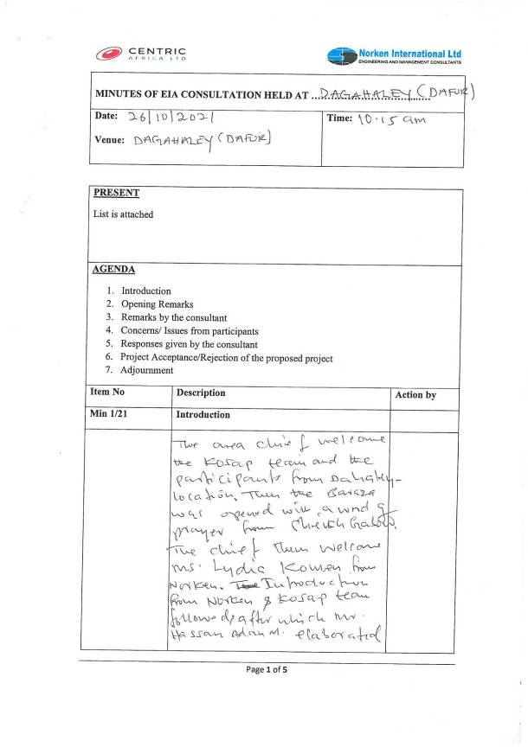
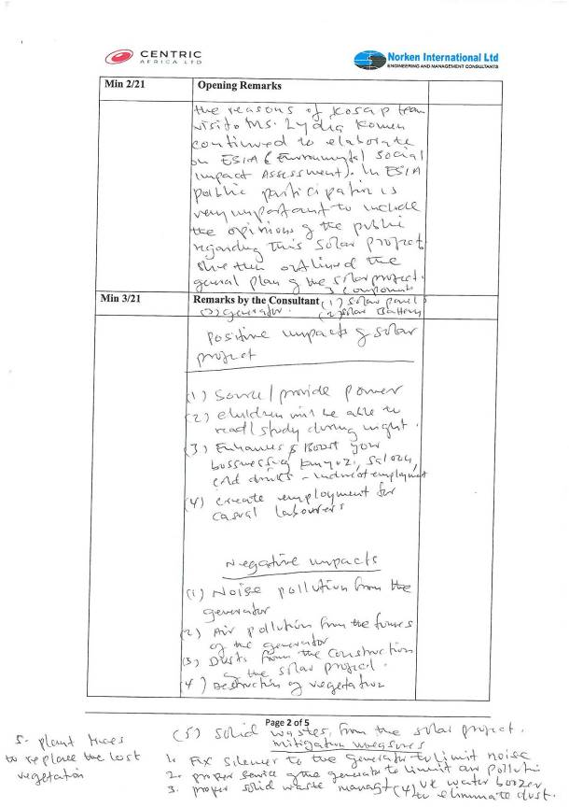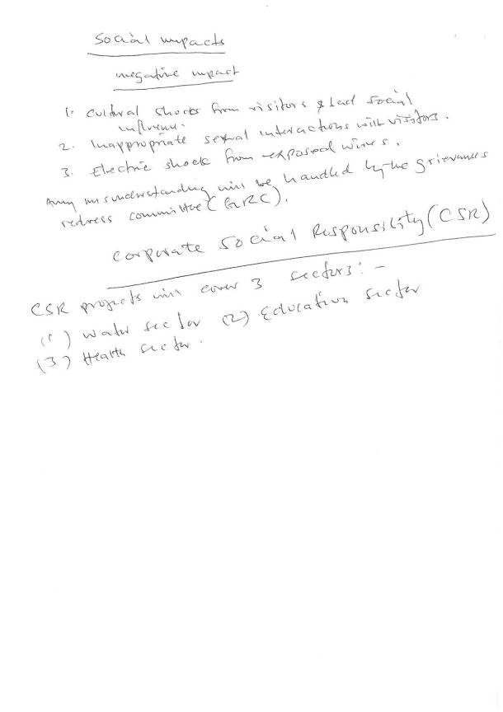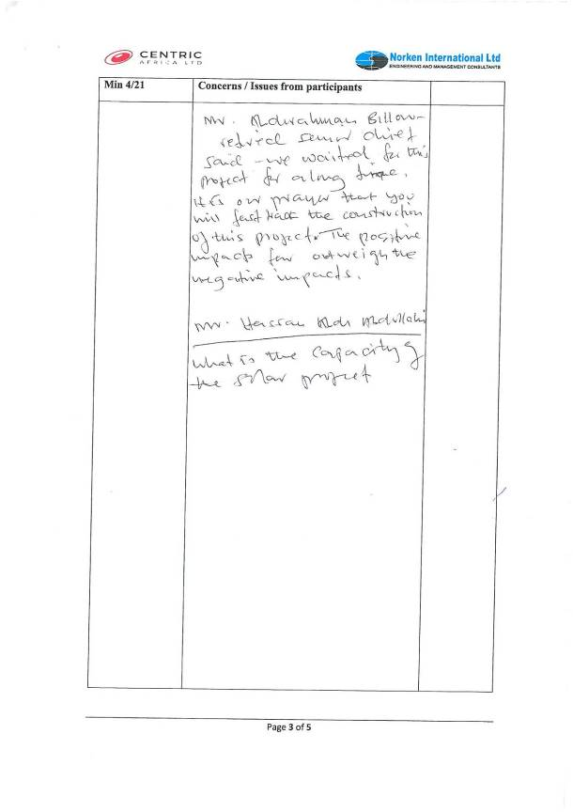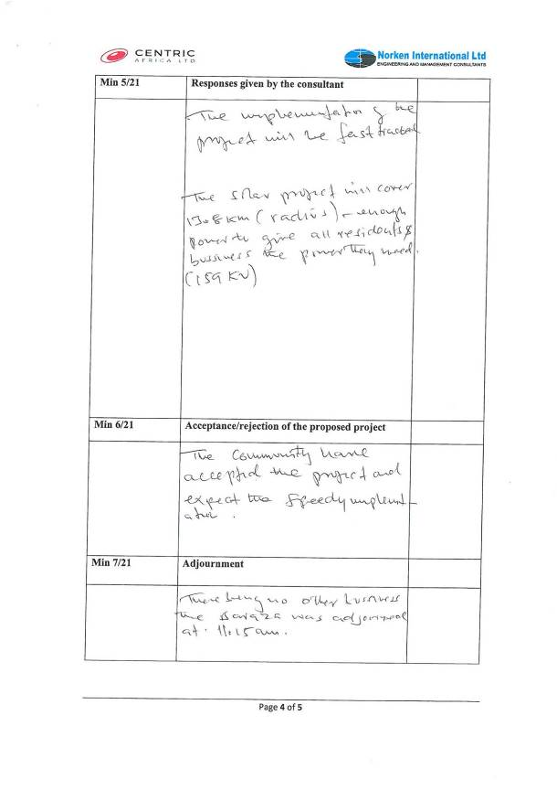

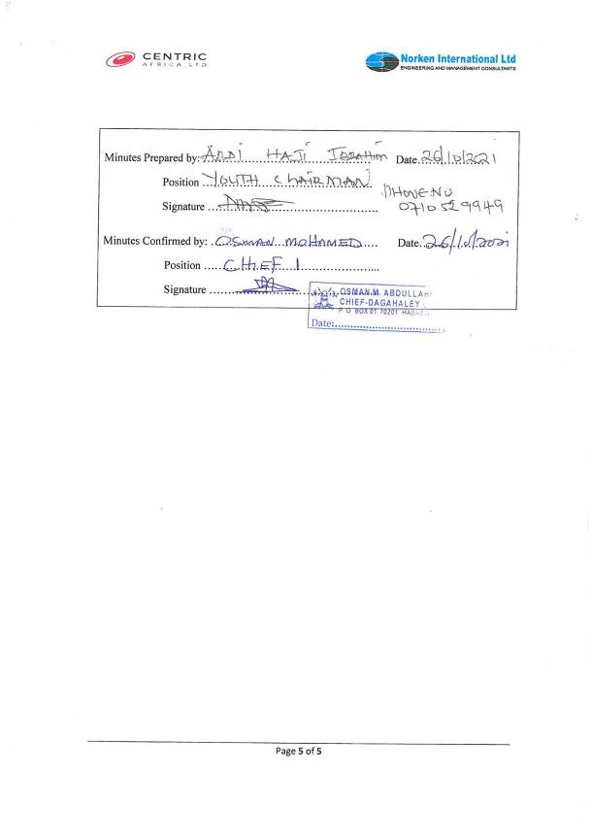

Appendix 2 Attendance List Public Participation
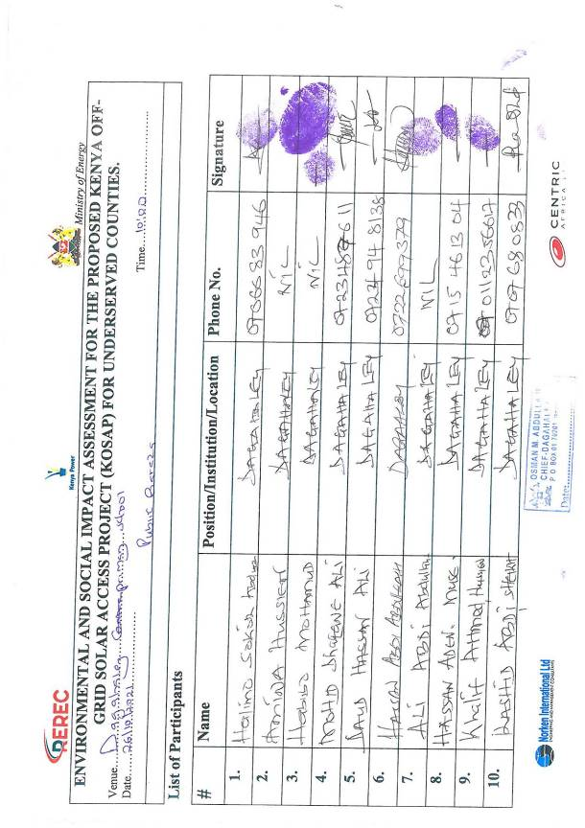
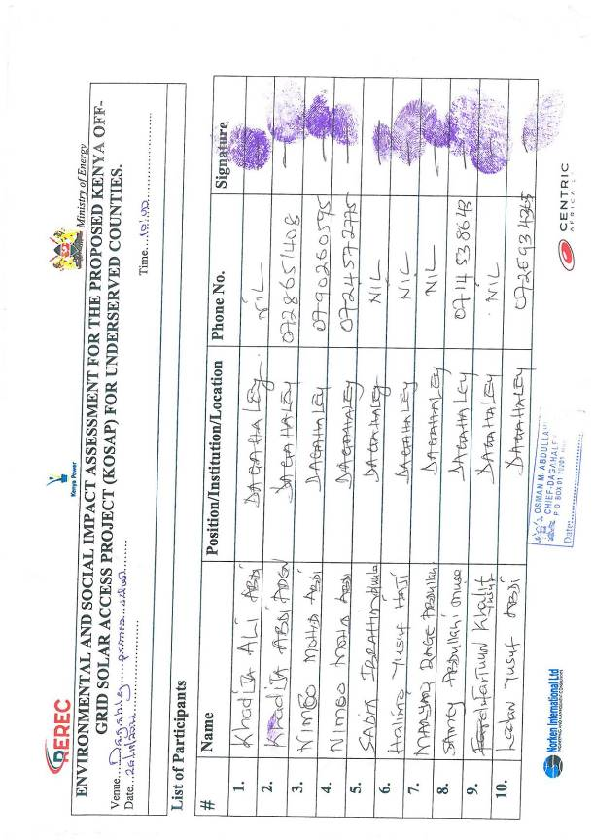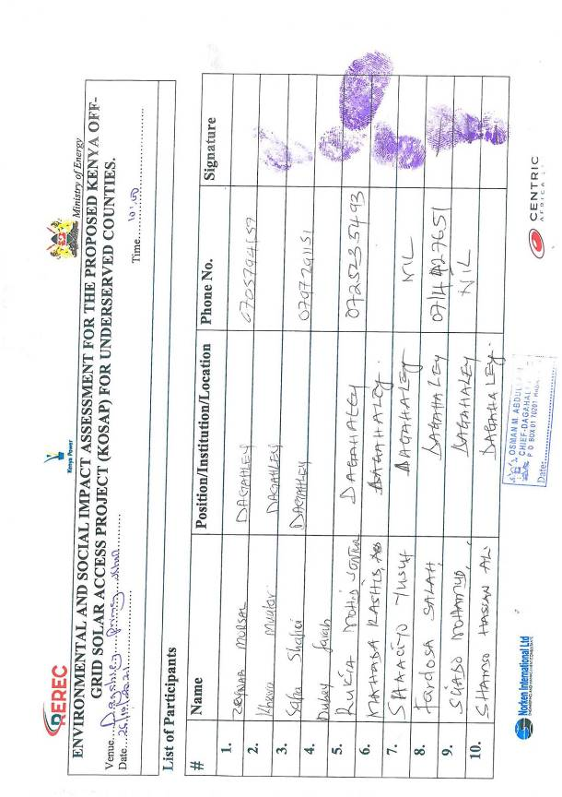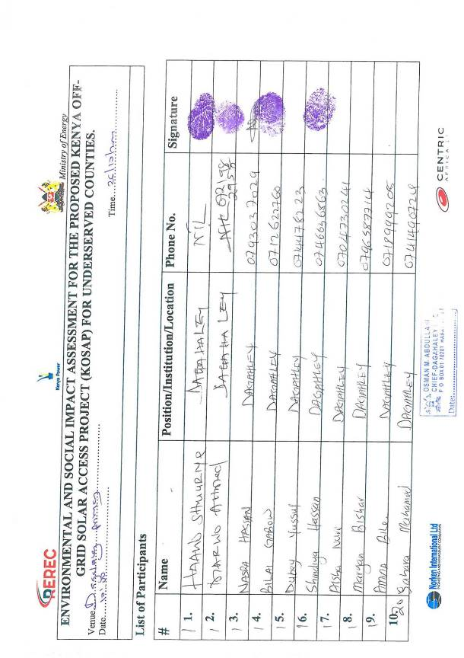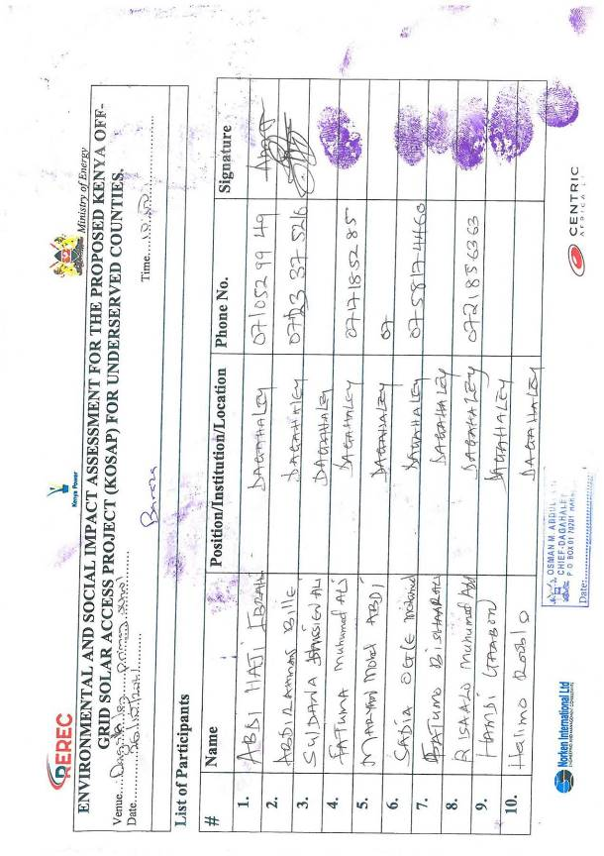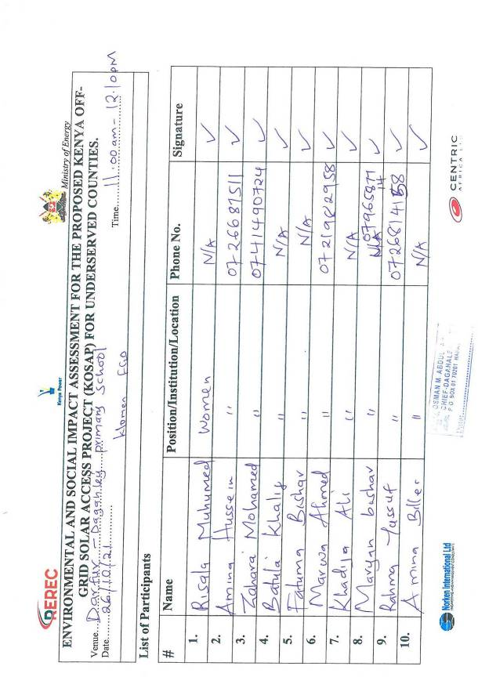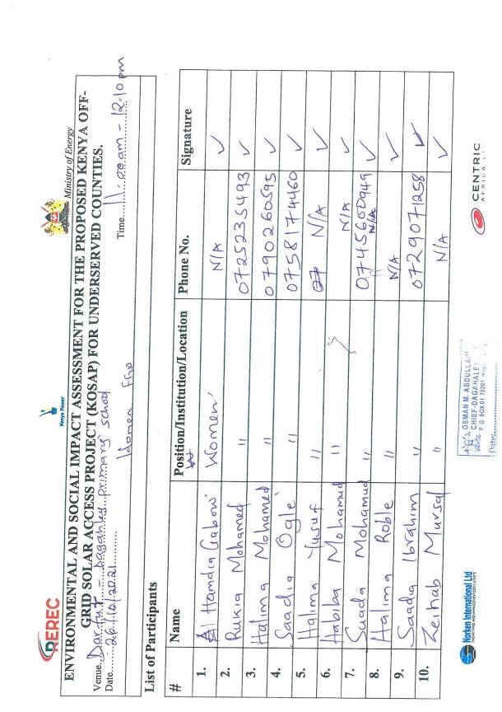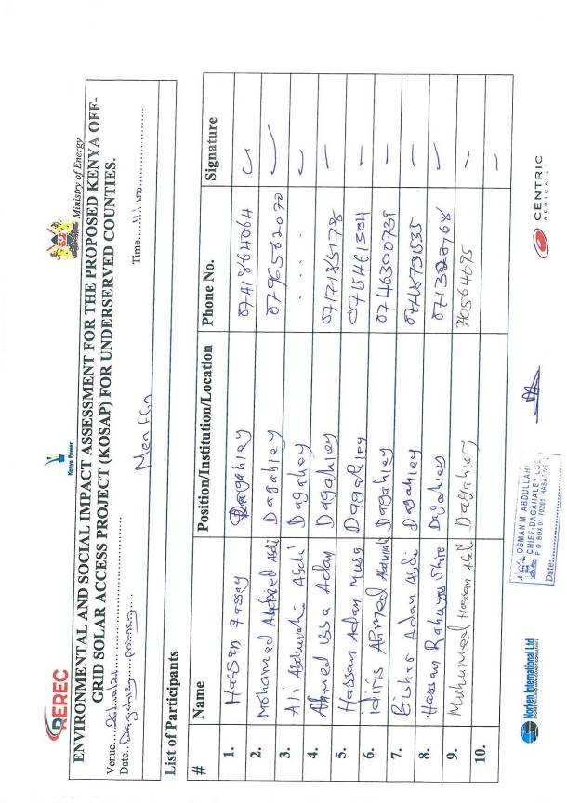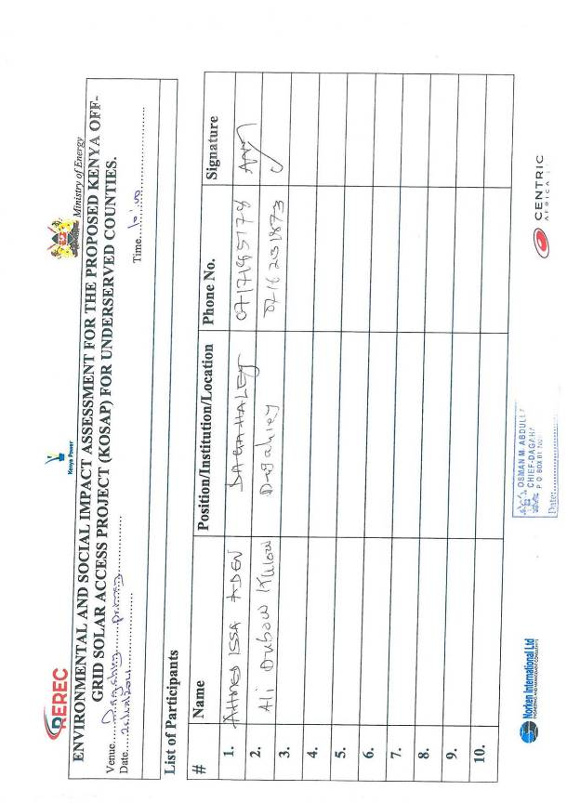

Appendix 3 Minutes and lists of land identification Meeting
MINUTES OF COOMMUNITY CONSULTATION MEETING LEADING TO LAND
IDENTIFICATION AND GRIEVANCE REDRESS COMMITTEE CONSTITUTION FOR
PROPOSED DAFUL SOLAR MINI-GRID PROJECT
DATED: 3RD JUNE 2021 VENUE: DAFUL TOWNSHIP.

The meeting started at 10:00 a.m on 03/06/21 with a word of prayer from one of the members present.

Min: 1 Agenda
Preliminaries
Project design
Land acquisition consultations
Positive and Negative impacts of the proposed project /mitigation measures
Way forward
A.O.B

MIN 2 Meeting Preliminaries
The meeting was called to order by the area chief at 10.00 a.m. The meeting began with a word of prayer from one of the elders (Community Sheikh). The Chief welcomed the vising team from MoE, KPLC, and Wajir County Government in a special way, he further welcomed the community members present for attending the developmental meeting in the community. He further emphasized the importance of having electricity in their community since it will improve their living standards. The chief further informed the team from MoE, KPLC, and Wajir county government that there various government institution within the neighbourhood and requested these facilities to be given first priority to be considered for electricity connection. He also further noted that there are other community facilities that include; Schools, Dispensary, Borehole, Primary School, Secondary School, Market, Mosques, Borehole, Police Post and Safaricom Mast in the area. He finished making introductory remarks by inviting the Director of Energy of Wajir County to introduce his team and welcome MoE and KPLC staff to address the meeting.

Min 3. Introduction of the Project Implementation Unit Team (PIU)
Samuel Abaya thanked all community members present and went on introducing team members from MoE, KPLC and Wajir County Government. He further explained to the meeting that the proposed will require a piece of land that the community had set aside for government projects for the purpose of constructing the mini grid that will benefit the community. Mr. Abaya further explained to the community members present that the proposed Mini grid project is being funded by the World Bank and implemented by the Ministry of Energy, KPLC and County Government of Wajir. He in turn invited Eng. Kyalo to take members through the project design.

MIN. 4 Project Design
Eng. Kyalo explained to the meeting that the government of Kenya through vision 2030 is planning that every household should be connected with power hence the government has come up with this project called Kenya Off Grid Solar Access Project (KOSAP) that is meant to connect Kenyans in the rural areas which are far from the national grid. This project is being implemented in the 14 counties where Wajir is one of them and the process of starting the project has commenced in Wajir. He further noted the proposed project will have solar panels, small diesel generator, control room, distribution lines to various homesteads. The project is being funded by the World Bank and the Government of Kenya.

Eng. Kyalo informed the meeting that the project would also involve the reticulation of power connection to each homestead in the area. He informed the meeting that each household will be required to pay Kshs 1,000 (Kenya Shillings One Thousand only) as connection fees. After the payment each household will pay for their bills based on their consumption. He further explained to the meeting that we needed land that the community had set aside for government projects for the purpose of constructing the mini grid. He then welcomed the Land Surveyor to speak to the gathering

MIN 5 Land acquisition process Min 5: Land Identification process
The team Surveyor Urbanus Muthoka told the meeting that the team appreciated the time they took to come for the meeting to discuss the project. He informed the meeting that the projects would be implemented in 14 counties in the country. Mr. Muthoka explained to the meeting that the project could only commence once the project proponent acquires land where the project would be constructed.

Mr. Muthoka confirmed to the community present that land is both a social and economic factor of life. He explained to the gathering that he would map out the identified land for the proposed project. He further added that the project required a minimum of 2 (two) acres. He further reiterated that the main purpose of the team visit was for the community to pin point identified land for the project, then the multi-disciplinary team would assess the suitability of the land for the project. If satisfied the surveyor would proceed and get the beacon points and map the parcel of land awaiting land acquisition. The Surveyor asked the meeting if it was the first time they had heard about the project. The members of the community confirmed that a team had visited the town some time earlier regarding this said project.

Mr. Muthoka explained to the gathering that the team that had previously come to their area was a team of consultants. The members present confirmed the same and that they had shown them the site of the proposed mini grid. He told them that the team that had come previously were consultants who had come to view the land. He further said that he was the surveyor of the team and would take the coordinates of the land to commence the land acquisition process. He further explained that he would then prepare a sketch map of the land and forward the same to the County Government for approval. Once the county approved the scheme it would be forwarded to the National Land Commission for approval and the process of preparation of a letter of allotment. The meeting was told that the title would finally be in the name of either Kenya Power and Lightening Company (KPLC) or the Rural Electrification and Renewable Energy Corporation (REREC). Mr. Muthoka then welcomed the Environmentalist Mr. Mwangangi to address the meeting.

MIN 6: Environmental impacts of the proposed project /mitigation measures
The Environmental Expert Simon Mwangangi thanked the community once again for listening to other Team members and their participation. Simon told the gathering that it was important that there be consensus by the community members on the land that they will be allocated since it will serve good for the community.

Mr. Mwangangi explained to the meeting that another meeting will be held for Environmental and Social Impact Assessment for the proposed site which will be submitted to the National Environmental and Management Authority (NEMA) for review. NEMA officers will undertake site visits to inspect and confirm that an Environmental and Social Impact Assessment had been done on the project and assess the community engagement on the proposed project. Subsequent to this the Contractor would then commence the construction of the mini-grid.

He further told the meeting that the proposed project will come along with both positive and negative impacts of the project. He began with the benefits. He said, the community would enjoy light from electricity and each household connected will no longer need to use paraffin lamps to light their homes. Electricity will be generally cheaper that the use of paraffin for lighting. Electricity will benefit school going children. They will be able to study to late hours in the evenings. There will also be an opportunity for the Teachers to teach the students late into the evening and also use the same light to give them early morning classes.

The community will also enjoy power for security lights at night. This will enhance security within the community at night. He further told the community that there may be members in the community who would love to buy televisions. Televisions will be a good source of entertainment and information of current affairs both locally and internationally. With electricity some community members will start businesses, the youth will open Barber shops among others. He asked the community where they cut their hair and many responded that they travel to long distances to access that service. He further told them this will then not be necessary as with the electricity in their township will enable barber shops to be established within.

Simon went ahead and told the gathering that the project will come along with employment opportunities for the community. This will be in the category of skilled and semi-skilled and unskilled jobs. The project will give priority to the locals for employment opportunities, especially for unskilled positions. The skilled works will be for masons, electricians when the contractor begins the construction. The work will be available for Men, Women and the youth. The rates payable will be agreed with the contractor but in line with the Kenyan Labour Laws. The Women will have an opportunity to sell tea, chapatti and food to the workers who will be working on the site of the mini grid.

The Contractor will also buy building materials like sand, gravel, stones and cement from the local community. Materials that will be available within the community for sale will be purchased by the contractor. Some materials like solar panels will be imported for the project.

The local Health Centre will also be supplied with electricity at an affordable cost. This will be a benefit in that the dispensary will now be able to refrigerate medicines that require being stored in cool places for patients. Laboratory and Pharmacy services will be more efficient for the community. Pastoralists engaged in the sale of livestock meat and/or milk will have access to infrastructure for cold storage facilities of their produce

Simon told the meeting that every project has both positives and negatives effects. He went further to explain the negative aspects of the project. He said the project will involve nonlocal people coming to work on the site. This means that the non-locals may come with habits that are not culturally acceptable to the Ogaden community that live within Daaful Township. The workers may walk around the sites without shirts and in shorts. This may be unacceptable behaviour to the community. If the community have rules they wish to have adhered to, the contractor will hold inductions with the elders for all his workers to understand and adhere to cultural standards.

The community will also experience noise pollution during the construction period the noise will be from excavation, drilling and vehicles driving to and from the site. This will be for just a while. The contractor will be limited to working from 8am to 5pm to control the noise. Samuel acknowledged that water is scarce in this area. He said that the contractor will require water from the locals to carry out the construction of the project. This will be an inconvenience for a while.

Dust pollution will also emerge from the site. The contractor will mitigate this by the use of tackifiers and soil stabilizers to reduce the dust. The vehicles may at times be driven at a high speed when transporting materials. The introduction of bumps will be used to control the speed of the vehicles. During construction of the project, the community may have trees in the proposed project land. In case the land has trees, they will be cut and cleared for the project. However, the contractor will plant trees to replace the ones cut and plant additional trees for the community on the site.

Accidents may occur during this period too. For example a worker could get injured by a stone falling on them or hammer injuring a worker. The contractor will ensure that all workers wear a helmet, gloves, overall and safety boots at all times when on site. If a worker is found without any of the safety gear, he will be dismissed from the site on the spot. In case of any injury to the workers the Contractor will bear the responsibility for the staff. The contractor will give all the workers the regulations they must abide to while at work. Mr.
Mwangangi then welcomed Mr. Abaya to address the meeting.

MIN 7: Social Impacts
Samuel thanked the community members for turn out in large numbers for this developmental project that will benefit them. He went ahead and talked about Gender Based Violence that will result from the proposed project as an issue that needed to be mentioned. He said if a man got a job on site and is paid his wages, his wife may demand money knowing that he has been paid. This also applies in vice versa. The woman may work, and the husband may demand money from the wages paid. If one spouse does not cooperate, the consequence could lead to violence in the home.

He further noted another social issue that may occur when the women are employed on the site or cook for the workers, they may be sexually harassed or sexually abused. Such cases must be reported. HIV AIDS is also a disadvantage. The risk to this exposure is real and members of the community and workers should be aware since everyone is vulnerable.

Samul further noted Child labour is a negative activity that will not be condoned. A worker may wish to get additional money by bringing in a child to assist in his work. Such a situation will not be accepted. He further noted that other social impacts that might come along with the proposed impacts include;
Theft cases might be reported
Unwanted children cum pregnancies
Family disputes might arise especially on wayleave access
Land intake for government project

Mr. Abaya further noted that there are other social benefits the proposed project will come along with, they include;
Employments
Electricity connection
Improvement of the current health and education standards
Easy access of information
More businesses will come up/ economic empowerment i. e informal sector

Electricity as a source of energy can also be dangerous. Children may play around with nails in the sockets in the house. This can cause electrocution. When trying to save such a child, one may be bare footed and become a path for the electricity and get injured. The power poles can also be a curious object for the youth to climb risking their lives by falling from the poles. Precautions need to be taken where children and the community warned on the dangers of electricity. With all the disadvantages the meeting was told that there will be a solution for all the issues.

Samuel then told the meeting that to address grievances, the team will require that a
Grievance Redress Mechanism (GRM) to be put in place by the community. This GRM will have a committee that will help solve the grievances arising from the project. The community will need to identify persons who will sit on the committee and they should comprise a man, woman, youth and a person representing the special group e.g. a person living with a disability. The Committee will help address grievances to their conclusion. If in any case the committee is unable to solve an issue, they will be guided by the implementing agency on where to forward the matter. If it is still not solved at that level, then the Kenyan Courts will be used to resolve the issue. He said it is our hope that the grievances will be solved at the local level. The meeting was also told that the members of the Committee will be required to volunteer their services. This is because there will be no payment for their services. The committee was elected comprising a representative of men, women, youth and special needs in the society. Their names are;

No. | Names | Represents | Id. No | Phone No.
1 | Nimo Mahamed Abdi | Women | 21650503 | 0704472939
2 |  | Men
3 |  | Men
4 | Dekow Khalif Yussuf | Youth | 21215985 | 0794758577
5 |  | Special Need

MINUTE 8: Plenary session
Community Members present were given a chance to contribute and ask questions in regard to the proposed project as follows;

QUESTION/COMMENTS | ANSWER/REMARKS
Abdala Hassan  We are glad of this forum, welcome and we have heard about this project for long, now we are seeing success. We say we are grateful to you our visitors and those who decided the project to be implemented here. The residents all welcome the project. We will identify land within our proximity for ease of electricity distribution. | Engineeer John Kyalo:  Thanks for your good questions. As we said in the meeting; use qualified technicians who will advise you on everything and issue you with a wiring certificate. Wiring inside a customers house is the responsibility of the customer, and if something goes a mess, the customer is to blame.
Abdi Kadir Decor  I am a community facilitator for this settlement ? we are very impressed, excited and welcome you. My questions are:  Is the project solar, diesel or a combination?  What is our expectation as youth and also for women: we can be meter readers and also do security jobs  As a community we will provide land but we want you to take care so that it doesn’t bring negative impacts to environment and to people. | Simon Mwangangi:  Thank you for your comments and questions which I would like to answer as follows:  Project is co-generation main one being Solar then when batteries run down to be backed up by diesel generation.  Job opportunities will be provided to community members as a priority for the jobs they qualify for.  Every project has some negative Environmental and Social impacts. A detailed Environmental and social impact assessment will follow and an  Environmental Management Plan will be developed to provide mitigation measures for the negative impacts.
Deroh Ali Abdi  Greetings  What you say to us is a dream till you implement project. We are eagerly waiting. I have to see the project to believe. The backbone of every government is the citizens. We have been left behind in terms of development, and urge you to implement project the sooner you can. | Engineeer John Kyalo:  This project is not a dream and even if it takes one year before construction begins, do not lose hope. We request for your cooperation all along. There are a number of clearances we have to clear first starting from ESIA, county approvals, tendering among other preconstruction activities.  Thanks.

Nima Mohamed Abdi  Greeetings. We are happy about project. Before you came, others came and said they would come back, are you related to them?  I need to see project to believe. | Engineer Kyalo:  As I have just responded to previous question, this project is real in government efforts to ensure every citizen gets connected to electricity.
Kalif  I am the youth Chairman. My questions are: When is the project being implemented?  A project has different stages, assess area demands and other factors, then implementation. Is this assessment stage or decision stage or implementation stage. Last year in July, a group asked for land, same assessments done, and still no project is seing on ground. Do not leave us with empty hope, if project is fruitful we will be happy as a community and we will cooperate. | Simon Mwangangi:  This is preconstruction stage specifically land identification where we shall screen identified land for suitability. If it is suitable we will proceed to tendering and land acquisition before project construction begins.
Farah Dagane Abdi  I am thankful to everyone for attending the meeting. We have had many meetings, given hope and not seen fruits. Are we being used for soliciting funds? We welcome you and promise you we will cooperate. | Dorothy Kagwiria.  This project is real and we are sorry to hear most of your contributions and questions narrow to doubts and lingering questions of whether project is real, whether you are being used for soliciting of money and other doubts.  I once again emphasize project is real, it will be implemented by the ministry of Energy through Energy sector bodies specifically Kenya Power and Rural Electrification and Renewable Energy Commission (REREC) with funding from World bank.  We have to follow steps of Public  Participation, land identification, ESIA and other approvals before contractor comes to ground. We are related to the previous group which came looking for land for solar
 | mini-grid project and we are progressing what they did.

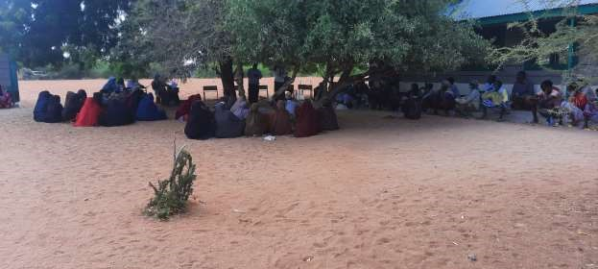

MEN FGD
Simon Mwangangi called the Focussed group discussion for Men into order and thanked the Men present for turning up for the meeting in good numbers and for their contribution in the Public Baraza.
Simon went ahead and asked the Men to give their concerns and views on how they wished to be involved in the project. Their responses and concerns were as follows.
Farah Abdi:
Men will play a key role in land identification Bashir Hussein:
Other benefits like jobs will follow; we need me to be considered for jobs like security
Ahmed Mohamed
We are ready for anything that will be required. We need security jobs especially those police reservists within our community shall fit for security jobs.
Dero Ali Abdi
Men will participate in two jobs – one is land identification and secondly men will participate in dispute resolution. As men, we have responsibility of accepting project as a benefit to the community and guard it from any external threats.
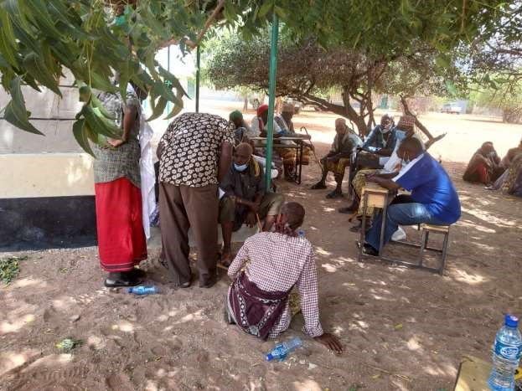
Men FGD in progress
The members present confirmed most of the issues had been discussed. Simon thanked the members present for their attention and contributions and requested Men to select their representative to the Grievance Redress Committee.
The following were selected.
Mohamed Aden Mohamed of ID. number 2349086 and phone number 0720662868 Hussein Ali Soyan of ID number 6822659 and phone number 0794596418

WOMEN FOCUS GROUP DISCUSSION
The group was led by Dorothy who was able to explain why a separate discussion was put up in order for them to have the opportunity to freely express themselves.
She explained the agenda of the visit by the officers from National government and county government was to undertake an environmental and social screening of the proposed site to check suitability in terms of environmental, technical, social and health requirements.
The second objective was to undertake community engagement to sensitize the community on the project and the third objective was about land acquisition for the project and the need for a project grievance redress mechanism.
She gave a summary of the project in terms of its positive and negative impacts and their mitigation measures, the safety precautions and the land acquisition process. She also explained the need for the women to select a representative to the project committee who would represent their views/issues to the committee for redress.
She ensured all the women had understood their rights, roles and benefits concerning the project. Further the women were educated on how they can take up economic opportunities that will raise during project implementation. They were also given opportunity to air their issues/ questions and or /give suggestions to make the project implementation process better.
The discussions went further to bring out issues on how the women can take advantage of the project benefits rather than taking a back seat. She explained to them that they would benefit more from the electricity because they will be able to use clean energy to cook and also benefit from access to information through use of radios and TV that are powered by electricity enabling them to make informed choices on different issues such as nutrition, health, farming among others. They were also set to benefit if they could set up small businesses like salons, cold drink kiosks, cooling milk because it spoils easily, children will have time to study and enhanced security due to the fact that the area will be well lit among other benefits. Gender based violence issues were also discussed including; forms of GBV, rationale for addressing GBV, ways in which a project can worsen existing GBV risks or create new risks, the need to report and document any complaints against workers, report incidences of GBV while ensuring survivor centered approach (respect for the choices, wishes, rights and dignity of the survivor). The women were told to be more vigilant to ensure young girls do not fall prey to GBV incidences. The women were requested to keep talking to the girls on GBV risks and the need to raise alarm in case of risks factors early enough.
All the women were in agreement for the project to be brought to the community.
Questions and answer session:
Q/A -Halima Hassan- Will the representative selected for GRM be the same to sign the land agreement form.-
Response- Yes, it will be the same person.
The women selected their GRM representative for Daful /Dagahaley Mini-grid as follows
Serial No. | Name | ID NO. | Cell No.
1 | Nimo Mahamed Abdi | 21650503 | 0704472939

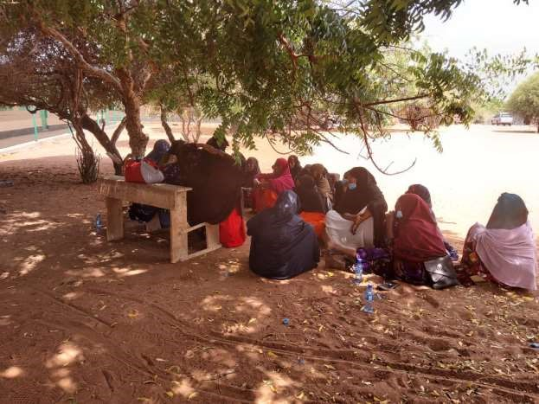
Women FGD in progress

FOCUS GROUP DISCUSSION FOR YOUTHS
This FGDs were led Samuel Abaya
He welcomed the youths present for the focus group discussion. He further explained to them the proposed project the government wants to implement in their neighbourhood will be supplying electricity to the community. This electricity will be generated through solar panels and standby generator. This project is being funded by the World Bank and being implemented by Ministry of Energy through Kenya Power and Lighting Company and County Government of Wajir.
The youths noted were engaged on how the proposed project will be implement in the area and they identified the following positive impact the project will come along with as follows;
Creation of direct and indirect employment for the community people
Reduction of travel expenses since health services will be near them
Clean source of energy (electricity) in their neighbourhood
Improvement of education standards
Increase of the land value
Improvement of the economy of the area
Access to information and news since the community members will invest in the purchasing of the radios, Tvs, and internet services

Further the youths identified the negative impacts that the proposed minigrid will come up with in their neighbourhood;
Introduction of visual impacts due to the proposed mini grid and low voltage lines
Clearing of vegetation on the proposed project site to create room for the construction of the minigrid
Increase of population in the neighbourhood especially during the construction phase
Increase of crimes and other evil vices i.e. unwanted children, early pregnancies, spread of sexual transmitted diseases, petty theft.
Mixing of various cultures of different people who will be working during the construction and operational phases of the proposed minigrid project.
More intake of water during the construction and operational phases of the proposed minigrid
Instance of air pollution will be witnessed during the operation phase of the proposed mini-grid.

The youth further identified various areas of involvement during the implementation and operation of the proposed minigrid which include;
Taking up of employment opportunities both skilled and unskilled within the project site. These employment chances include; security, traffic marshals, drivers, marsonary and casual work among others.
They will assist in dispute resolutions on various conflicts that might arise during the construction and implementation of the proposed minigrid.
Ensure there are equal oppournities to all community members especially during employment and supplying of construction materials for the proposed minigrid.
Orientation of the construction team of the proposed minigrid into local community’s culture and religion so as to avoid confrontations with the construction team
To be given an oppournities to supply the construction materials that are local available especially the sand, murram, hardcore, building stones, wood among others
To be provided with an oppournities of transporting other materials and equipments that could be required for construction and operation of the minigrid.
Need to be involved in the ESIA consultation to ensure the project is environmental friendly.
Land identification
Sub- contracting especially supply of building materials, transportation services, supply of fuel, supply of food items and water
Offering translation services between the contractors and the local community • To have a representation in the project implementation committee.

When youths were asked if they support the proposed project? All of the youths present were in full support of the proposed mini grid project and agreed that they will lobby other youths to support the project.

Samuel then concluded by thanking the community for their attention and said we would move to a question and answer session. He also told the meeting that Dorothy a member of the team would meanwhile hold a separate meeting with the girls and women to allow them to also speak their minds and ask questions freely away from the men

Way Forward
Members present welcomed the project and requested that it be implemented the soonest possible so that their problems of staying without electrical power gets sorted once and for all. They further agreed that the land they are giving for the proposed project is the land which the community has set aside for government projects and no any form of compensation will be demanded by the community.

MINUTE 9: A.O.B
Five community members were identified to sign Land Identification Form on behalf of the community.

MINUTE 10: Closure of Meeting
There being no other business, the Chairperson thanked all the attendants for turning up and their contributions. Members agreed to keep in touch and clarify on any necessary information as regards the intended projects. The meeting ended with a closing prayer at 15:50 PM.

END.

List of attendance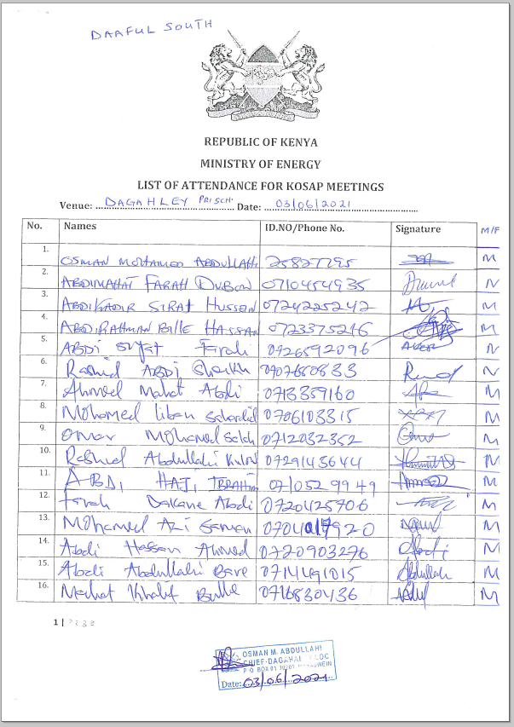 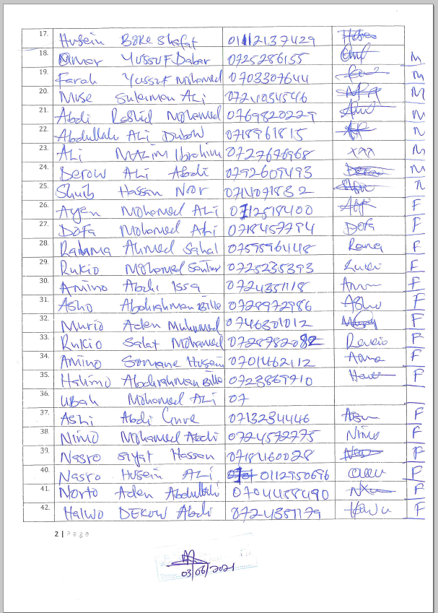 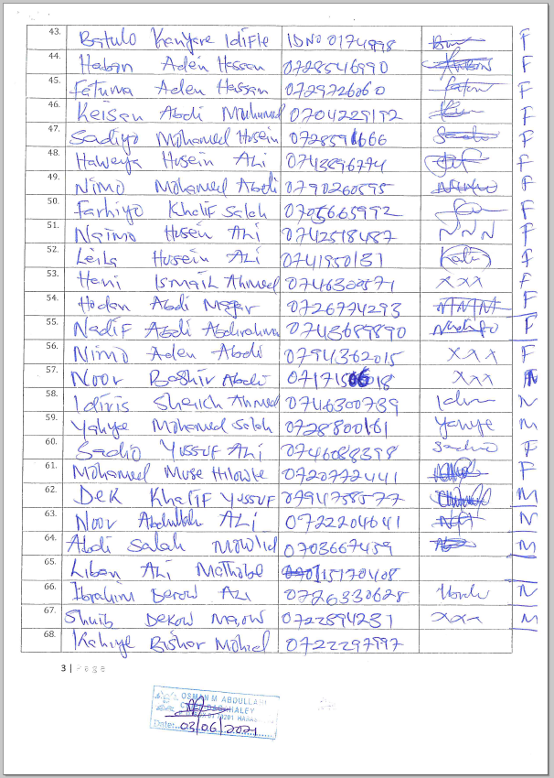 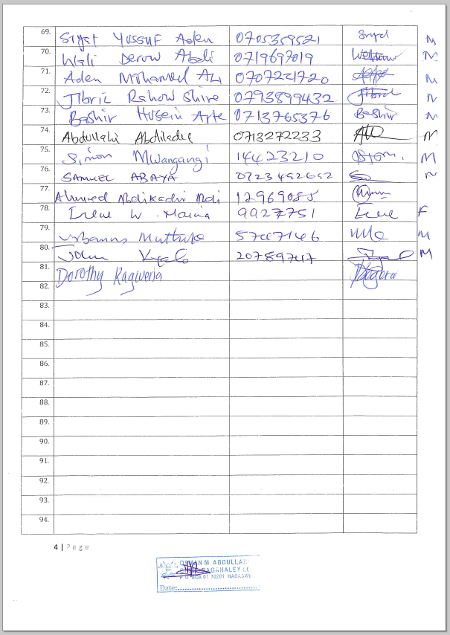 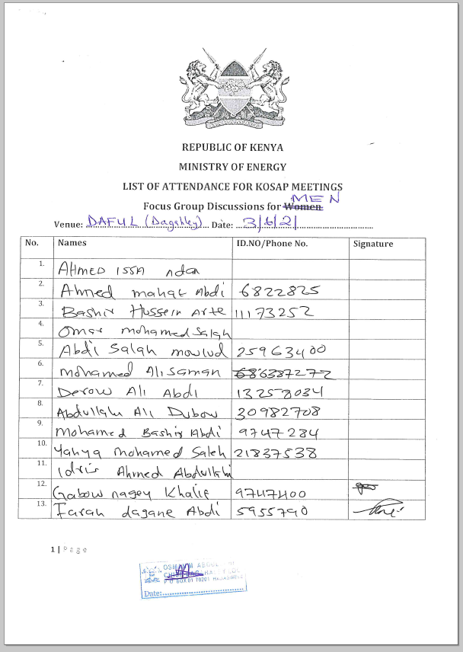 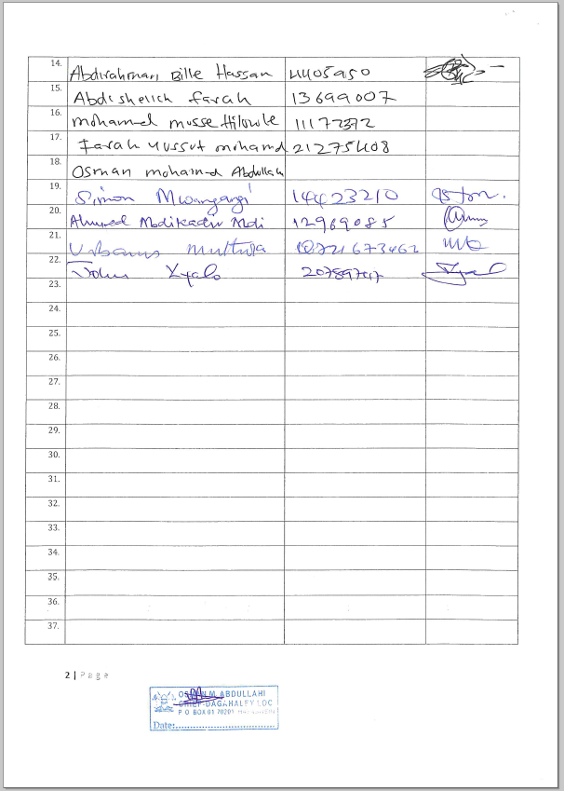 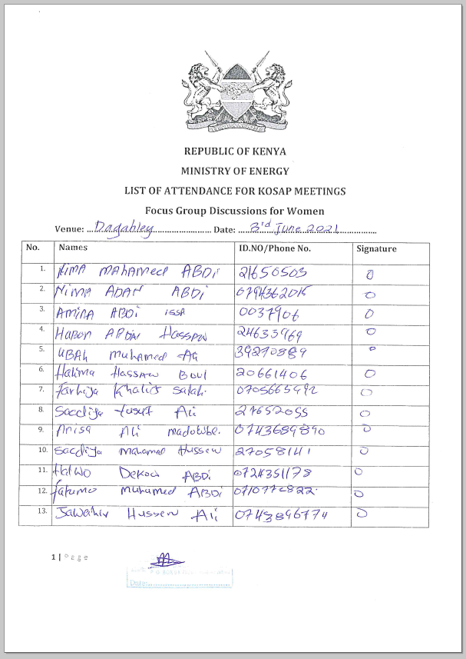 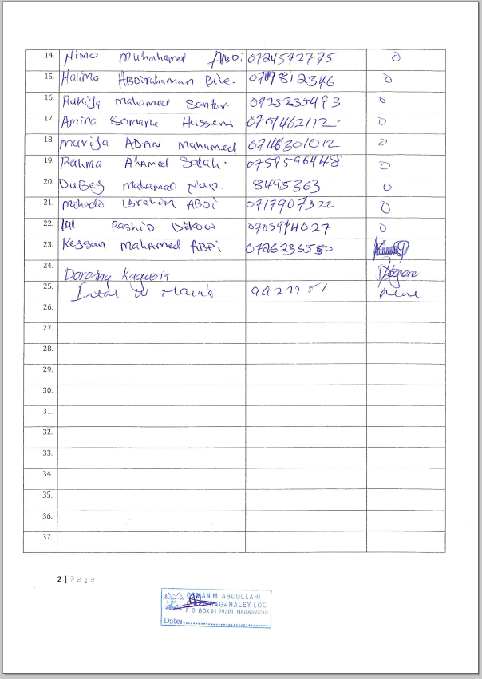 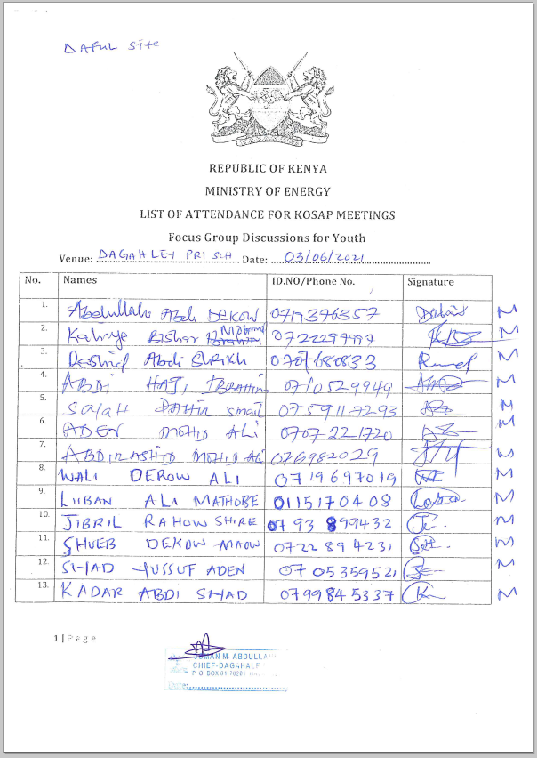 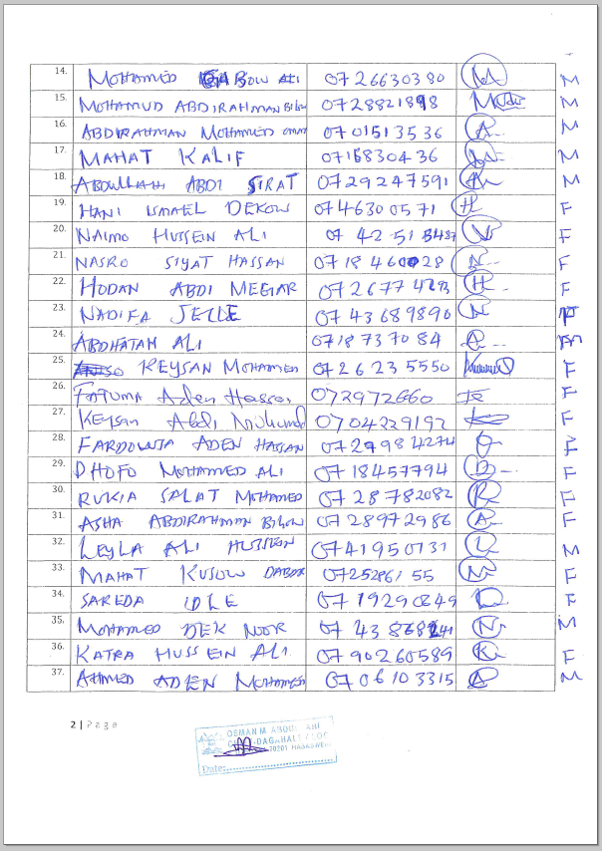 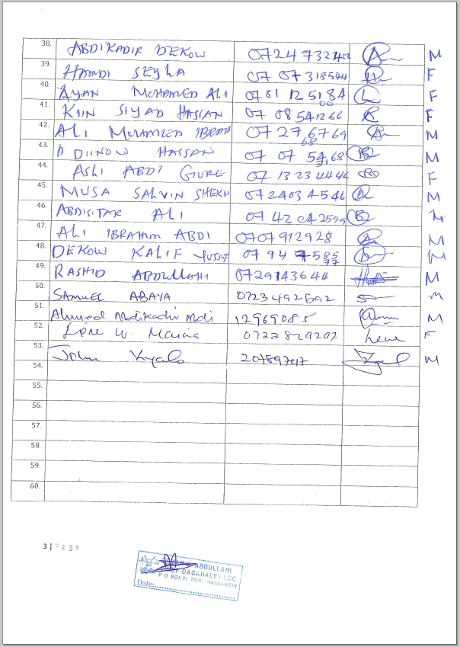

Appendix 4 Abbreviated Resettlement Action Plan (A-RAP)

- Daaful (Dagahaley) Sub-project Site
The Daaful (Dagahaley) sub-project site is on unregistered community land and held in trust by the County Government of Wajir on behalf of the community, in line with the Community Land Act 2016. The proposed site is uninhabited, has no structures, community facilities, or encumbrances, and it is used for grazing.Consultations leading to the identification and selection of the sub-project site are captured in the Environmental and Social Screening report for Daaful(Dagahaley) .Refer to Chapter 4 of the ESIA for the comprehensive socio-economic profile.

- Actual Census Survey of PAPs and Valuation of Affected Assets
The number of project-affected persons (PAPs) is 7908(approximately 1500 households). The land acquisition-related impacts are loss of land and pasture. Mitigation measures include in-kind compensation for loss of land and pasture, and designing power distribution lines to avoid impacting trees, crops, structures, and community facilities. No physical displacement is anticipated; however, there is minimal loss of pasture occasioned by the acquisition of land utilized by the community for grazing. The 1.62 Hectares identified for the sub-project will be acquired compulsorily by the National Land Commission (NLC). The proposed site will be valued and compensated in line with the provisions of the Resettlement Policy Framework (RPF) prepared under KOSAP. Refer to section 4.3 of the ESIA for socio-economic Environment.

- Compensation Measures Agreed with the PAPs and other Resettlement Assistance to be Provided
The proponent requested the community identify three priority projects, whereby one out of the three would be provided as in-kind compensation for loss of land and pasture. The Daaful(Dagahaley community proposed the desilting of Wargadud water dam and fencing the dam and constructing watering point outside the dam area to prevent pollution. The value of the priority community project will be proportional to or higher than the value of land under acquisition. In addition, loss or damage to crops, trees, structures, and community facilities will be compensated in line with the provisions of the RPF, and as summarized in the entitlement matrix below.

3.1 Entitlement Matrix

Types of Impact | Person(s) Affected/Eligible for Compensation | Compensation/Entitlement/Benefits | Responsible organization
- Loss of Land
Loss of unregistered community land. | Community. | Compensation in-kind as prioritized by the community. | KPLC
Loss of land in unregistered group ranches. | Group ranch members. | Compensation in-kind as prioritized by the community.
Loss of land in registered group ranches. | Group ranch members. | Compensation in-kind as prioritized by the community.
Loss of land owned by the National Police, county governments and the Ministry of Interior | Government agencies. | No compensation for public land allocated to another government body.
Loss of land owned by the Kenya Forest Service (KFS) and Kenya Wildlife Service (KWS). | Government agencies. | No compensation for public land allocated to another government body. However, payment of conservation fees to KWS and KFS as stipulated under their respective regulations is foreseen.
- Loss of Use on Land
Loss of use on public land (e.g., grazing, farming etc.). | Communities utilizing public land. | Communities do not own public land; however, they utilize public land with consent from the relevant agencies. The project will implement the infrastructure project prioritized by the community as compensation for the loss of public land use. | KPLC
Loss of use on unregistered community land, unregistered group ranches and registered group ranches ( e.g., grazing, farming etc.). | Communities utilizing unregistered community land, unregistered group ranches, and registered group ranches. | Compensation in-kind as prioritized by the community.
- Loss of /Damage to Assets on Land
Trees | Community members on unregistered community land; community members utilizing public land; members of registered and unregistered group ranches and government entities. | During detailed design for power distribution lines and construction of the mini grid and community project, any crops, structures, trees, and community facilities shall be avoided to the extent possible. However, loss or damage to the above will be compensated/restored at full replacement cost, in line with the provisions of the RPF. | KPLC
Crops
Structures
Community facilities e.g., water sources (earth pans, boreholes etc.). | Community members on unregistered community land, community members utilizing public land, and members of registered and unregistered group ranches.

4. Consultations with PAPs About Acceptable Compensation Options and Alternatives that have been Considered
Detailed consultations with PAPs on land acquisition and compensation, including the modalities of acquiring land and compensation options, were undertaken during the Environmental and Social Screening, Environmental and Social Impact Assessment, and the NLC land valuation process. The following sections provide a summary of the consultations.

4.1 Engagement of Project -Affected Persons (PAPs)
Local administration and County Renewable Energy Officers (CREOs) supported the proponent and implementing agency (IA) to mobilize community members and other stakeholders for public consultations and engagement activities. National and county government entities, community segments (men, women, youth, elders, persons with disability, vulnerable and marginalized groups, etc.), NGOs, and local leaders were engaged through key informant interviews, community meetings, and focus-group discussions. The proponent and IA implemented appropriate measures to ensure PAPs effectively participated in the consultations. Refer to Chapter 6 of the ESIA on public consultation and engagement.
Once the compensation award and Bill of Quantities (BoQs) are known, the Implementing Agency (IA) will engage the community and agree on the community project to be executed as in-kind compensation. During these consultations, the IA and the community will define the roles and responsibilities of the community in monitoring the implementation of in-kind compensation and maintenance once the IA hands it over to the community. Thus, the IA and the community will effect an agreement to be signed by the local leadership; representatives of the Grievance Redress Committees at the locational, county, and national levels; A-RAP Implementation Committee, and Implementing Agencies.

4.2 Identification of Community Representatives
The Daaful (Dagahaley) Locational Grievance Redress Committee (LGRC), constituting a chairperson, secretary, and three members, was formed through community consensus. The committee’s membership comprises men, women, youth, persons with disabilities, and ethnic minorities. The LGRC is responsible for engaging PAPs and resolving complaints. Refer to sub-section 8.7.9.3 of the ESIA on the Grievance Redress Committees. Further, the community will constitute the A-RAP Implementation Committee responsible for coordinating community engagements on the A-RAP and monitoring the implementation and closure of the A-RAP. The representation of the committee will consider gender, vulnerability, and intergenerational sensitivities.

4.3 Summary of Consultations on Land Acquisition and Compensation Options
Date | Objective | Implementing  Entities | Land Acquisition and Compensation Aspects  Discussed | Key Issues Raised | Responses  Given
June 3rd 2021 | Environmental and Social Screening.  Voluntary land donation (VLD).  Constitution of the Locational Grievance Redress Committee (GRC). | Ministry of Energy (MoE)  Kenya Power (KPLC)  Rural Electrification and Renewable Energy Corporation (REREC) | Site identification and land allocation for the sub-project.  Criteria for VLD.  Community entitlements (forms of compensation and implications for each). | None
October 26th 2021 | Environmental and Social Impact Assessment. | Consultants  MoE  KPLC  REREC | Land acquisition through compulsory acquisition (not voluntary land donation).  Selection of three priority community projects, whereby one is to be implemented as in-kind compensation for land. | Community requested for desilting of Wargadud water dam and fencing the dam and constructing watering point outside the dam area to prevent pollution. | The proponent has set aside KES 1 million to implement the priority in-kind compensation project.  The value of the project will be proportional to or greater than the value of land.  NLC will determine the value of land.
May 2023 | Compulsory Land Acquisition. | NLC | Site inspection and inquiries.  Land valuation.  Award of compensation.

5. Institutional Responsibility for Implementation of the ARAP
Entity | Role
Ministry of Energy | - Coordinate A-RAP implementation and provide budget for in-kind compensation.
National Land Commission | - Implement the statutory process for compulsorily land acquisition, including site gazettement and inspections, inquiries, valuation, and award of compensation.
KPLC | - Monitor all land acquisition and compensation aspects (including A-RAP closure), complemented by a third-party monitor.  - Provide budgets for stakeholder engagement, grievance management, and monitoring, including the facilitation of the Land Acquisition and Compensation Implementation Committee, and the Grievance Redress Committee.
Mini-grid Contractor | - Implement in-kind compensation concurrently with the solar mini-grid project.
Supervising Consultant | - Monitor and report on implementation of in-kind compensation, and overall project compliance with social safeguards.
Grievance Redress Committees | - Formed at the locational, county, and national levels, and responsible for resolving complaints, including A-RAP related grievances.
A-RAP Implementation Committee | - Coordinate A-RAP engagements at the community level, monitoring A-RAP implementation and closure.
Affected Community | - Responsible for the operation and maintenance (O&M) of in-kind compensation project. An agreement stipulating the O&M roles and responsibilities of the community will be effected.

6. Procedures for Grievance Redress
The Project procedures for grievance redress were established through a public consultation process and informed by the existing conflict resolution structures in the community. The Grievance Redress Mechanism (GRM) comprises tiers at the project, county, and national levels. Refer to sub-section 8.7.9 of the ESIA for a detailed GRM.

7. Implementation Timetable and Budget for the ARAP Implementation

7.1 Timelines
The proponent will commission the community project by May 25th, 2025, before operationalizing the mini-grid. The mini-grid contractor will implement the mini-grid and the community project simultaneously. The Supervision Consultant and IAs will implement a commitment register to ensure the mini-grid contractor can achieve the agreed-upon milestones. The register will be complete with clear and practical timebound indicators, which can be monitored by all parties – the PAPs, IAs, the Ministry, third-party monitor, and the Bank.

7.2 Budget
The proponent has set aside KES 1 million for the community project (budget captured in the ESMP). The compensation award from NLC and the Bill of Quantities will inform the final cost of the community project. The costs for in-kind compensation, stakeholder engagement, grievance management (including the facilitation of the GRCs and the A-RAP Implementation Committee), and monitoring are covered under the project.

Appendix 5: NEMA Licence
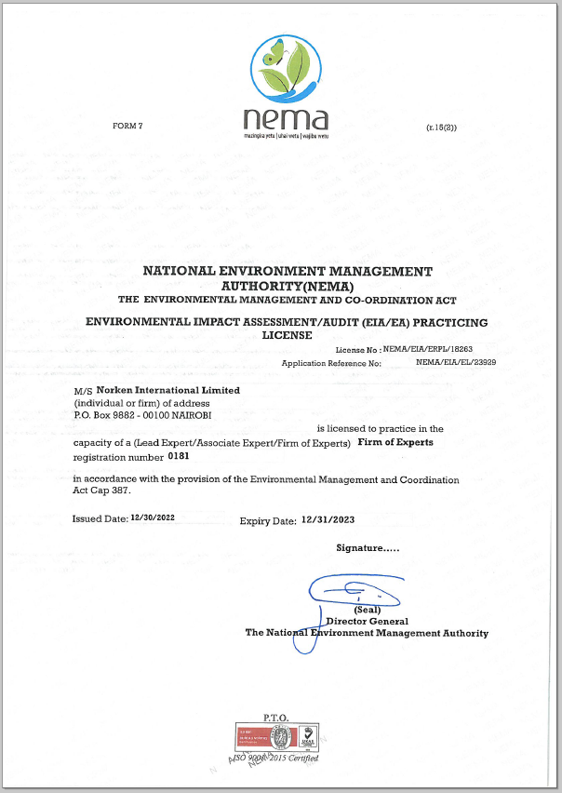
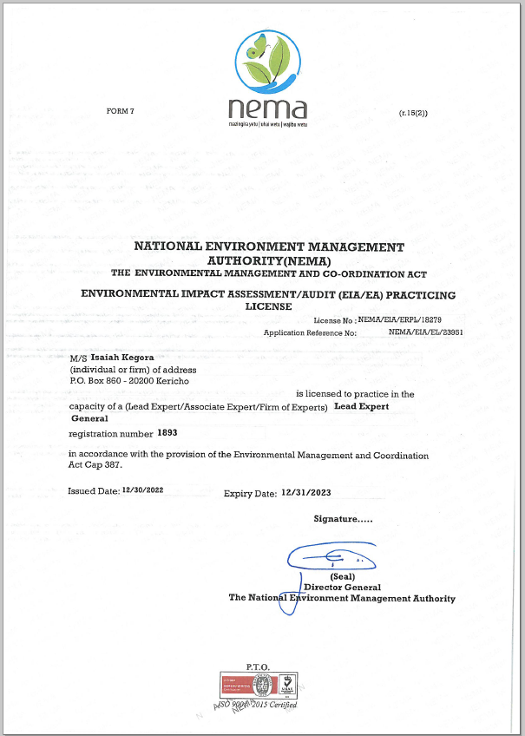

() As per the Energy Act of 2019, this role will now be performed by the Energy and Petroleum Regulatory Authority (EPRA).
A cost basis that will yield compensation sufficient to replace assets, plus necessary transaction costs associated with asset replacement).

